LIGHT

SECTION 6-REFLECTION
From Hands on Science by Linda Poore, 2003.

STANDARDS:

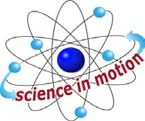
Westminster College

Students know light is reflected from mirrors and other surfaces.

Students know an object is seen when light traveling from an object enters our eye.

Students will repeat observations to improve accuracy, and know that the results of similar scientific investigations seldom turn out exactly the same because of differences in the things being investigated, methods being used, or uncertainty in the observation

Students will differentiate evidence from opinion, and know that scientists do not rely on claims or conclusions unless they are backed by observations that can be confirmed.

Students will predict the outcome of a simple investigation, and compare the result with prediction

Students will use numerical data in describing and comparing objects, events and measurements.

Students will collect data in an investigation and analyze them to develop a logical conclusion.

MATERIALS:
For Each Student: For the Teacher:
2 mirrors overhead projector
2 pieces of foil (4” x 4”) flashlight
penny ball
Flashlight with batteries

EXPLORE 1:

MIRRORS REFELCT REVERSED IMAGES
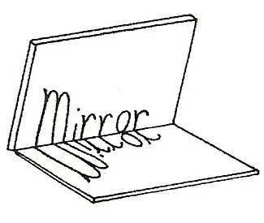
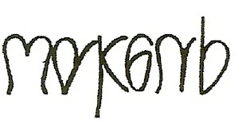
- Pass out mirrors, 2 pieces of foil, penny, flashlights with batteries, and the worksheet, Mirrors Reflect. Have students
complete the worksheet to discover how the mirror reverses the image.

- Discuss how a mirror reverses the image as it reflects light from the letters.
What does this secret message say? Have students read it with mirrors and then write their own secret message.

MATH: SYMMETRY
DISCUSS: What things have symmetry? (circle, skateboard, eyeglasses, the number 3)
Show students how to use a mirror to test letters for symmetry. PREDICT: Which letters can you bisect with the mirror and still see the whole letter?
Students complete the work sheet, Mirrors Reflect.

WHY MIRRORS REVERSE THE IMAGE:
Have everyone touch their left eyebrow with their left hand. Check students to be sure they do this correctly.
Then have them face a partner. What do they notice? (They are touching the opposite sides.)
The second person is like a mirror for you.
Have one person be a mirror now and copy their partner. (They move their finger to match the same side as the first person. The second person has to use the opposite hand to be the mirror image.)

WILL FOIL REFLECT AN IMAGE WHEN IT IS CRUMPLED?
Have students:
Try to read their name by looking at a reflection of it with a piece of flat, smooth foil.
Crumple the second piece of foil and try to read their name with it. Can you see your name reflected in the smooth foil? (probably)
Can you see your name reflected in the bumpy foil? (No, the bumps scatter the light so less light brings the image back to your eyes.)

- Find surfaces in the room that are good reflectors.
Are they rough or smooth? (smooth, such as the faucet and clock)

DEMONSTRATE:

WHY DO SMOOTH SURFACES MAKE GOOD REFELCTORS?
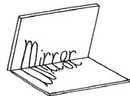
Predict what would happen if you throw a ball on a smooth surface compared to a very bumpy surface.
Compare the angle of rebound of a ball thrown at a chain link fence (bumpy surface) to the same ball thrown at the same speed at a smooth wall. Compare the ball’s rebound off the bumpy fence and smooth wall to light reflecting off crumpled foil and smooth foil.
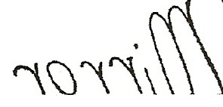
(Light reflects in many directions off rough surfaces, diffusing the image.) A smooth surface sends most of the reflected light back in 1 direction – carrying the image with it.

HOMEWORK:

SECRET MESSAGES:
Have students write a secret message backward that can only be read in the mirror.

EXTENSION:
LEONARD DA VINCI, a famous Italian painter and inventor of machines, wrote all his lab notes backward from the bottom right side of the paper to the top left, so that people could not read it and use his ideas.

IN ADVANCE:
You need a very dark room for the following activity.

EXPLORE 2:

LIGHT TRAVELS IN A STRAIGHT LINE
Have students:
- Reflect light from a flashlight with two mirrors.
Send light form one mirror to the other. (Turn off the lights.)

CAN YOU REFLECT A BEAM LIGHT AROUND THE ROOM?
Light travels in a straight line. (Darken room)
Use an overhead projector light and have 3 students with mirrors stand around the room within 8 feet of the projector. time them to see how quickly they can reflect light around the room to each mirror, back toward the projector and onto the teacher’s hand! (First shine the projector light on one mirror, then have the next student position himself or herself to catch the reflected light, etc. Hold mirrors very still. Notice that light travels in a straight line.)

- To reinforce that light travels in a straight line, take a ball of thick yarn or string. Have one student hold one end of the yarn on the light source. Take the yarn to each mirror. The yarn shows the path that the light travels as it reflects from one mirror to the next, in a straight line.

IN ADVANCE:

PROTRACTORS:
If you do not have protractors for your students, make copies of the protractor sheet on clear acetate and have the students cut them out. (End of section)

EXPLORE 3:

WHICH MIRROR ANGLE MAKES THE MOST REFLECTIONS OF A PENNY?
  - EXPLORE:
Place 2 mirrors together at an angle.
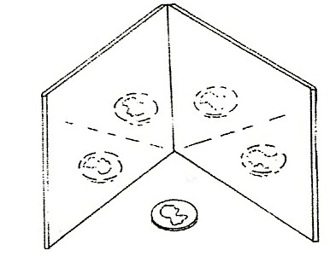
Change the angle of the mirrors and count the pennies you see.
Do you see the most pennies when the mirrors are close together or father apart? (close together)

RECORD DATA
Pass out the worksheet Angles and Reflections.
Put a penny on the X. Place 2 mirrors together in a ‘V’ on the lines. Tilt them down toward the paper slightly and look at the penny in the mirrors. Count the penny reflections only. Do not count the real penny.

MATH: MEASURING ANGLES
Teach the students how to use the protractor to measure angles. Measure each angle together if this is a new skill. Have an overhead transparency of the worksheet to guide the students.

EXTENSION:
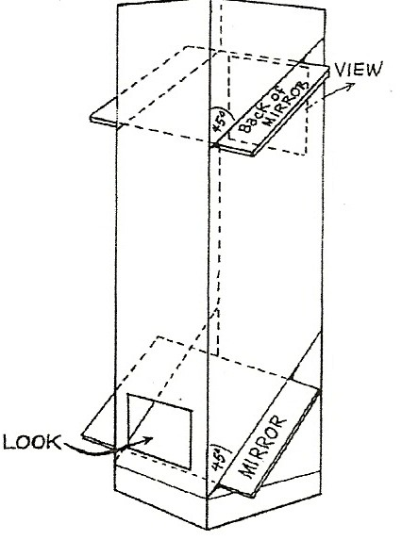
MAKE A PERISCOPE in a tall rectangular box→→ using 2 mirrors and draw a diagram to show the path of light. Put one mirror at a 45° angle in the top of the carton and one mirror at a 45° angle in the bottom of the carton. (You can use 2 or 3 one- half gallon milk cartons attached together to make a tall box.

EXPLORE:

CONVEX AND CONCAVE MIRRORS:
WHICH MIRROR MAKES IMAGES APPEAR UPSIDE DOWN?
- Pass out spoons.
Discuss concave and convex surfaces of a spoon. Have students ‘cup’ their hand.
They are looking at a concave palm. (Remember, it has a
cave.) The back of a cupped hand is ‘convex’.

- Have students: Hold a pencil, point up, 1” in front of a spoon. Look at it with the concave and convex sides. Which side reflects the pencil point, and yourself, upside-down? (Concave, the light rays cross and invert.)
Touch the pencil point up to the concave side of the spoon. Observe. (It is not upside-down. You see it before the focal point where the rays cross.) Move the concave side of the spoon away from you. Observe. (The pencil image flips and becomes upside-down.)

What happens to the pencil image as you move the spoon closer to it? (The image of pencil becomes fuzzy at the focal point and then flips right side up when the spoon gets very close or touches it.) The diagram below shows how a concave mirror inverts the image.

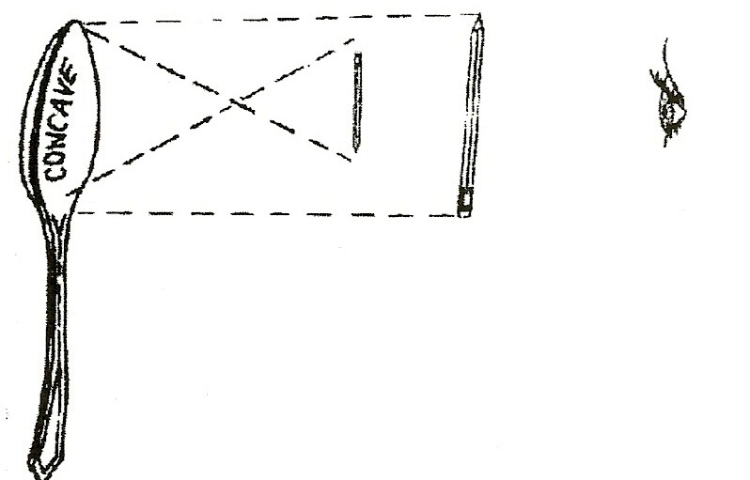
- CONCAVE MIRRORS make objects appear smaller. When held at a distance, the image inverts at the focal point and is observed as smaller and upside-down.

CONVEX MIRRORS
Look at the convex side of the spoon ‘mirror’. Hold the spoon sideways. What can you see in the ‘mirror’ that is not directly behind you? (sides of room)

UNDERSTANDING CONVEX MIRRORS
Convex mirrors collect light from a large area, reflecting images into your eye and making images appear smaller, thus more distant.

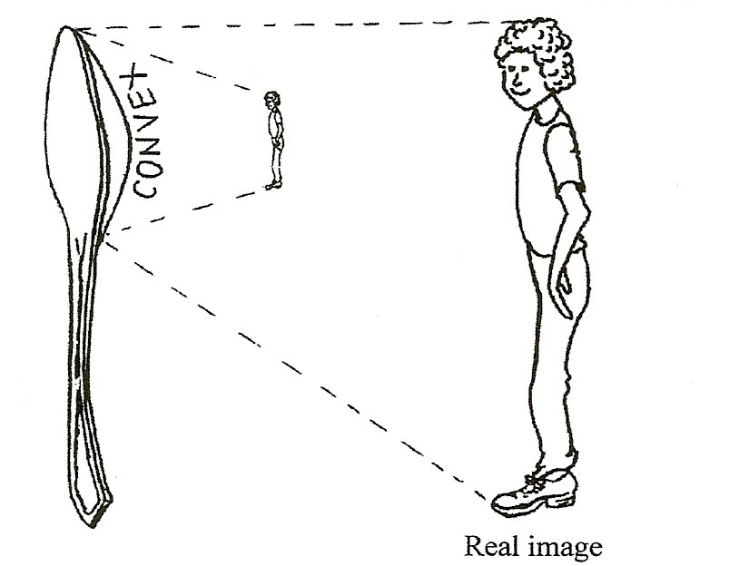

EXTENSION:

SOME CAR MIRRORS ARE CONVEX
Some side mirrors on cars and vans are convex to enlarge the field of view, thus you can see several lanes of traffic. The cars in the mirror appear smaller due to the large field of vision reflected in the mirror. On these mirrors it says, “Objects in mirror are closer than they appear” because when you see a ‘small’ car in the mirror, you might assume it is far away when it is actually very close. Convex mirrors are also used in parking garages to see ‘around’ a corner.

MATERIALS:
2 Flashlights
1 circle of black paper (2” diameter)

REINFORCE:

FLASHLIGHTS USE A CONCAVE REFLECTOR
- Pass out flashlights. Have students: look at the reflector in a flashlight. Is it concave or convex? (Concave)
Discuss how this curved surface reflects light. (The concave surface reflects the light back to the center to focus more light in one area.)

- To test the students’ theories cut a radius on a 2” black circle. Open one flashlight. Cover the curved inside reflector surface of 1 flashlight with black paper, allowing the bulb to poke through. Turn on this flashlight in a darkened room and compare its light to a regular flashlight. (Very little light is reflected so it appears dim.)

MIRRORS REFLECT
- What does this word say?→

- Put your mirror on each side of the word mirror.→
Place your mirror above and below the word. Tilt the mirror down toward the paper.

- Draw a red line at the place where you put your mirror when you could see the word correctly in your mirror.

- Look into your mirror and try to write the letter P backwards so it appears correct in the mirror.

- Print the word CAT backwards while looking into a mirror so that the mirror image is correct. Try to print your name this way, looking in the mirror so it is correct in the mirror.

SYMMETRY
6. Cover half of the letter A with the mirror so you can see the rest of the A in the mirror. Now try the R. Does the R have symmetry? | A R
7. Write 8 large letters you think have symmetry on the line below. Test them with the mirror. Draw a red line at the place where you put the mirror to see the whole letter. Put a red X over any letter that didn’t have symmetry.

ANGLES AND REFLECTIONS

HOW MANY PENNIES DO YOU SEE IN 2 MIRRORS?
  - Stand 2 mirrors on lines A and F, facing you and touching at the O. Put a penny over the X.
  - Tilt the mirrors down a little toward the paper to see the penny in the mirrors.
  - Count the number of pennies you see in the mirrors. Record the data below.
  - Change the lines on which the mirrors stand to change the angle.
  - Record the number of pennies for each angle.
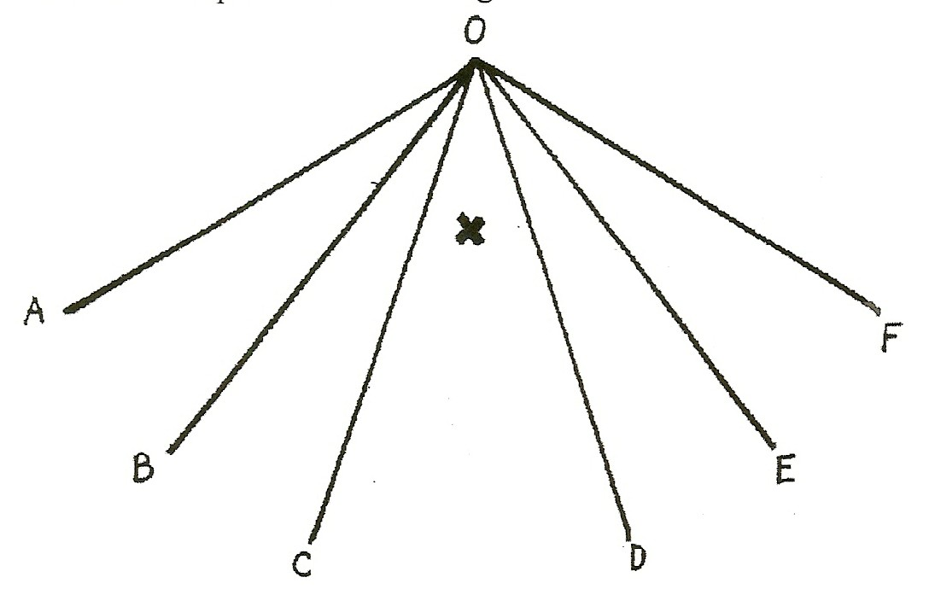

ANGLE | NUMBER OF REFLECTED PENNIES | NUMBER OF DEGREES
AOF
AOE
BOE
COE
COD

  - Use a protractor to measure the degrees of each angle. Record the degrees.

  - To make the most reflections, do you put the mirrors closer together or farther apart?

  - Does the angle between the mirrors need to be small or large to obtain the most reflections?

