SPACE

Section 5-THE SLANT OF THE SUN’S RAYS
From Hands on Elementary School Science, Linda Poore 2003

Standards Addressed:

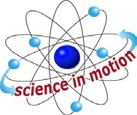
Westminster College

Students know energy comes from the Sun to Earth in the form of light.

Students will use numerical data in describing and comparing objects, evens and measurements.

Students will predict the outcome of a simple investigation and compare the result with the prediction.

Students will collect data in an investigation and analyze those data to develop a logical conclusion.

MATERIALS:
FOR EACH PAIR:
1 thermometer
worksheet-The Sun’s Rays (end of section)
- 8” x 11” piece of black construction paper 2 textbooks (teacher will provide)

DEMONSTRATE:
Pass out the thermometers and discuss the value of each line on the Celsius scale. (each line is 1 degree) Practice reading the room temperature.

EXPLORE:

COMPARING ENERGY FROM SLANTED AND DIRECT SUN RAYS
[S, energy-Sun]
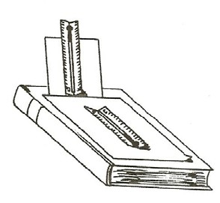
  - Do this experiment when the Sun is directly overhead. (noon?)
If the Sun is not overhead, be sure the students angle one thermometer directly at the Sun and the other at a slant. For instance, in the afternoon, the thermometer leaning at an angle may be the one directly facing the Sun, and the flat thermometer may be receiving slanted rays.

[S, data-measure]
  - Have the students read the work sheet. Discuss the experiment.
Group students in teams of 4’s so each team compares the temperature of a tilted vs. a flat thermometer.
Give each team a black piece of construction paper, folded in quarters. Cut one fold halfway across the paper.

Place the black paper on 1 textbook.
Use a second textbook to prop up the cut side of the paper at a slant.
Record the beginning temperature of each thermometer before going outside. Go out to a sunny area,
Lay one thermometer flat on the black paper and the other thermometer at a slant with the bulb end up. (so rays hit it at a slant)

PREDICT:
Which thermometer will receive the most heat energy? Record the temperatures of each thermometer after 10, 20, and 30 minutes on the work sheet.
Which thermometer showed the greatest change? (direct rays)

[S, predict] [S, data-conclusion]

  - During summer, the United States is tilted toward the Sun and its rays hit the United States more directly.
During the winter, the Sun’s rays strike the United States at a slant due to the tilt of the Earth, making the temperature cooler.

KEY WORDS:
PHOTOVOLTAIC CELLS: Solar cells are made of silicon. The solar cells absorb light energy from the Sun and release electrons, producing an electric current.

NOTE: The small connection points on the back of the motor will break off with rough handling. The alligator clip wires attach these two connection points to the 2 wires on the solar cell. Do not drop the solar cell.
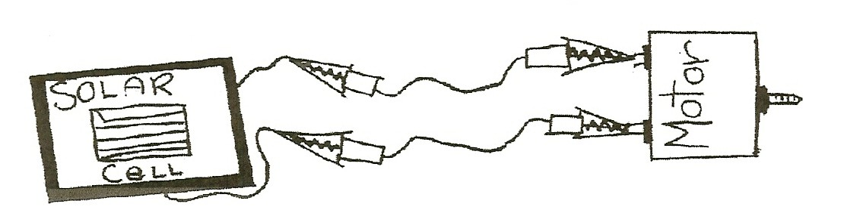

MATERIALS:
Solar cell flashlight
2 alligator clip wires Post-it™ note motor

DEMONSTRATE:

THE SUN’S LIGHT ENERGY BECOMES ELECTRICAL ENERGY
- Discuss how solar calculators work. Do you need the Sun? (light) Will the Sun give the calculator power? (Yes-light energy) Students experiment with solar energy in Light by Linda Poore.

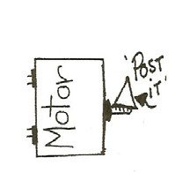
- SOLAR CELL: Show the students the solar cell and motor. Use the alligator clips to connect them in a circuit.
Make a ‘flag’ on the motor shaft so students can see it turning by cutting a ½ by 3” strip from the sticky end of a Post-It™ and fold it over the shaft or tape a small piece of paper to the motor shaft.
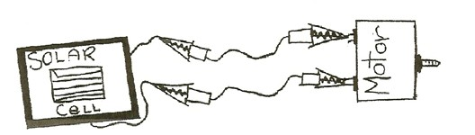
Is there enough light in the room to make the motor turn? (no) Shine the flashlight directly on the solar cell. What happens? (turns)

[S, predict] [S, sun/light energy]

ASSESSMENT:
COMPARING SLANTED AND DIRECT RAYS
DEMO: Have students: Write 1 to 6 on their paper. Lay the flashlight on a table so the students can see it. Place the solar cell facing down on the table and attached to the motor with a paper flag near the solar cell.
Write predict next to number 1. Answer the following questions:

- To make the motor turn the fastest, would you put the solar cell directly in front of the flashlight or at an angle? (Model the 2 choices with the flashlight turned off and facing the solar cell.) [S, predict]

- Demo 1: Place the solar cell/motor system 8” in front of the flashlight so it receives direct light rays. Complete the sentences:
The rays are . The motor turns

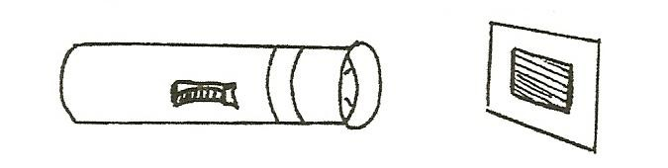

- Demo 2: Place the solar cell/motor system 8” in front of the flashlight so the solar cell is at a 30° angle to the flashlight. Complete the sentences:
The rays are The motor turns

- Do slanted rays or direct rays give more light energy?

- What would you do to make the motor go faster?

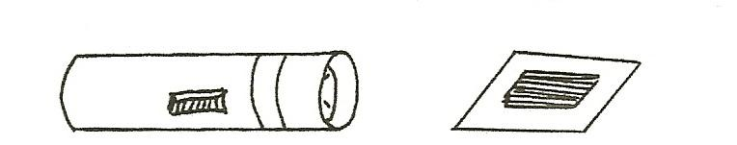

- How can you make the motor stop without touching it?

[S, data-conclusion]

Answers: 1. Direct. 2. Straight or direct, fast. 3. Slanted, slow. 4. Direct. 5. Stronger light, move the flashlight closer or use a bigger solar cell. 6. Answers vary-such as cover the solar panel with our hand.

EXTENSION:
Take the solar cell/motor system outside. Does the sun’s energy make the motor turn? (yes) What would happen if you covered the cell with black paper? (no light energy so the motor stops)

[S, Sun/light energy]

RESEARCH:
Have students brainstorm to list places they have seen solar cells collecting the Sun’s energy. Use the internet or other resources to find uses. (Examples: to power freeway phones, satellites and solar cars. Some outdoor yard lights collect solar energy during the day to run the light at night.)

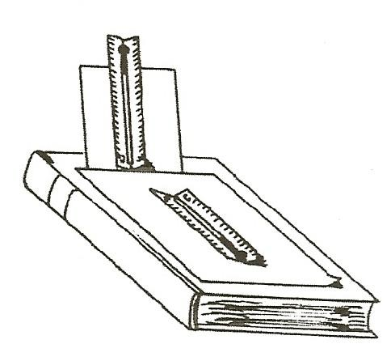
The Sun’s Rays
Does the slant of a thermometer to the Sun’s rays affect the amount of heat energy it collects?

- Record the beginning temperature of each thermometer.
- Place the black paper on your textbook and use the second textbook to prop up one thermometer. The slanted thermometer should have the bulb end up.
- Place both experiments in the sunlight.
- Record the temperature every 10 minutes.

Predict: I think the thermometer will receive the most heat energy from Slanted Rays or Direct Rays (circle one)

Experiment 1 Experiment 2
Beginning Temperature | THERMOMETER RECEIVING SLANTED SUN RAYS  _°C | THERMOMETER RECEIVING DIRECT SUN RAYS  °C
After 10 min. | °C | °C
After 20 min. | °C | °C
After 30 min. | °C | °C
Difference (Beginning-ending temp.) | °C | °C

Draw the Sun and the thermometer receiving slanted rays from the Sun. | Draw the Sun and the thermometer receiving direct rays from the Sun.

- Which experiment collected the most heat?
- Write a conclusion, describing what happened and why.

