MACHINES AND MOTION

SECTION 5: TOOLS THAT WORK AS LEVERS

STANDARDS:

Westminster College

Students know tools and machines are used to apply pushes and pulls forces) to make things move.

Students know the way to change how something is moving is by giving it a push or a pull The size of the change is related to the strength, or the amount of “force,” of the push or pull.

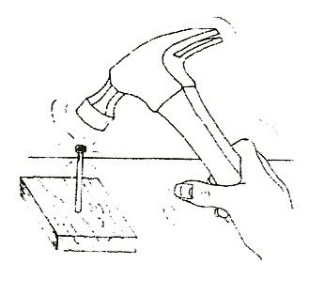
MATERIALS:
hammer rock (4” diameter)
board can (soup or coffee)
screwdriver screws
can opener can with lid
30 nails (2” – 3”) comb

NOTE:

WORK = DISTANCE X FORCE:
The further distance you do the work, the less force you need. (Compare holding the hammer at the end of the handle to holding it close to the head where the work is done. The longer the handle, the less force necessary to do the same work.)

IN ADVANCE:
Make a nail hole in one short wood board and label the board in permanent marker for Section 5. Keep this board in the Section 5 bag. Do not hammer nails in the 2 other boards used as ramps.

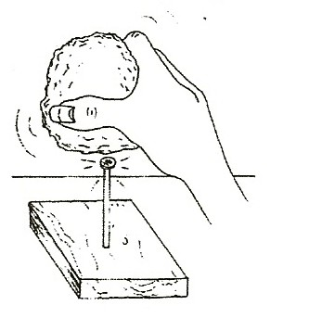
DEMONSTRATE:

WHICH TOOLS USE LEVERS TO DECREASE THE AMOUNT OF FORCE NEEDED?
- HAMMER THE NAIL
How can we get the nail into the board? Who can push it in? What tool can we use? Try hitting a nail with:
a rock
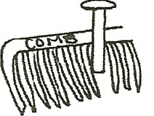
a hammer holding the head only and a hammer using the handle
Hold the nail stead with a comb wedged around it.
←This prevents the hammer from hitting any fingers.
Discuss how a lever helps do work. (The handle lets you do the work over a greater distance with less force.)

TOOLS THAT WORK AS LEVERS

REMOVING A NAIL
Have students try to remove a nail with the hammer claw by first holding the hammer head and then holding the end of the handle.
(Work = Force x Distance, the handle puts the work at a distance from your hand. You move the handle further than the nail moves.)

LIFTING A LID WITH A LEVER
Show students the can with the lid. (like a small paint can) Try to open the can with the lid using:
your fingers, a nail, a bottle opener, and then a screwdriver.
Is it easier to hold a screwdriver close to the can or at the end of the handle to lift the lid? (handle) Try it.
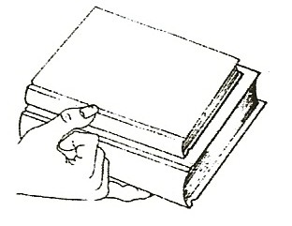
Discuss the length of the lever compared to the amount of force needed. (Longer lever = further distance and less force needed to do work.
For instance, the bottle opener barely moves at the sharp end compared to the distance you move your hand.)
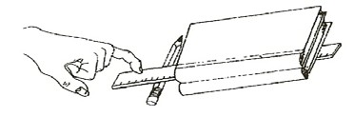

- Have the students try to lift several books with their smallest finger.
Then use the smallest finger with a ruler and a crayon together, working as a lever. (see drawing)↑
Try pushing the ruler close to the books and compare to pushing at the end of the ruler. Discuss how this relates to lifting the lid in #3 above.

- Try to make a hole in the ‘soup’ can by pushing a nail with your hand. use the can opener. How does this lever help you do work? (You do the work over a greater distance.)

DEMONSTRATE:

WHAT IS A WHEEL AND AXLE? HOW DOES IT HELP US DO WORK?
- The screwdriver is a wheel and axle. Try to put a screw into a nail hole using your hands. Try again with a screwdriver.
The thick handle makes work easier.
Try holding the screwdriver along the metal part instead of the handle. (You must use more force but turn the handle a shorter distance.)

- The screw is actually an inclined plane wrapped around a pole. Therefore, it takes less force to push a screw into the board because it moves a greater distance by turning around as it enters the board.

