AIR

SECTION 6: AIR PRESSURE
From Hands on Science by Linda Poore, 2003.

STANDARDS:

Westminster College

Students know solids, liquids, and gases have different properties.

IN ADVANCE:
Have ice available. Put hot water from the teacher’s lounge in the ice bucket or use a hot pot.

MATERIALS:
1 2-liter soda bottle hot water
tray of ice water 2 ice buckets

EXPLORE:

HOW STRONG IS AIR PRESSURE?
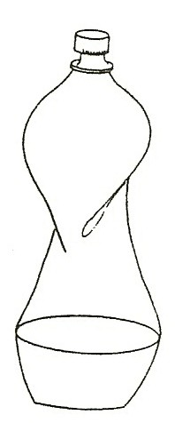
- Fill the 20liter bottle ¼ full with very warm water and swirl the water to heat the bottle. Dump the water and quickly screw on the cap. Is the air in the bottle hot or cold? (hot) Hold the bottle by the cap. What happens? (bottle caves in) For fast results, set the bottle in the tray of ice water.

WHAT PUSHES THE BOTTLE IN?
First, the hot water heated the air in the bottle. The hot air rose and some of it left the bottle. There are less air molecules in the bottle now.
After you cap the bottle, the air inside begins to cool and contract, taking up less room. It has less pressure than room air, as there is less air in the bottle (some air escaped). The air in the room has more pressure and pushes harder, denting the bottle in.

AIR PRESSURE AFFECTS THE WEATHER
High pressure usually brings clear weather and low pressure brings strong winds and poor weather. Changing air pressure also brings winds. When a high pressure front meets a low pressure front, it pushes it out of the way, bringing fair weather.

KEY WORDS:

BAROMETER:
Measures changes in air pressure. Increasing pressure means fairer weather. A sudden drop in pressure indicates a storm or rain.

Westminster College SIM Page 1

