SECTION 6: BALL AND CUP CONTEST

LAB

INTRODUCTION
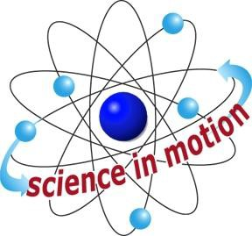
Westminster College

With the ball and cup, students will apply their knowledge of gravity and Newton’s laws to succeed in operating this old­fashioned toy. Newton’s second law can be used to explain why the ball falls into the cup. According to Newton’s second law, an object moves in the direction of the force that it experiences. As the student swings the ball around on the string, the string pulls inward on the ball. The ball moves in the direction that the string pulls it. The result is a circular motion. In circular motion, an inward force continually turns an objects straight­line path. This inward force is called centripetal force. Use your own judgment in introducing this concept to students.
Because it is complex, it should be considered as an optional presentation. The behavior of the ball and cup can be explained with just gravity and Newton’s second law.

ASSESSMENT ANCHORS ADDRESSED
S4.A.2.1 Apply skills necessary to conduct an experiment or design a solution to solve a problem.

S4.C.1.1 Describe observable physical properties of matter.

S4.C.2.1 Recognize basic energy types and sources, or describe how energy can be changed from one form to another.

S4.C.3.1 Identify and describe different types of force and motion, or the effect of the interaction between force and motion.

PURPOSE
In this activity, students construct a traditional toy and determine how they use gravity in operating the toy.

MATERIALS

For Each Pair of Students For the Class
Activity Sheet 6 Table tennis ball
Table tennis ball Cup
Cup Scissors
Ruler Flat wooden stick
stick Kite string
Masking tape Measuring tape VCT
Video­ Toys in Space
Teacher provides items marked with *

Westminster College SIM Page 1

