WEATHER

SECTION 6: CLOUDS, FOG, AND SMOG
From Hands on Science by Linda Poore, 2003.

STANDARDS:

Westminster College

Students know solids, liquids, and gases have different properties

Students will draw picture that portray some features of the thing being described.

Students will record observations on a bar graph.

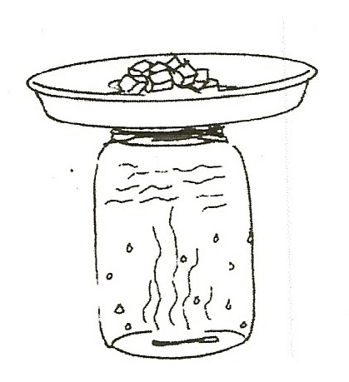
Students will describe the relative position of objects by using two references(e.g., above & next to, below & left of.)

NOTE:
Warm air can hold more moisture than cold air. When you cool the air, the water vapor in it changes to a liquid as the cooler air cannot hold the same amount of moisture. Fog forms only when the air is cool.

PRETEST:
What is smog? What is fog? What is a cloud?

MATERIALS:
For each Pair For the Teacher
1 plastic jar with lid 1 glass quart jar or bottle matches
ice in a pie tin
hot pot-warm water

DEMONSTRATE:

WHAT CAUSES FOG? WHAT IS A CLOUD?
- Put several inches of very warm water in the jar and swish it around for 15 seconds. Pour the water out.
Light a match, hold it in the jar upside down, and shake the flame out so smoke fills the jar.
Immediately cover the top of the jar completely with a pie tin with ice.
The water condenses as it cools and the jar becomes foggy. A cloud is water droplets that condense on tiny dust particles in the sky. The smoke form the match provides the particles.

- Pass out the worksheet, Making Fog.
Draw the experiment and answer the questions.

- FOG is a cloud sitting on the ground.
How does it feel to be in the fog? (wet, cold)
When water evaporates form a lake into the sky, it cools at high altitudes and forms clouds.
After a hot shower, the room is full of ‘fog’.

- Have students take a deep breath and exhale on their hand. What do they feel? (warm air)
Have students exhale into a slim jar and screw on the lid. What do they observe? (fog, the warm moist air cools when it touches the cooler jar and the water vapor condenses.)
The same thing happens when you exhale on a cold day.

- SMOG is a mixture of fog, smoke, and chemicals. Repeat the fog experiment above, but place a burning piece of paper in the glass jar. When it goes out, quickly cover the jar with a pie tin with ice. Watch the smog form in the jar. (darker than fog) Discuss the role of auto exhausts and factories on producing smog. What can you do to prevent smog? (walk-drive less)
What time of year is the smoggiest? (August and September in Lost Angeles, CA)

ASSESSMENT:
Evaluate student answer on the worksheet Making Fog.

NOTE:

WHERE IS THE WEATHER?
The weather is located in the troposphere, the atmosphere up to 10 miles above sea level. Nitrogen makes up to 78% of the atmosphere and oxygen is 20%.
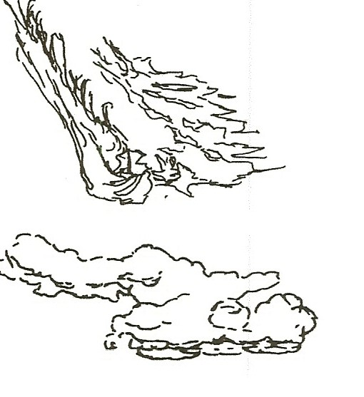
Carbon dioxide, helium, neon, ozone, and water vapor make up the last 2% of the atmosphere.

CLOUD TYPES
CLOUDS ARE CLASSIFIED BY ALTITUDE

HIGH: 20,000’-40,000’
CIRRUS are high and feathery, filled with ice crystals (also cirrostratus and cirrocumulus) Usually indicates good weather.

MEDIUM HEIGHT: 6,000’-20,000’
Altostratus, nimbostratus, altocumulus

LOW: 0-5000’
STRATUS (also stratocumulus) hang low in layers making the sky overcast or foggy. Rain is likely. Fog

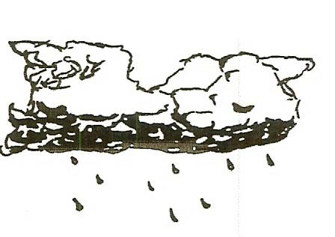
is a stratus cloud on the ground.

CUMULUS clouds look like cauliflower with flat bases and usually indicate fair weather. (also cumulonimbus-a combination with nimbus)

NIMBUS are rain clouds that appear dark as they are filled with rain drops that block out the Sun’s light. Really dark clouds hold snow.

AIRPLANT CLOUDS form when water vapor from the airplane’s engine freezes into ice crystals. These contrails help forecast the weather. If they vanish quickly the weather will be good. When they linger, a storm may be approaching. (It is colder, thus the ice crystals remain.)

EXPLORE:

OBSERVE CLOUDS
- Go outside on cloudy days and observe the clouds.
Draw them and label the drawings with the name of the cloud type. Use a reference source to get more information on cloud types.
SAFETY: Remind students to never look directly at the Sun.

- Tell the students they are pick a cloud and describe its position in the sky relative to themselves. They must use 2 references in their description and they cannot point or tell its shape.
(e.g., it is above the tree and to my right or it is behind me, below the Sun and to the left of the school)
The other students will then point to the cloud described.

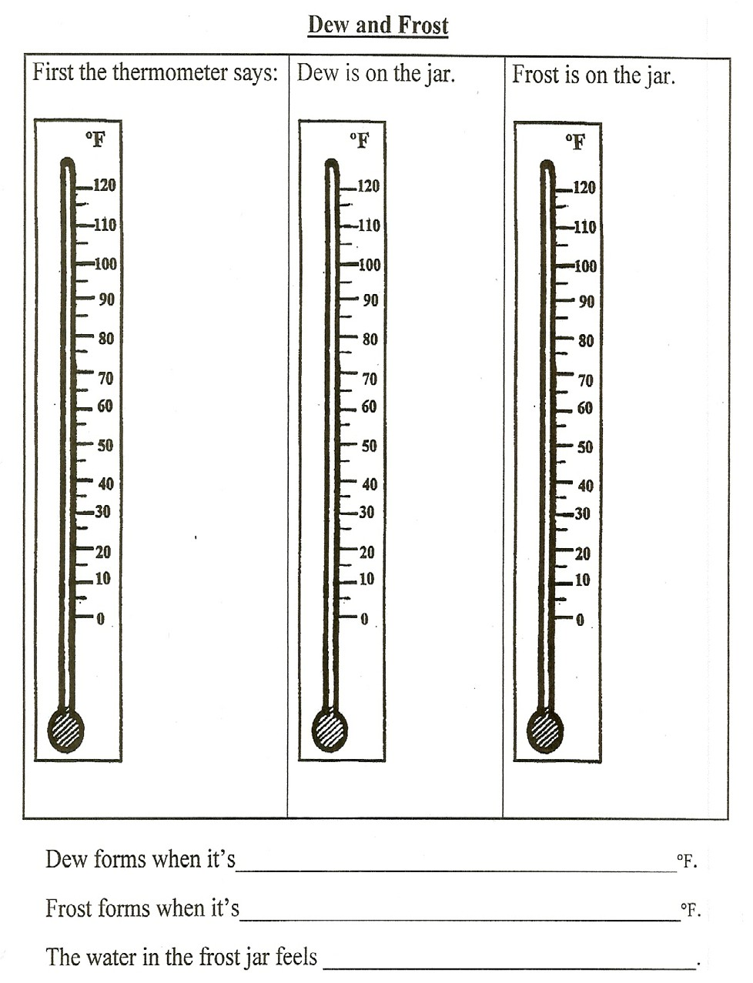

MAKING FOG

What did we put in the jar?

What did we put above the jar?

What happened inside the jar?

Draw the experiment.

What was added to make smog?

Does your city have smog?

How do you feel when it is a smoggy day?

