REFLECTION, DIFFRACTION, REFRACTION SECTION 6: FOR A PLANE MIRROR, THE ANGLE OF INCIDENCE EQUALS THE ANGLE OF REFLECTION

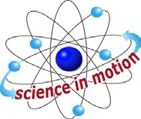
Westminster College

PROCEDURE:
- Place a sheet of loose leaf paper on your work surface. Keep the long edge of the paper parallel to the edge of your work area.
- This activity needs a darkened room. Turn off lights in the work area.
- Fasten slit cap to flashlight.
- Attach all 4 mirrors to mirror stands.
- Place one plane mirror at top right corner of paper. Align the straight edges of mirror with the paper’s edge.
- Point the narrow light beam at the bottom corner of a plane mirror. Observe the incident and reflected light beams.
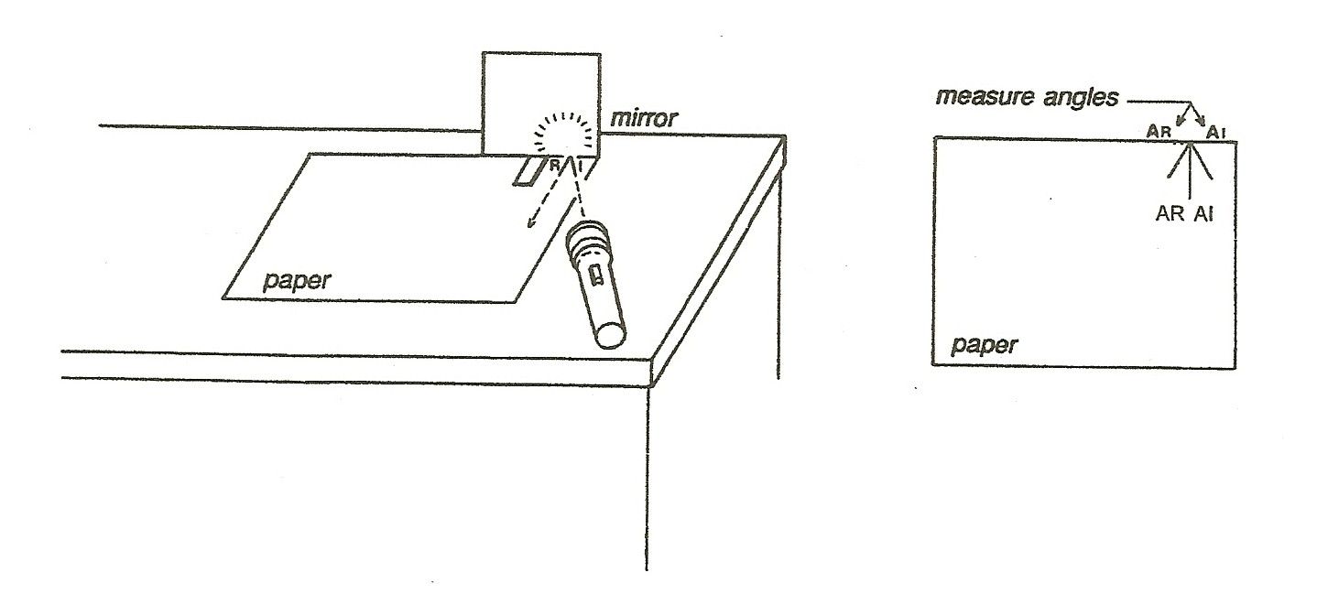

- Trace the path of both the incident and reflected light beams. Mark one I and the other one R.
- Draw a normal line for this mirror by drawing a line perpendicular to the mirror from the point where the light is being reflected. Measure the angle between the incident ray and the normal line (Angle of Incidence) “I” and the angle between the reflected ray and the normal Lien (Angle of Reflection).
- Place a second plane mirror at a right angle to the first mirror.
- Point the narrow beam of light at the bottom corner where the mirror edges meet. Record your observations.
- Two mirrors are placed at right angles to each other. In the diagram, identify the incident and reflected light rays. Hint: one light ray serves as both a reflected light ray and an incident light ray.

THE ANGLE OF REFLECTION

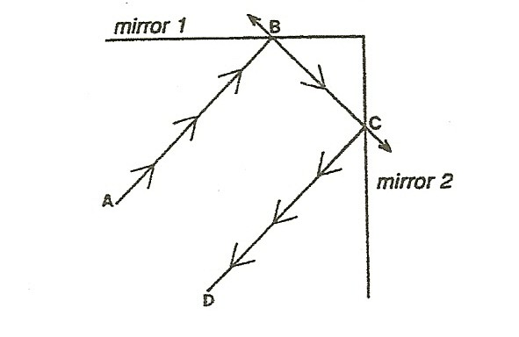

ADDITIONAL ACTIVITIES:
- Look through a kaleidoscope. These images are caused by reflected light, in a process similar to what you just observed. Can you determine where the mirrors are? Try building your own kaleidoscope using 3 small pieces of smooth reflective material. (Small mirror pieces taped together in a triangle, or aluminum foil covered pieces of cardboard facing shiny side toward the center of the triangle work well)
- Using inexpensive plane mirrors and cardboard tubes, build a periscope.

