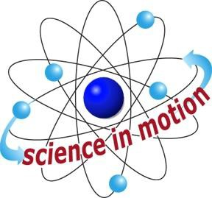
SECTION 6: LONGER LASTING BUBBLES

LAB

INTRODUCTION

Blow a bubble that will last for ten minutes… twenty mintues…over an hour! Yes, it is possible! In 1917, Sir Thomas Dewar made a bubble that lasted 108 days. Since then, Eiffel Plasterer, a physicist

Westminster College

who has been blowing bubbles for close to sixty years, belw a bubble that lasted for 340 days! Present this challenge to your students, and let them apply what they’ve learned about bubbles. This open­ended experiment serves as an excellent culmination to a unit on bubble science.

ASSESSMENT ANCHORS ADDRESSED
S4.A.1.1 Identify and explain the pros and cons of applying scientific, environmental, or technological knowledge to possible solutions to problems.

S4.A.2.2 Identify appropriate instruments for a specific task and describe the information the instrument can provide.

S4.C.1.1 Describe observable physical properties of matter.

PURPOSE
Students will culminate all that they have learned about bubbles when they try to make bubbles that last!

MATERIALS

For the class:
*1 pint sized containers *Newspaper Dishwashing liquid Eyedropper
Glycerin 1 one gallon container
1 pie pan *water
straws
Teacher provides items marked with *

Westminster College SIM Page 1

