MACHINES AND MOTION

SECTION 6: MACHINES WITH WHEELS

STANDARDS:

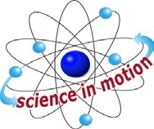
Westminster College

Students know tools and machines are used to apply pushes and pulls forces) to make things move.

Students know the way to change how something is moving is by giving it a push or a pull The size of the change is related to the strength, or the amount of “force,” of the push or pull.

Students know an object’s motion can be described by recording the change in position of the object over time.

Students will measure length, weight, temperature, and liquid volume with appropriate tools and express those measurements in standard metric system units.

Students will use magnifiers or microscopes to observe and draw descriptions of small objects or small features of objects.

ASSESSMENT:
Describe how the pencil sharpener is a wheel and axle. How does it help us sharpen pencils easily? (You turn the handle a greater distance with little force and the small axle turns the cutters less distance with more force.) Find another wheel and axle in class! [door knob or door handle, egg beater (in kit) and screwdrivers]

HOMEWORK:
Ask students to bring a small, fast ‘matchbox type’ cars to schools.

MATERIALS:
1 egg beater

DEMONSTRATE:

THE EGG BEATER HAS GEARS AND A WHEEL AND AXLE:
- CHANGES SPEED
Have a student turn the handle slowly. Ask the students if the beaters are moving faster, slower, or the same as the student’s hand. (faster)
Have the student change the speed he/she is turning the handle.
Count the number of gear teeth on the handle and compare it to the number of gear teeth on the beaters. (more on the handle)
(If the handle has 50 and the beater has 10, then the gear ration is 5:1 and the beaters will go 5 times as fast as the handle.)
Which would be faster, to stir some cake batter or use the beater?

CHANGES DIRECTION
Turn the handle on the eggbeater slowly. Do the beaters go the same direction as your hand? (no, perpendicular to your direction)
This allows you to turn up and down, which is easier than turning around. Do both beaters move the same direction? (no)

WHEEL AND AXLE
The handle is the wheel and it is attached to the gear with a metal bar called the axle. If you could remove the handle, it would be too hard to move the axle. The handle moves around a bigger diameter (distance) than the axle, making work easier.

PENCIL SHARPENERS HAVE A WHEEL AND AXLE
Remove the handle from a pencil sharpener and try to sharpen a pencil by turning the axle. It is impossible. The handle turns a ‘big’ distance compared to the axle; therefore you use less force.

THE DOORKNOB IS A WHEEL AND AXLE
Does a doorknob help you do work?
Could you open the door without the knob?
Do you turn more distance with or without the knob?
If you remove a doorknob at school, remember to leave the door open. Have the students turn the knob first, then try turning the axle with the knob removed.

ASSESSMENT:
A steering wheel on a car is a wheel and axle.
- Explain what would happen if it was taken off.
- Could a person turn the axle? (no)
- Would it be harder or easier to make turns with a tiny steering wheel?

MATERIALS:
small cars masonite boards, rulers

EXPLORE:

CAR RACES
  - DISCUSS: What can you do to make your car go faster? (lubricant the wheels, smooth surface, bigger push)

  - RULES: The car can get its energy only from rolling down a ramp. The angle of the ramp (masonite board) is determined by the ‘driver’.

  - DISTANCE RACE: Have the students change the ramp angle to discover how to make the car go the farthest distance.
Practice for 10 minutes.
Each car races one time. The car that goes the farthest distance wins. Record the number of centimeters the car goes as points. This is the student’s score. (Lay several meter sticks end to end from the start line to measure distances.)
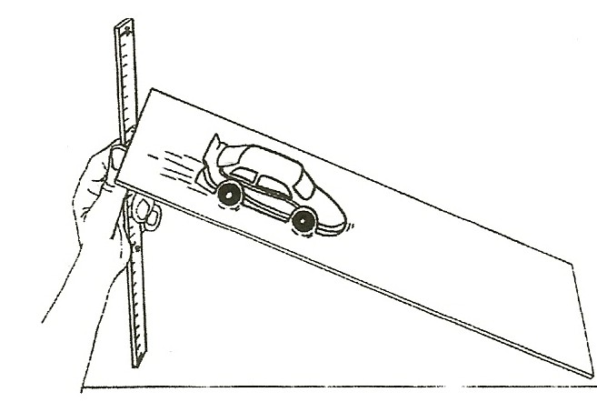

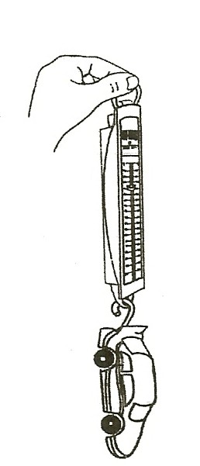
  - STOPPING RACE: Have students experiment with their car to
find out how to make their car roll to a stop in 60 cm. Start the car on a ramp. Measure the distance of 60 cm on the flat surface, once the car leaves the ramp and mark it with a chalk line.
Put a ruler on either side of the line for measuring results. Give the students time (10 minutes) to test ‘drive’ the car. Each car gets one chance for the ‘Stop Race.’
MATH: Take off a point for every centimeter the car misses the 60 cm distance (e.g., If the car misses the chalk line by 10 cm then the score is 50.)

SPEED RACE:
Put all ramps on 3 textbooks so they are the same height. Each student releases their car from a ramp.
Time how many seconds it takes for each car to go 2 meters. Record the results. Make a graph to compare the speeds.
Change the title on the graph worksheet in Section 3 to Which car is the fastest, and put the students names on the key at the bottom.

WEIGH THE CARS
Using the spring scales, weigh the car and record its weight (mass) on the chart. Compare the cars.
Did the heaviest car go the farthest? Did it go the fastest?

ASSESSMENT:
Describe what you did to try to get your car to win the stopping race.

MATERIALS:
12 marbles
1 very large and 1 very small jar lid book
roller skate or skateboard wheel

DEMONSTRATE:

BALL BEARINGS:
- Have students:
Rub their hands together quickly for several minutes. What happened? (Friction causes heat)
Rub their hands together with a pencil between them.
How is it different? (Hands roll across each other, causing less friction as less surface is touching so the hands do not get hot.)
Rolling has less friction than sliding.

- Place the marbles in a small lid and cover it with a larger lid. Put a book on top and turn it with your finger.
The book should roll on the marbles and have little friction.
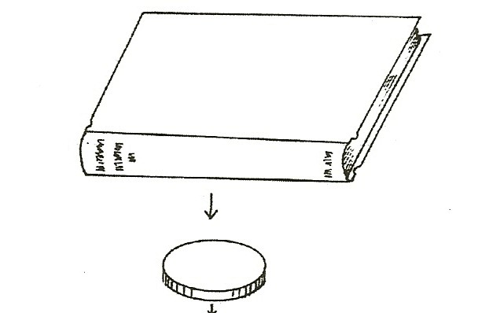

- Try to turn the book without the marbles. Discuss.
( The book slides on more surface area, creating more friction.)

- Discuss skateboard bearings. What do they do? (reduce friction) Ask a student to bring in some bearings from a skateboard. Observe.

