POLLUTION

SECTION 6-OIL AND WATER DON’T MIX
From Hands on Science by Linda Poore, 2003.

OBJECTIVES

Westminster College

Students begin to understand the environmental impact of oil spills by discovering how difficult it is to remove oil from water and from feathers.

Student will observe what happens when oil is added to water.
Student will compare the structure of feathers before and after contact with oil.
Students will infer the effects of oil spills on birds.
Students will try to remove oil from water.

MATERIALS
For Each Student For Each Team (2)
1 feather 4 cotton balls
1 magnifier 1 calibrated cup (1oz)
1 petri dish, top or bottom 1 plastic spoon

For The Class
1 bottle motor oil 1 roll paper towels 1 two quart pitcher
1 bag mystery powder 2 plastic spoons
tap water

PREPARATION
- Fill the pitcher with tap water. Place the bag of mystery powder, the calibrated cups, a bottle of motor oil, two plastic spoons, and the pitcher of tap water at a distribution station. Fill each calibrated cup with 1 oz(2 Tbsp) of mystery powder, one cup per team.

- Each student will need a magnifier, a feather, and a paper towel. Each team of two will need the top or bottom of a petri dish filled with water, 1 tsp of motor oil, a plastic spoon, a calibrated cup filled with 1 oz (2Tbsp) of mystery powder, and four cotton balls.

BACKGROUND INFORMATION
Years ago, when the use of oil was not as widespread as it is today, the dangers associated with its transport and use were not of global concern. Today, in order to fill demand, oil companies must tap underground oil reserves all over the world: in the sea and desert, in the steamy jungle and frozen Arctic. But

transporting oil from its source to a refinery, and from the refinery to the user, can be perilous. An accident could create an environmental disaster.

Spills from oil tankers are not the only hazard associated with handling oil. The discharge of refinery waste material into the water and air, and the improper disposal of used motor oil by dumping it into sewers, also contribute to pollution.

GUIDING THE ACTIVITY
- Divide the class into teams of two. Distribute the top or bottom of a petri dish to each team. Have one student from each team bring the dish to the distribution station. Fill the dish half full with tap water. Then use the plastic spoon to add about 1 tsp of motor oil into the water. After the students have returned to their seats, have them describe what they observe.
The students should observe the oil floating on the surface of the water.

Ask, Imaging that you petri dish is a lake or an ocean. How might oil get into the water?
Accidents can occur when oil is drilled, transported, or refined; motor oil is often disposed of improperly; and oil can also seep up through cracks in the ocean floor.

Ask, What do you think would happen to birds that live in, or that feed on fish that live in, this water?
Most students will realize that the birds could come in contact with the oil.

- Give each student a feather, a magnifier, and a paper towel. Have them use the magnifier to examine the structure of the feather. Point out how the parts lock together but can easily be pulled apart.
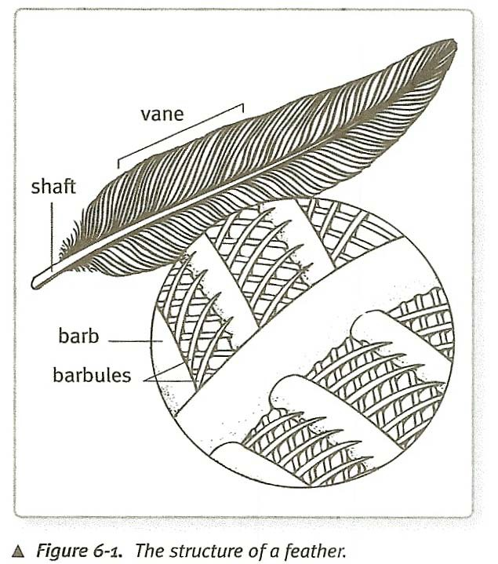

- Direct the students to dip the feather into the oil and water mixture in the petri dish and blot it on the paper towel. Have the students use a magnifier to observe the feather again. Ask them to describe what the oily feather looks and feels like.
They should describe it as matted and sticky.

Ask, How might birds be affected by oil in their feathers?
The students should suggest that birds would not be able to use their matted feathers. As a result, they would not be able to swim, gather food, or flee from enemies. Many could become waterlogged and drown. They may also be poisoned by ingesting the oil while preening their feathers.

- Encourage the students to try to clean the oil off the feather.
Students may try blotting the feather with a paper towel, or rinsing it with clean water, neither of which will be very effective.

Now ask, How do you think you could remove the oil from your petri-dish ocean?
Give students a chance to discuss the question. List teams responses on the board.

- Tell the students that they will compare three methods of removing the oil from the water: (1) scooping it out with a spoon, (2) blotting it with cotton balls, and
(3) sprinkling it with a mystery powder.

Distribute a plastic spoon to each team. Encourage the students to take turns trying a variety of scooping techniques to remove the oil from the water.

Students will probably find that holding the spoon almost parallel to the water and skimming the surface is most effective. Remind them that they would not be able to “lift” the ocean; therefore, any technique that involves lifting or tipping the petri dish does not count.

Ask, Why is it difficult to spoon the oil out of the water?
Oil and water are both liquids that spill off the spoon when the spoon is tipped.

- Next, distribute four cotton balls to each team. Encourage them to try using the cotton balls to remove the oil from the water.
After students have experimented, ask, Why is it so difficult to remove oil with a cotton ball?
The cotton ball picks up both water and oil.

Give students time to discuss the problems with the spoon and cotton-ball techniques and to share any ideas they have about other techniques that might work.
If possible, give students an opportunity to try some of those techniques.

- Now distribute a calibrated cup filled with mystery powder to each team. Instruct the teams to sprinkle about half of the powder into their petri dishes directly on top of the oil. Then ask, What is happening to the oil?
Students will notice that the powder is “capturing” the oil and forming pellets which can then be lifted out of the water.

Let the powder sit for 5 minutes. Then have students remove the porridge-like substance with their spoons.
Tell students to add more powder as needed to make a stiff porridge.

Ask, Which of these three techniques was most effective in removing oil?
Students should respond that adding the mystery powder enabled them to remove the most oil and the least water.

Encourage students to discuss how the mystery powder works. Tell them that the powder was developed specifically for cleaning up oil spills.
Safety Note: The Mystery powder is extremely slippery when wet. It may also give off toxic fumes if burned, so avoid exposing it to extreme heat or open flame.

The “mystery powder” used in this activity is actually an oil polymer designed to aid in the cleanup of hydrocarbon spills. It is also seeing increased use in “Safety diapers” that prevent diesel, crude oil, and other hydrocarbon spills from spreading in soil. It polymerizes (Most) crude oil and acrylic paint thinners within 15 minutes into a hard substance. It polymerizes diesel and gasoline into softer substances which will melt down when exposed to sunlight or another heat source. This oil polymer does not polymerize refined (new) motor oil, but instead causes it to curdle. While this curdling allows students to more easily remove the motor oil from water in this activity, it should be noted that the oil polymer is not working to its full potential.

