LIGHT

SECTION 6-REFRACTION-BENDING LIGHT
From Hands on Science by Linda Poore, 2003.

STANDARDS:

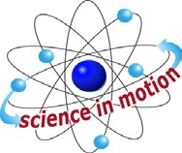
Westminster College

Students know an object is seen when light traveling from an object enters our eye.

Students will differentiate evidence from opinion, and know that scientists do not rely on claims or conclusions unless they are backed by observations that can be confirmed.

Students know telescopes magnify the appearance of some distant objects in the sky, including Moon and the planets. The number of tars that can be seen through telescopes is dramatically greater than the number that can be seen by the unaided eye.

Students know the color of light striking an object affects the way the object is seen.

Students will predict the outcome of a simple investigation, and compare the result with prediction

Students will collect data in an investigation and analyze them to develop a logical conclusion.

IN ADVANCE:
Have students bring in unusual shaped clear glass jars, vase, etc. (slim olive jars, ‘square’ Taster’s Choice® coffee jars, round fish bowls) Keep these jars in the kit for next year!

MATERIALS:
For Each Pair:
1 piece wax paper (6” x 6”) 1 cup water
1 jar of water 1 spoon
- cup

NOTE:
REFRACTION (bending) occurs when light crosses (at an angle) a boundary between 2 transparent substances of different indexes of refraction. The speed of light changes, making the object appear to be in a new place. Light travels faster through air than water, so the image arrives at your eyes through the air faster than through the water, causing a distorted image.

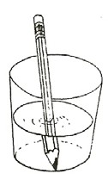
EXPLORE:

WHAT MAKES A PENCIL APPEAR TO BEND IN WATER? OBSERVING REFRACTION
- Pass out cups with water. Have students put their pencil in a cup of water at different angles. Look at the pencil at the top edge of the water. How does it look? (The pencil appears normal when held vertically. If held at a slant, it appears bent or larger.)

- Discuss how light bends as it passes through water.
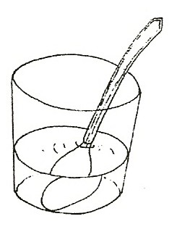
Light ‘bends’ because water and air have different indexes of refraction. Light travels faster through air than through water so as light waves move from air to water, they slow down and bend when they enter the new substance at an angle.

- WHICH JAR MAKES THE SPOON APPEAR LARGER? Predict how a spoon will look in each jar with water. Experiment. Put the spoon in different shaped jars. Try curved jars.
Try water in jars with flat sides. (e.g., Taster’s Choice®) Draw a picture of the spoon in the jar of water.

- WHY DOES THE SPOON APPEAR LARGER? The curved jars with water act as convex lenses. Which jar makes the best magnifier? (most curved) Jars with flat sides do not magnify.
What happens if there is no water in the jar?
(No magnification as light is not refracting or passing through 2 different media).
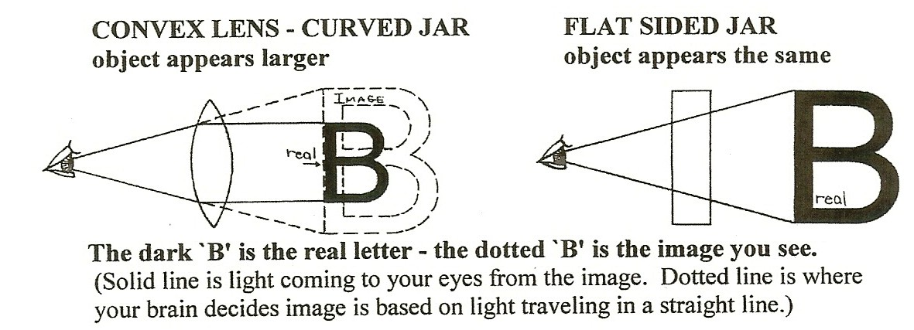

KEY WORDS:

CONVEX LENS:
Convex lenses are thicker in the middle and magnify the image.

CONCAVE LENS:
Concave lenses are thinner in the middle and make things appear smaller.

CUP MAGNIFIERS
Fill the cups with the frosted lip with water and use them as magnifiers. Put printed letters behind the cup and read through the side of the cup. (It magnifies because it acts as a convex lens.)

Place print under the cup and read through the bottom of the cup. Raise the cup 1” to 2” above the paper. (letters are tiny)
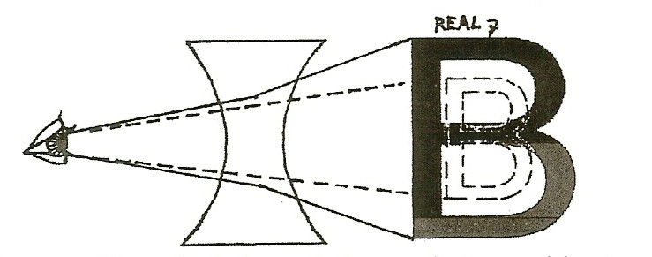
Feel the shape of the bottom of the cup. Is it concave or convex? (The bottom is a concave lens and makes objects appear smaller. )

- What happens if you look through the cup bottom without water in the cup? Nothing. To refract light, light must change its speed as it moves between 2 different transparent materials. (air and water)

BOTTOM OF CUP-CONCAVE LENS
object appears smaller (note dotted ‘B’ is what you see)

- HOW DO MAGNIFIERS WORK?
The convex shape of water in the cup spreads the image by refracting the light outward, magnifying the image. This is how a magnifier works. Your brain assumes that light travels in a straight line without bending, thus perceiving the image larger for a convex lens.

NOTE:
Do not confuse lenses with mirrors. Reflective optics like mirrors react differently as you look through the lens to the other side.

MATERIALS:
For Each Pair: For the Teacher:
- magnifiers 1 lens set

EXPLORE:

CONVEX AND CONCAVE LENSES
- Pass out magnifiers. Are they convex or concave? (Convex)

- Look at objects on your desk and across the room. Discuss. Convex lenses make close images appear larger.
Convex lenses invert images that are far away, making them appear smaller and upside-down.

- Have students draw light rays to show what happens to the light when you look across the room through a magnifier. (Use crayons to draw the path of light.) (Light rays cross, inverting image.) Have students describe (write) what happens to light passing through a magnifier. (it bends) See diagram and explanations to follow.

WHY DOES THE LENS WORK?
A convex lens makes objects appear larger if you are in front of the focal point (close to the item you are looking at). Your eyes imagine objects larger through a convex lens as your eye expects light to travel only in straight lines
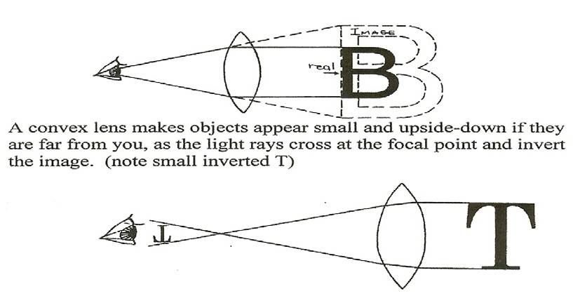
– as shown with dotted lines below.

ASSESSMENT:
The teacher holds a convex lens in front of his or her eye as he or she looks at students. (eye is larger)
Have Students: write convex or concave and explain their prediction. Hold a concave lens in front of your eye. (eye is smaller)
Describe how the eye appears with the convex lens and why.

MATERIALS:
For the Teacher:
wax paper
newspaper in 5” x 5” pieces

EXPLORE:

WHY DOES WATER MAGNIFY?
- Pass out 6” x 6” pieces of wax paper to each pair of students.
Have students: Sprinkle 5 drops of water on the paper and look at the small print on a newspaper through small drops. (No drops bigger than your thumb nail.)
Compare flatter, big drops to thicker, small drops.
Read letters as you slide the wax paper over the small print. (Small drops are thicker, thus magnify due to the curvature of the drop.)
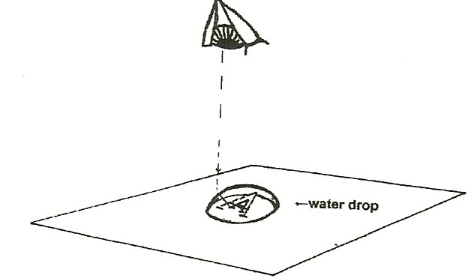
- Look at the diagram: The dark A is the real ‘A’ and the dotted A is how the letter appears through the drop. You imagine that the A is larger because your brain assumes all light travels in straight lines and does not compensate for the bend (refraction) caused by the lens. On the diagram the light coming from the bottom of the real (solid) ‘A’ bends and goes to the eye. The eye assumes that the light came straight (see dotted line in diagram) and thus from a larger ‘A’. (See convex lens diagram with the ‘B’ to review refraction.)

- Look across the drops from the side. Which drops are thicker or taller? (Small drops are thicker and magnify more due to a greater curvature. Bigger drops are flatter and don’t magnify.)
Discuss how light bends through water to magnify.
Which instruments use a convex lens? (Telescope, microscope)

MATERIALS:
For Each Pair: For the Teacher:
1 colored 35mm slide 1 flashlight
1 flashlight 1 plastic slit card
- piece blue plastic 1 piece (12” x 18”) white paper
- magnifiers 1cm x 5 cm red and blue plastic 3” x 4” piece black paper
2 student worksheets (end of section

IN ADVANCE:
Get old 35 mm colored slides or have students draw pictures on small pieces of transparency acetate or leftover scraps of ‘laminated’ plastic.

EXPLORE:

CAMERAS, TELESCOPES, AND PROJECTORS HOW DO THEY WORK?
Use the magnifiers with the 2 student worksheets to make models of cameras, telescopes, and projectors. (worksheets at end of this section.)
Students learn how each devise uses lenses.
The Space unit by Linda Poore has an inexpensive telescope in it.

SAFETY:
Do these activities only indoors. Never look at the Sun as blindness could result. Magnifiers and lenses intensify the Sun’s energy.

IN ADVANCE:
Using the plastic slit card, place a small piece of red plastic over 1 slit and blue plastic over the next slit and cover the remaining slits with 2 layers of masking tape. (Use the colored acetate from the kit.)

DEMONSTRATE:
MAGNIFIERS REVERSE THE IMAGE: (Darken room.)
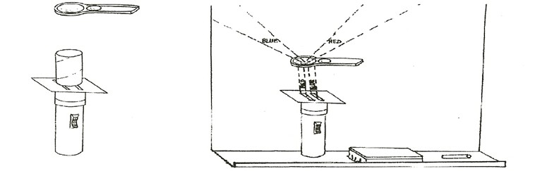
- Place a flashlight on a chalk rail vertically so it shines up the chalk board onto a piece of white paper. Lay the slit card on top of the flashlight lens, blocking the light to make 2 colored rays. ←Put a cardboard toilet paper roll between the magnifier and slit card to hold the magnifier about 4” above the slit card. Move the magnifier as needed to focus the colors on the white paper.

- Observe the rays. Rays cross at the focal point so the red and blue colors switch sides. This is why you see things upside-down when you look through the magnifier across the room and why the projector inverts the image. You have to put a slide in the projector upside-down to have it correct on the screen.

MAKE A PROJECTOR:

(Use a colored 35 mm slide or draw a picture on a 2” x 2” piece of clear plastic).
Project the image of the slide on the ceiling or a wall or hold the slide and flashlight above the desk and project the image down onto the desk if the room is not dark. The image will invert and be larger. Place a cardboard toilet paper roll between the flashlight and the slide to make the image clearer and brighter. This directs more light through the slide.
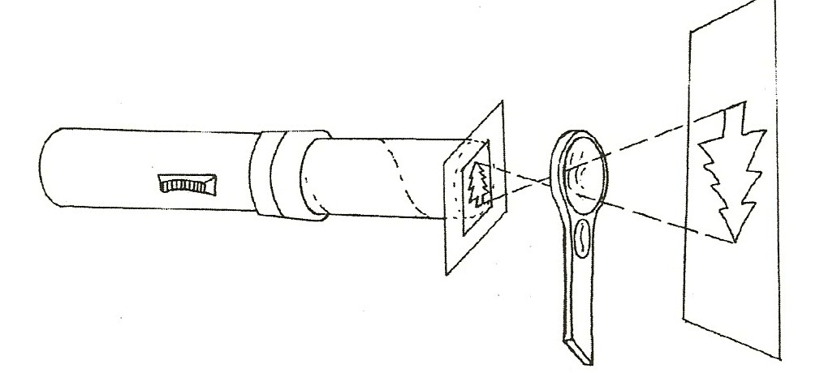

EXPLORE:

A CAMERA CATCHES AN IMAGE ON PAPER:
  - Project the image of your ceiling lights onto a white piece of paper on your desk. Hold your magnifier several inches from the white paper on your desk and focus the ceiling light on the paper by moving the magnifier until you see the image of the light fixture on the paper.

  - To see the light reverse, put a blue piece of plastic over the top half of your flashlight lens. Shine the flashlight down onto a desk through a magnifier. Focus the magnifier to get a sharp image on the paper. The position of the colored piece is reversed on the paper. (on the bottom)

  - Go outdoors and stand in the shade while you face the Sun. Hold the magnifier one inch from a white paper. Pull the magnifier away from the paper until a tree or other object in the distance is focused on the paper upside-down. A camera lens projects the image in reverse inside the camera on film like your image on the paper. When light energy strikes the film it causes a chemical reaction that captures the image upside-down.

