SPACE

Section 6-THE PLANETS
From Hands on Elementary School Science, Linda Poore 2003

STANDARDS:

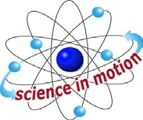
Westminster College

Students know that the Earth is one of several planets that orbit the Sun, and that the Moon orbits Earth.

Students know telescopes magnify the appearance of some distant objects in the sky, including Moon and the planets. The number of stars that can be seen through telescopes is dramatically greater than the number that can be seen by the unaided eye.

Students will use numerical data in describing and comparing objects, events and measurements.

Students will collect data in an investigation and analyze those data to develop a logical conclusion.

KEY WORDS:
ORBIT: The path an object follows when it revolves around another object. PLANET: An object in space that reflects light from a nearby star around which it revolves due to gravity.
SATTELITE: An object that revolves around a larger body. Moons are satellites.
SOLAR SYSTEM: A system of objects in orbit around our Sun.

PRETEST:
How many planets are there? Use the pretest at the end of this section. (Answers: 1. Mercury, 2.Venus, 3. Earth, 4. Mars, Asteroid, 5. Jupiter, 6. Saturn,
7. Uranus, 8. Neptune, 9. Pluto, 10. Forced by Sun’s gravity

MATERIALS:
Planet poster

DISCUSS:

WHAT IS THE ORDER OF PLANETS IN OUR SOLAR SYSTEM?
Show the students the planet poster in the kit. Name the planets. Use the following sentence to help remember the order of our planets:
My Very Educated Mother Just Served Us Nine Pizzas. [S, planets-orbit sun]

MUSIC:

THE ORDER OF THE PLANETS FROM THE SUN
Learn the order of the planets by singing the following song to the tune of “If You’re Happy and You Know It Clap Your Hands.”
Mercury, Venus, Earth and Mars (clap, clap) Mercury, Venus, Earth and Mars (clap, clap) Jupiter, Saturn, Uranus, and Neptune
Pluto is the furthest one away (clap, clap)
(Pronounce Uranus: Yor-a-nus, accent on the first syllable)

MATERIALS:
For Each Team of 4: For The Teacher
4 meters of adding tape 2 playground balls, same size
1 measuring tape 1 planet poster colored paper
data chart: Making a Model (end of section)

EXPLORE:

MARKING A MODEL SHOWING SCALE AND STRUCTURE
Using the chart at the end of this section, make a display of the planets showing their relative sizes and distances. Each piece of adding tape needs to be 4 meters long. [S, data-compare]

MEASURING DISTANCES
Teach the students how to use the measuring tape in centimeters. Make sure students start at ‘0’ when measuring an object and pull the tape tight across the object.
Practice using the measuring tapes by measuring the length and width of the student’s desk, a reading book, and a piece of paper. Record the measurements. Check students’ answers for accuracy.

MAKING A MODEL OF THE SOLAR SYSTEM SHOWING THE RELATIVE DISTANCE BETWEEN THE PLANETS
Pass out the materials and the work sheet, Making a Model.
Put up the Planet Poster from the kit and name the different planets. First draw a Sun at one end of the adding tape.
Show students the section of the data chart they will use.
Chart shows the number of millimeters from the Sun to each planet. Measure the distance to each planet beginning after the Sun drawing.
Mark a line across the paper where each planet is located relative to the Sun and the other planets.
Draw a small picture of the planet on the line and put its name below the line. (e.g. Measure 36 mm or 3.6 cm from the Sun and draw a line. Draw a dot for Mercury on this line.)
Mercury is very small compared to the other planets. [S, data-measure]

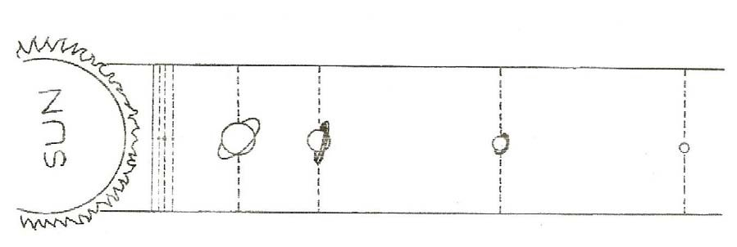

NOTE:
Students’ planet distance can be used as a border for a bulletin board.

DISCUSS:

DO OBJECTS FAR AWAY APPEAR SMALLER?
- Place a playground ball at the far end of the playground. Have the students look at its size compared to a matching ball 3 feet from the class.
- Why does the moon sometimes look as large as the Sun? (Moon is closer.)

SCALE AND STRUCTURE
Why do stars look so tiny, even though over half of them are larger than our closest star, the Sun? (Very far away) The Sun is very larger compared to the Earth, but looks small in our sky because it is far away. It looks much larger than any other star because it is much closer than other stars.

[S, planets-orbit]

ASSESSMENT:
List the planets in order from the Sun. State one special characteristic of each planet. Photocopy the pre/post test at the end of this section.

READING A CHART: [S, numerical data compare] Give each student a copy of the chart on the planets. (end of this section) Xerox these questions or write them on the board.

- The largest planet is .
- Pluto is miles from the Sun.
- The planet with 11 rings is .
- The smallest planet is .
- The hottest planet is .
- The lightest planet .
- The planet 143,000,000 miles from the Sun is .
- List all the planets that are smaller than Earth
.

DISCUSS: [S, planets]

LOOK FOR PLANETS AND CONSTELLATIONS IN THE SKY
- Xerox the work sheet: How to find planets in the sky (end of section)
- On the board, draw a diagram showing the position of the planets and constellations and describe which direction to face to view them. Have the students copy the diagram and the work sheet, indicating the direction to face (N, E, S, or W). Students write where and when the planet can be seen. (e.g., Mars, southern sky, 8-10pm)
- Take the students to the playground and have them face the direction they should face at night to see the planet(s).
Have them point to the height in the sky where you viewed the planet or constellations. A dark parking lot or the school playground is a good place to view the night sky.
- Ask students to predict: Will the planets stay in the same place all night? (No as the Earth rotates, the stars overhead appear to move in a circle.)

ART:

Make planet flags, using symbols to depict facts about a planet. (e.g., Saturn flag with lots of rings and moons)
Do research on the Internet or in reference materials to discover facts about your planet.

LANGUAGE:
Write a poem, song or rap about your favorite planet, describing its main characteristics. Read or sing it to your class and let them guess your planet.

MATERIALS:
1” diameter rubber playground ball tape
flashlight with batteries
miscellaneous objects with different textures, colors, shapes, etc box ball fits in

EXPLORE 1:

EXPLORING A MYSTERY PLANET COLLECTING AND ANALYZING DATA
- Tape various cloths, colors, shapes and textures to an old playground ball. (e.g., sandpaper, floral cloth, egg carton mountains, cotton, etc.) Each cooperative group can supply one or more mystery items to be added to the planet.

- SATELLITES SEND US INFORMATION ON THE PLANETS Scientists learn about planets from information sent from satellites. The information comes in small pieces as the satellite passes over a small area of the planet or a planet’s moon during each fly-by. Give each cooperative group of 4 students on ‘fly-by’ of the ‘ball planet’ with a flashlight in a dark room and have them write what they observe, as if they are receiving the pictures taken from the satellite and sent to Earth.

COLLECTING DATA
The teacher places the ‘ball planet’ in a Xerox box and positions different sides of the ball toward the open side of the box for each ‘fly-by.’ Students must be 12” from the planet. The teacher turns on the flashlight, opens the box, sweeps the light across the opening, and closes the box. Students can report only what was seen lighted by the flashlight.

ANALYZING DATA
Each group could be given a mission (e.g., fly over the North Pole, fly past the dark side away from the Sun, fly over the South Pole, etc. Together the class shares data orally and draws what they think the planet looks like. Turn on the lights between each ‘fly-by’ so students can report what they saw and draw or write notes.

- After the activity is finished, compare the ‘ball planet’ to the student drawings to see how well they interpreted the information. Have the students decide how many ‘fly-bys’ are needed to receive clear information about the planet.

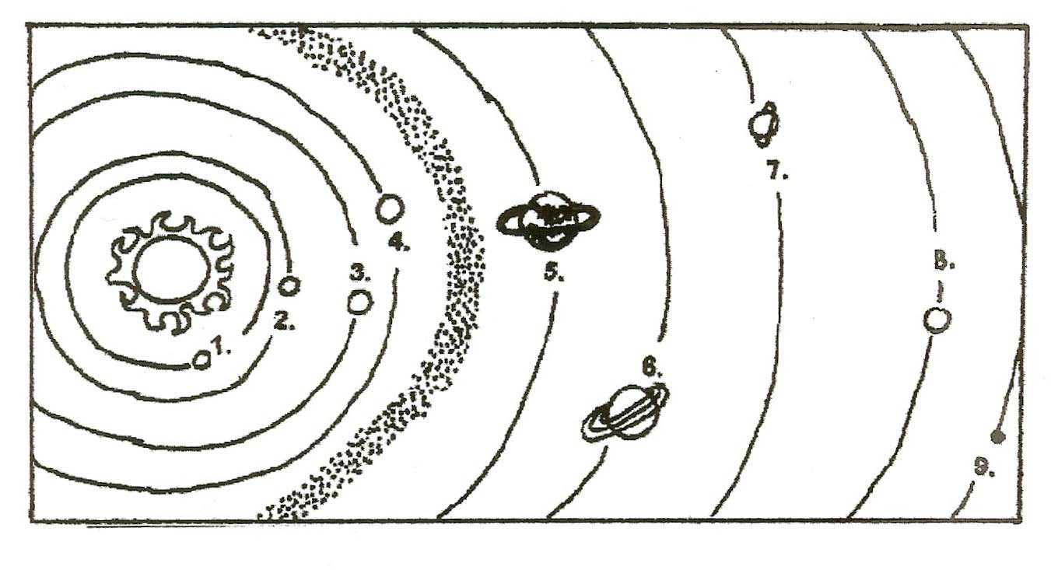
PRETEST OR POSTTEST
(CIRCLE ONE)

Can you name the planets in order from the Sun? Write the names below.
1.
2.
3.
4.
Look between orbits 4 and 5. These are rock in orbit. What are they called?
5.
6.
7.
8.
9.
10. Why do the planets orbit the Sun?

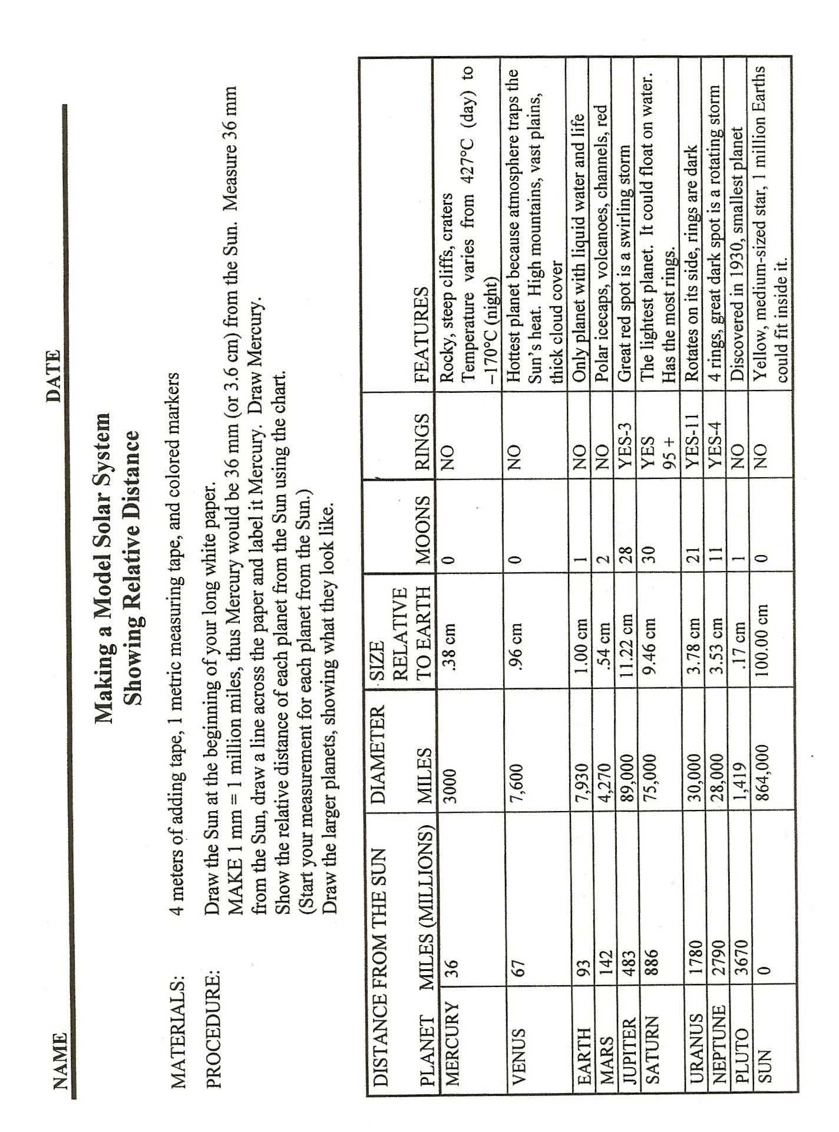

HOW TO FIND PLANETS IN THE SKY

Planet Direction to look Time

My sky map: Write the name of the planet or star and where it can be found in the sky tonight. Write the time to look for it. Is it low, medium or high in the sky?
Go outside at night with an adult. Use this map to find planets or constellations.
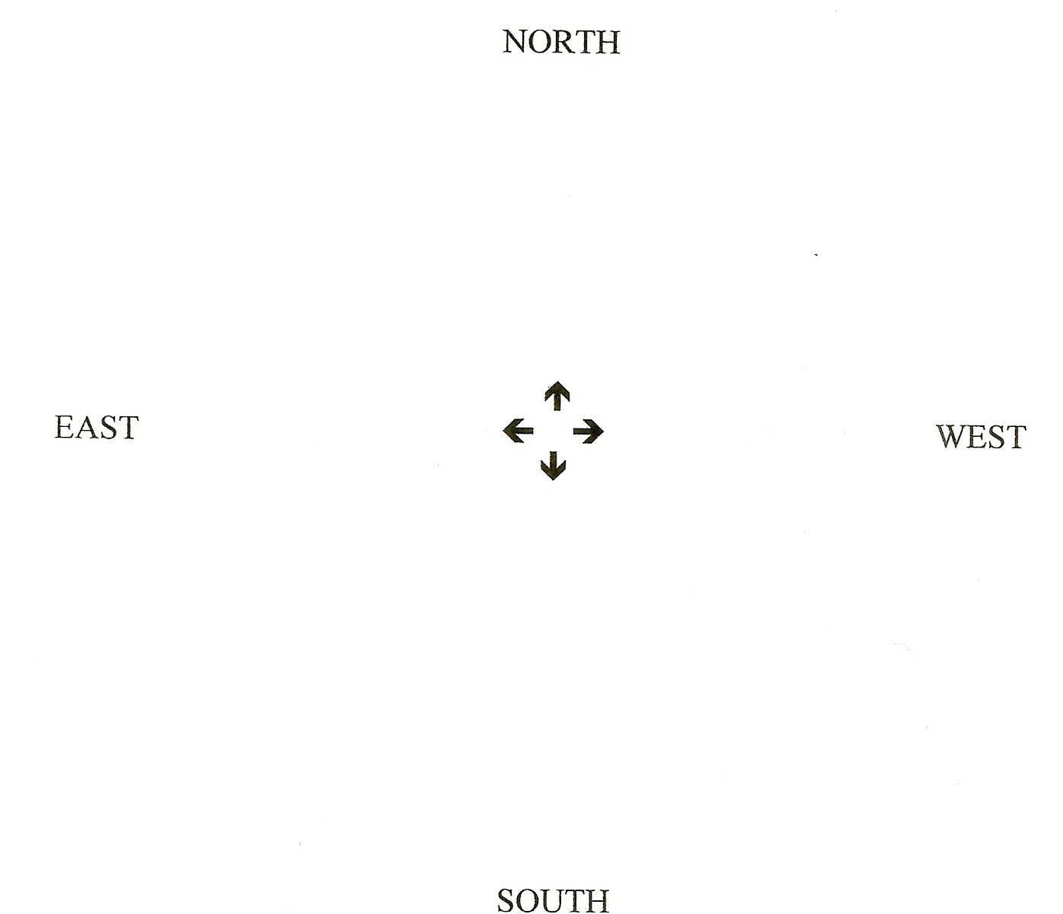

RECEIVING A PHOTO FROM A SATELLITLE IN SPACE

Photos from space are sent as numbers that are decoded by computers. A picture is a series of dots and each dot’s brightness, position and color are recorded as a number.

For instance, in a black and white picture there are 256 shades of gray, each shown as a different number. One computer byte has 256 states. Each dot is represented by a number between 0 and 255 (or 256 choices) to indicate its color.

Here are the data sent from the satellite of something photographed in space. Color in each area indicated to decode the photo. Then make your own message or picture on the rest of the graph. Make a numerical code. Let someone receive your message.
