SOUND VIBRATIONS
ACTIVITY 6: BLOW YOUR OWN HORN
From Science in a Nutshell
Westminster College
OBJECTIVE:
To discover how the length of a column of vibrating air is related to the pitch of the sound it produces.

MATERIALS
journal page for Activity 6
ruler scissors drinking straws
masking tape

BACKGROUND:
In previous activities, you discovered how solid materials (rubber bands and metal strips) vibrate and produce different sounds. In this activity, you will experiment with a vibrating gas—a column of air.

You will change the length of the column of vibrating air and discover how a change in length changes the pitch of the sound it produces.

EXPERIMENT:
- To make a horn out of a drinking straw, partly flatten 1-2 cm (about 0.5in) of one end of a drinking straw. Use scissors to flatten end so that it is pointed at the end.
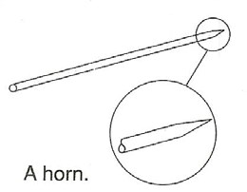

- Put the flattened end of the drinking straw in your mouth and blow.
- If at first you are not able to get a sound, try the following: put the flattened (pointed) end deeper into your mouth, or place the straw at an angle in your mouth, or flatten the ends so that they are closer together, or just blow harder.
- Which part of the straw is vibrating? What is vibrating inside the straw? Record your answers on the Journal page for Activity 6.

Westminster College SIM Page 1 BLOW YOUR OWN HORN

After you are able to get a sound from your horn, cut about 2 cm off the straight end of the straw. Blow into the straw again. Do you hear a different sound? How is it different?
- After you are able to get a sound from your horn, cut about 2 cm off the straight end of the straw. Blow into the straw again. Do you hear a different sound? How is it different?
- Keep cutting small pieces off the straight end of the straw and blowing into it after each cut. How does changing the length of the straw change the column of air and the pitch of sound? Record your ideas in your journal.
- The flute and the piccolo are both musical instruments that use vibrating columns of air. Which instrument do you think produces the higher-pitched notes? Record your answers in your journal.

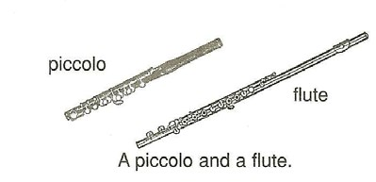
- Now, construct a simple musical instrument called the “pipes of Pan.” Begin by using 2 drinking straws. Measure and cut the first straw 13 cm (about 5 in.) from one end. The remaining piece will be 7 cm (about 3 in.) long.
- Measure and cut the straw second so that one piece is 10 cm (about 4 in.) long and another piece is 5 cm (about 2in.) long. Throw away the unused part of the second straw. Make sure that you have four pieces that measure 13 cm, 10 cm, 7 cm, and 5 cm.
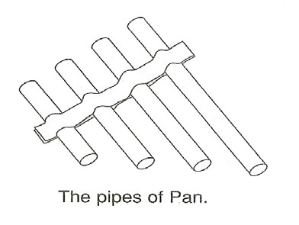
- Lay a strip of tape on a table, sticky side facing up. Place the four straws in order of length on the tape, with about 1 cm (about 0.5 in.) between each pair of straws. The straws should form a straight line at one end and a slope at the other end.
- Place a second piece of tape on top of the straws to secure them in place.
- Blow across (not into) the straight end of the pipes, one straw at a time. Vary how hard you blow until you get a whistle sound. Record what happens to the sound as you go from the longest to the shortest straw.

Westminster College SIM Page 2 BLOW YOUR OWN HORN

SAFETY NUT:
Everyone should have his or her own horn. Share observations, not germs.

IN A NUTSHELL:
• The length of a vibrating column of air influences the pitch of the sound produced. • Shorter columns of vibrating air produce higher-pitched sounds.

.
CRACKING THE NUT:
A tuba produces the lowest notes of all the brass instruments in an orchestra. It has between 19 and 23 feet of tubing. Why is all this tubing necessary?

Westminster College SIM Page 3

