DETECTIVE LAB

SECTION 7: IDENTIFYING MYSTERY INKS
From Science in a Nutshell

OBJECTIVE:
To separate and examine the different dyes in black inks.

MATERIALS:
paper cup
filter paper strips
Journal Page for Activity 7 round labels
black water soluble markers pencil
scissors transparent tape tape measure water

Westminster College

BACKGROUND:
Examining handwriting is not the only way to identify who wrote a particular message. You can also identify the ink that was used. Did you know that ordinary black ink, which appears to be only black, is actually made up of several different colors? The amount of each color in black ink allows you to identify the pen used to write a note.

You can use a process called chromatography to separate the different dyes that make up black ink. The word chromatography comes from the Latin words chromo and graphy, which means color and write.

The colors in black ink can be separated by putting the ink on a piece of filter paper and letting water travel up the paper. As the water carries the ink up the filter paper, the different dyes that make up the ink will stop traveling at different places, forming a pattern of colors. This paper with the pattern of colors is called a chromatogram.

If the police think they know who wrote a note, they can test the ink from the person’s pen and compare it with the ink on the note found at the crime scene. The results of the tests determine whether the two inks match.

In this activity, you will use chromatography to separate the different dyes used to make the black ink in three markers. Then you will compare chromatograms and identify the mystery marker.

IDENTIFYING MYSTERY INKS

EXPERIMENT:
- Use the markers in the kit to write A, B, and C on three labels. Put one label on the shaft of each of the black markers provided in the kits. Do not put the labels on the caps.

- Use one of the markers to make a line across one of the filter paper strips 2-3 cm above one short end. At the top of the paper strip, use a pencil to write the letter on the label of the marker used to make the line.
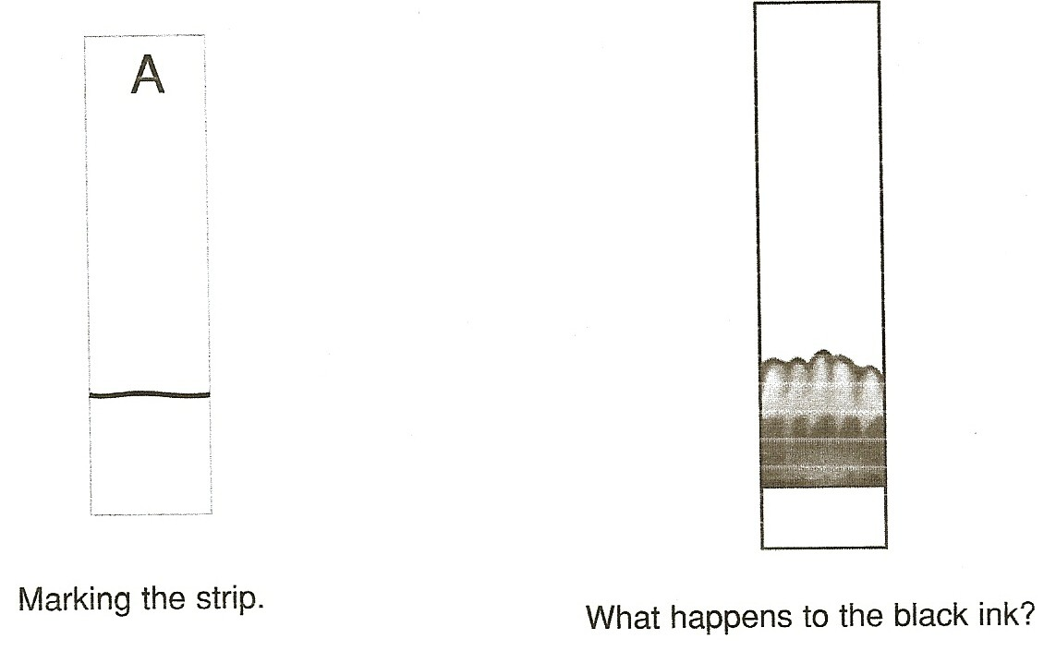

- Put about 2 cm of water into the paper cup. Hold the top end of the paper strip so that about 1 cm of the bottom end is in the water. Do not let the water touch the ink line.
- Observe closely as the filter paper slowly absorbs water. What happens as the paper gets wet near the line? Record your observations on the Journal page for Activity 7.
- Hold the paper in the water until the traveling water line is at least 3 cm above the original ink line. Take the paper out and tape it to the edge of a table so that it hangs down and can dry.
- Repeat steps 2-5 to make two more chromatograms using the other two markers in the kit.
- After the three chromatograms are dry, tape them under the correct label in your journal.
- Observe the colorful patterns made by the dyes in each of the black markers. Are all the patterns the same? Examine the differences you find in the chromatograms.

IDENTIFYING MYSTERY INKS

- Use a pencil to label the fourth strip X. Give your partner the three markers and the paper strip you have labeled X.
- Have your partner secretly choose one of the markers and draw a line across strip
X. Ask you partner not to tell you which marker was used.
- Repeat steps 3 and 5 to make a chromatogram on the mystery strip. When it is dry, tape strip X under the mystery marker label on your journal page. Compare this chromatogram with the others.
- Does the pattern on strip X match one of the other chromatograms? Can you identify which marker was used on strip X? Record your choice in the journal. Ask your partner if you were correct.

IN A NUTSHELL:
As water travels up the filter paper, it takes some of the dyes in the ink with it. The dyes in the ink stop traveling up the paper at different places, forming a pattern called a chromatogram.

CRACKING THE NUT:
Experiment with other water-soluble (also called washable) pens and markers of different colors. Compare these chromatograms. Record in your journal which color inks seem to form the most interesting patterns.

