MACHINES AND MOTION

SECTION 7: PULLEYS

STANDARDS:

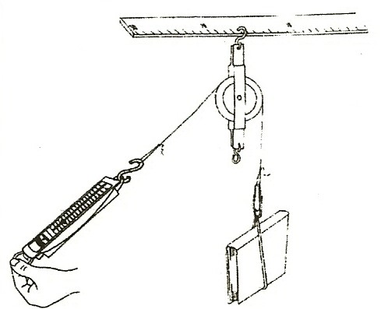
Students know tools and machines are used to apply pushes and pulls forces) to make things move.

Students will make predictions based on observed patterns and not random guessing.

Students will write or draw descriptions of a sequence of steps, events, and observations.

Students will measure length, weight, temperature, and liquid volume with appropriate tools and express those measurements in standard metric system units.

Students will follow oral instructions for a scientific investigation.

Westminster College

TEACHING TIPS:
Set spring scales on ‘0’ by moving the metal piece at the top up or down. The pulley experiments are set up by the teacher as demonstrations as it is difficult for second graders to set up the materials. Hanging the pulley from a large chart rack makes it convenient for each child to lift an object and feel the amount of force it takes to lift it with a pulley system. Alternate method: hang the pulley system from a ruler and have one student hold the ruler (see the pictures). Do the fixed pulley system first.

NOTE:
For Accuracy: Lift the object then do not move the scale when reading the amount of force. Pulleys do not make the object lighter, instead they reduce the force only if the work is done over a longer distance. (e.g., the object lifts 30 cm but you pull 60 cm on the rope.)

Fixed pulleys allow you to change direction but do not reduce the force. This does not make the force less since the object moves the same distance that you pull. (work = force times distance) However, it is easier to pull down (gravity helps you) than to lift up. (e.g., lifting hay to the second story of a barn.) Thus the work feels easier with gravity helping.

MATERIALS:
6 rulers chart rack
6 pulleys 10 spring scales
3 paper clips
6 strings with loops at each end – each 48” long
10 books with rubber bands around them for lifting (or 10 blocks of wood)

IN ADVANCE:
To make the fixed pulley system, hang the pulley first from the chart rack or on a ruler and then lay the string over the top of the pulley. Hang the book (or black) and scale from the string ends. (see picture)

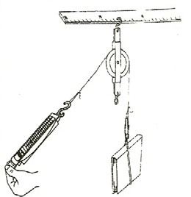
EXPLORE:

THE FIXED PULLEY
- Be sure the spring scales are on 0.
Pass out scales and books and let each student lift the book and report how much it weighs.
If all students have the same book, the weights should be similar. Use a transparency showing the scales so each student can see the answer.
Each student could make a dot on the transparency scale to record the weight of their book.
Have students write the book’s weight on their worksheet.

EXPERIMENT
Hang the same book on the fixed pulley system.
Let each student pull down on the scale to lift the book with the fixed pulley. Does lifting the book with the pulley feel easier, harder, or the same? (easier) Make sure that the string is in the pulley groove.

HOW MUCH FORCE IS NEEDED?
How much force does the scale say you are using to lift the book with the fixed pulley? (Often the force is greater than without a pulley due to friction.)
Have students answer the questions on the worksheet for the fixed pulley.

FIXED PULLEYS CHANGE THE DIRECTION OF WORK
You pull down and the weight goes up. If you pull 10 cm the book lifts 10 cm, so you do not do work over a greater distance. Why does it feel easier? (gravity is pulling down with you) More force is often needed to lift with this pulley due to the friction of the pulley wheel.

NOTE:
MOVEABLE PULLEYS let you do the same amount of work over a greater distance, thus reducing the amount of force needed.

The greater the distance the rope is pulled, the less force necessary to lift the weight. With one moveable pulley you can lift a 1 lb. weight 5’ using only 1;/2 lb. of force, if you pull your rope 10’.
(WORK = FORCE X DISTANCE, thus 1 lb. X 5’ = ½ lb. X 10’ or 5 lb/feet of work)

EXPLORE 2:

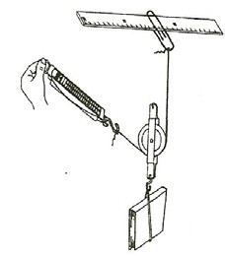
ONE MOVEABLE PULLEY
1.
Use the picture as your guide to set up this pulley by attaching one end of the string to the chart-rack or ruler using the rack ring or a large paper clip.
Put the string through the bottom of the pulley and attach the scale to the other end.
Hang the book on the lower hook of the pulley.
This pulley does not change direction, but the force needed is less. You pull twice the distance that the book lifts.

2. Have students: Tell you how much the book weighs.
Predict how this pulley might help lift the book. (less force needed)
Take turns lifting the book by pulling the pulley up. The book also goes up. Record the amount of force on their worksheet.

EXPLORE 3:
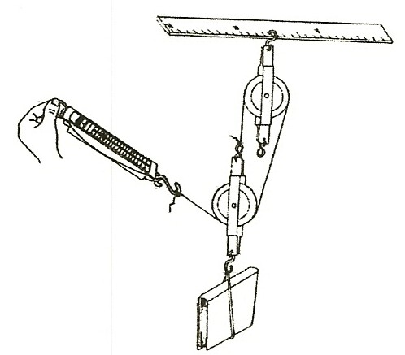
TWO MOVEABLE PULLEYS
- Use the picture as your guide to set up this pulley by hooking the top pulley to the chart-rack or ruler. Attach the string to the top hook of the lower pulley, pull the string over the top of the ‘top’ pulley and then through the bottom of the lower pulley. Attach the scale to this string. Hang a book or weight from the lower hook. Hang (or tie) the scale’s metal loop to the chart rack until ready to use.

- Let each student lift the book using the 2 moveable pulley system. Read the scale and record the amount of
force in grams. It takes very little force but you pull much farther than the book lifts.

MEASURING THE DISTANCE
If the book lifts 10 cm, then you pull 30 cm but with about one-third of the force. If you hang a page of lined chart paper behind the pulley system, you can move your hand 6 lines and see how many lines the book lifted. Did your hand or book move the most? (hand) (Mark the lines where the book and your hand are at the beginning and after you lift the book.)
Did the book move the same or a different direction than your hand?

Which pulley system made lifting the easiest? (2 moveable pulleys) Which pulley system did you pull the longest distance? (2 pulleys) Answer the questions on the student work sheet.

WHY DO PULLEYS MAKE THE WORK SEEM EASIER?
Moveable pulleys spread the work over a greater distance.
With 1 moveable pulley, you pull the string twice as far as the book lifts. With 2 moveable pulleys, you pull three times as far as the book lifts. Fixed pulleys help by changing the direction you lift.

- Find pulleys at home and at school: drapes, flagpole, sailboat, etc.

