WEATHER

SECTION 7: RAIN, THUNDER AND LIGHTNING
From Hands on Science by Linda Poore, 2003.

STANDARDS:

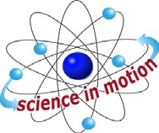
Westminster College

Students know solids, liquids and gases have different properties.

Students know how to use simple tools (e.g., thermometer, wind vane) to measure weather conditions and record changes from day to day and across the seasons.

Students know the properties of substances can change when the substances are mixed, cooled, or heated.

Students will make new observations when discrepancies exist between two descriptions of the same object or phenomenon.

IN ADVANCE:
20 ice cubes(ice cubes made with colored water will prove that the ‘rain’ water did not drip through the plastic bag but came from inside the jar. Heat water in the hot pot.

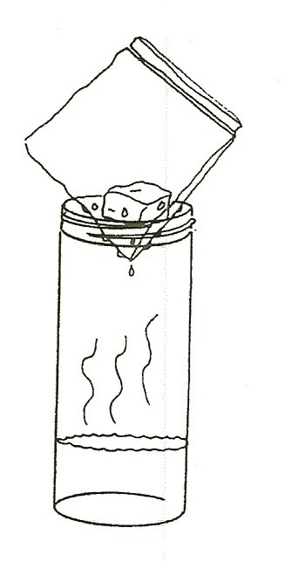
MATERIALS:
For each Pair For the Teacher
1 slim jar with warm water ice in the ice chest 1 sheet wax paper 1 hot pot
1 zip lock sandwich bag 1 spoon
- straw blue food coloring for ice

EXPLORE:

OBSERVING THE WATER CYCLE WHERE DOES RAIN COME FROM?
- Ask students where rain comes from.
When water evaporates from puddles, lakes, and oceans, it rises until it becomes too cool to remain a gas.
It condenses forming clouds.
When a cloud has too much water, the drops hit each other, making larger drops that becomes heavy enough to fall as rain.

- Pass out a jar with 1” very warm water to each of the students. Hang a sandwich bag in the jar with the ice cube hanging down. Fold the bag over the jar to cover (and seal) the jar opening. Observe.

FOG
Discuss. What happens after 1 minute?
(Water condenses on the upper part of the jar, forming a cloud.)

- After several minutes big drops of water condense on the lowest part of the bag (inside the jar) and eventually fall as rain in the jar. Let the students observe their experiment for 10 to 20 minutes. If the drops don’t fall, let the students lift the bag out and shake it. (Or place it on their hand so their hand becomes wet.)

THE ICE CUBE MELTS
What is happening to the ice cube? Why? (It melts because of heat from the water)
How can you make it ice again? (put in freezer or below 32°F)

- RAIN DROPS: Pass out wax paper to each pair. Have students use the straw to get water from the jar.
(Place the straw in the jar, put a finger firmly over the top of the straw, and remove the straw.)
Release the finger when the straw is held over the wax paper. Hit this ‘puddle’ with a pencil to separate it into drops. Are the drops the same size? (no)
Have the students pull drops together by dragging the straw form one drop to the next.
How many different sized drops can the students make?
Rain does not fall until the drops in the cloud are large and heavy. Wind in the clouds pushes the drops together, making larger drops.

ASSESSMENT:

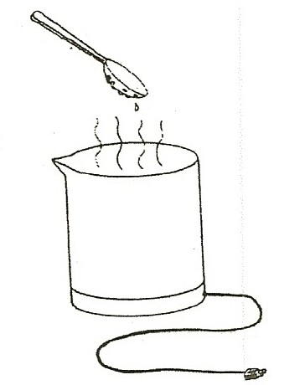
MAKING RAIN DEMONSTRATION: HEAT CHANGES WATER TO A GAS
Boil water in the hot pot. Ask the students how we can change the steam to a cloud. (Make it cold.)
Place a cold spoon above the steam. Watch the water condense.
Have the students say ‘condensation’ when they see the water form on the spoon.
Tilt the spoon and the drops will combine, become heavy, and fall like rain does from a cloud. Have the students describe condensation in pictures or words. (A pie tin with ice can be used instead of a spoon.)

NOTE:
Clouds form as water vapor condenses in the sky because cold air cannot hold as much water vapor (gas) as warm air.

MATERIALS:
For Each Pair
- pieces black paper chalk

EXPLORE:

HOW BIG ARE RAINDROPS?
ARE ALL RAINDROPS THE SAME SIZE?
Put a piece of black paper in the rain for 10 seconds or until you collect about 20 raindrops. Draw around each raindrop. Are they the same size? (no)
How many big, medium, and small drops did you collect?

ART
Use chalk to draw a snowy picture on the black paper. Pretend it is snowing at night. Discuss what happens to cause snow instead of rain. (Temperature must be freezing.) Does it snow where you live?

ASSESSMENT:

DRAW THE WATER CYCLE
Have the students draw a lake with clouds above it. Show water vapor going up to the clouds and write the big E word evaporation. Write the word condensation on the cloud. Show rain coming down. Introduce the word precipitation. (rain)

MATERIALS:
Funnel
wide mouth quart jar

EXPLORE:

HOW MUCH DID IT RAIN?
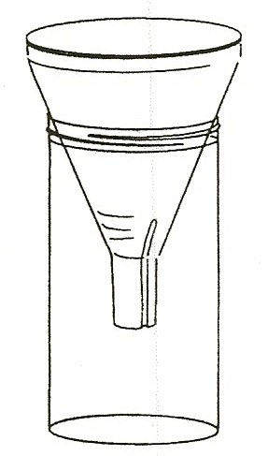
MEASURING RAIN WITH A RAIN GAUGE
- Put the funnel in the wide mouth jar and place it in an open area on a flat surface when it is going to rain. Leave the rain gauge out during the rainstorm. Put 1 cup of water in the jar to ‘weight it’ so the jar does not blow over. (place it away from any building)

- Check immediately after a rain. Pour out the extra cup of water used to weight the jar. Then place a ruler vertically up the side of the jar. Rain is measured in inches in the United State. Record the amount of rain collected.

- Check the weather report on the TV news or in the paper to see how accurate your measurement was. (Rain amount varies with location.)

MATERIALS:
For Each Pair For the Teacher
1 jar or cup of water 1 quart glass jar of water light(overhead projector or flashlight) 1 diffraction grating

EXPLORE:

MAKING A RAINBOW
In late afternoon stand with your back to the Sun and water the law or flowers, placing your thumb over the hose to make the water spray.
Point the water up so it falls in a curve.
The light gets bent inside each water drop and the colors split apart so you can see them.
White light is made up of a rainbow of many colors mixed together.
Draw a picture of you, the hose, and your rainbow, showing how you made the rainbow. Show where the Sun is in your picture. (You can get a hose from at the custodian to do this at school.)

NOTE:
If possible, teach the following lesson during a storm. The students can discover how far away the lightning and thunder is.

MATERIALS:
1 brown lunch bag bubble packing can of soda
cymbals or other loud instrument you can hit. (pans or pan lids)

DEMONSTRATE:

WHAT IS THUNDER? MAKING THUNDER INA BAG
- Thunder is produced because lightning heats up the air. The air expands rapidly, taking up more space.
This rapid expansion of air occurs when you open a soda can.
It causes the ‘pop.’ The air is held in the can under pressure. The faster the air expands, the louder the noise. Listen as you open a soda. What makes the noise? (air)

- Fill the paper bag with air and pop it. What causes the noise? You compressed the air until it pushed back hard enough to break the bag. The air rushing out made the bag vibrate making a noise. Have students wave a piece of paper back and forth rapidly. Air passing the paper makes the noise!
Pop the air pockets in bubble packing for the same affect. [Students may have Nerf™ toys(e.g., Nerf™ gun) that use air compression to make a bang.

LIGHTNING AND THUNDER OCCUR AT THE SAME TIME
Light travels much faster than sound. (Light travels 186,000 miles per second. Sound travels 1 mile in about 5 seconds.)
The lightning and thunder happen at the same time.
You see the lightning instantly and although the thunder occurs at the same time, it takes a longer time for the sound to get to you.

COMPARE LIGHT SPEED TO THE SPEED OF SOUND
Send 1 student across the playground with cymbals, pans, or something to hit to make a loud noise. Instruct the student to hold his arms far apart and then hit the objects together hard. Have all the students watch this student and raise their hand when they see the objects hit.
Did they hear it at the same time? (No, they hear it later.)
Repeat the experiment to be sure all students observe that the light brings the image first, and the sound arrives later.
The further away the student making noise is from the class, the easier it is to notice this difference.
Relate this concept to singing the national anthem at a ball game.
People far away seem to be on a different note because it took time for their sound to reach you.

HOW FAR AWAY IS THE STORM?
When you see the lightning, count the seconds until you hear the thunder. Divide the number of seconds you counted by 5 to get the miles between you and the storm. (If you count 10 seconds, then the storm is 2 miles away.) Save this activity for a stormy day. Can be done with parents for homework.

