SECTION 7: ROLLING ON

LAB

INTRODUCTION

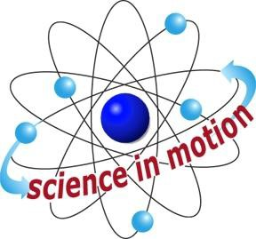
Westminster College

This activity focuses on the friction force that opposes forward motion. Friction occurs between a moving object and the surface on, or the medium through, which it moves.
Students discover tow ways to reduce friction: performing the experiment on a smooth surface, and attaching wheels to the moving object. A rough surface produces more friction between the moving object and the surface. The friction force is also much less for a rolling objects that for a sliding object. A rolling object is continually changing its contact point with the surface as it turns, so it does not actually rub on the surface. For a car wheel, the friction between the axle of the wheel and the axle support may be greater than the fiction with the ground.

ASSESSMENT ANCHORS ADDRESSED
S4.A.2.1 Apply skills necessary to conduct an experiment or design a solution to solve a problem.

S4.C.1.1 Describe observable physical properties of matter.

S4.C.2.1 Recognize basic energy types and sources, or describe how energy can be changed from one form to another.

S4.C.3.1 Identify and describe different types of force and motion, or the effect of the interaction between force and motion.

PURPOSE
In this activity, students apply Newton’s first law of motion to the behavior of a toy car.

MATERIALS

For Each Pair of Students For the Class
Car Activity Sheet 7
Connector Masking tape
Stopwatch VCR
Measuring tape Videotape­ Toys in Space Towel (for friction) *
2 tracks
Teacher provides items marked with *

Westminster College SIM Page 1

