SPACE

Section 7-SOLAR ENERGY
AND THE GREEHOUSE EFECT
From Hands on Elementary School Science, Linda Poore 2003

STANDARDS:

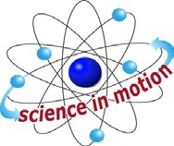
Westminster College

Students know energy comes from the Sun to Earth in the form of light.

Students will use numerical data in describing and comparing objects, events and measurements.

Students will collect data in an investigation and analyze those data to develop a logical conclusion.

Students will predict the outcome of a simple investigation and compare the result with the prediction.

Students will repeat observations to improve accuracy and know that the results of similar scientific investigations seldom turn out exactly the same because of differences in the things being investigated, methods being used, or uncertainty in the observation.

NOTE:

GREENHOUSE EFFECT:
Our atmosphere holds in heat, protecting us from becoming too hot or too cold and allowing life on Earth. Without this greenhouse effect, the Earth would be a frozen wasteland at -15°C.

MAN’S IMPACT ON THE GREEHOUSE EFFECT AND GLOBAL WARMING:
When the Sun strikes the Earth’s surface the light energy is changed to heat (infrared energy). Carbon dioxide, water vapor, chlorofluorocarbons, and methane in our atmosphere absorb this heat energy, trapping it and heating the Earth. Man has increased the carbon dioxide level in our atmosphere 25% since 1860 by burning fossil fuels, coal, natural gas, oil and burning the rainforests (this burning accounts for 25% of the world’s CO2 emissions). This has resulted in an increase in the Earth’s average annual temperature.

EFFECTS OF GLOBAL WARMING:
Ocean temperatures will become warmer, melting glaciers and causing flooding of coastal towns. Heat and drought may cause forests to die, food crops to fail and farmland to become arid deserts.

MATERIALS:
For each team of 4 students: 1 zip-lock bag (gallon size) 2 thermometers
- black paper, 9” x 12” scotch tape
worksheet ‘Testing the Greenhouse Effect’

PRETEST:

WHAT IS THE GREEHOUSE EFFECT?
What is causing the average annual temperature of the Earth to rise?

EXPLORE:

HOW DOES OUR ATMOSPHERE TRAP HEAT
Have students discuss their ideas about the Greenhouse Effect and global warming. Do they know what it is? (information above)

[S, Sun-light energy]
  - SETTING UP THE EXPERIMENT
Show students the materials. Give each student the work sheet.
Each team will compare the amount of heat collected by 2 thermometers, one sealed in a bag containing greenhouse gases and a control thermometer with no bag. Students will put a thermometer in a 1 gallon plastic bag and fill it with carbon dioxide gas. (Seal the bag except for 1” first, then blow to fill the bag and seal.)

  - PREDICT [S, predict-result] Which thermometer will get hotter? (thermometer in bag) Record the beginning temperature of each experiment.
Place both experiments together on a piece of black paper in sunlight.

COLLECT DATA [S, data-compare]
Students will: Compare the experiments and write a conclusion. How did the bag of carbon dioxide gas affect the temperature?
(Light energy was converted to heat energy and trapped in the bag.)
The black paper underneath acts like dark soil; absorbing light energy and converting it to infrared heat energy.

ANALYZE DATA: [S, data-numerical] [S, data-analyze]
Compare the experiment and write a conclusion.
How did the bag of carbon dioxide gas affect the temperature? (Light energy was converted to heat energy and trapped in the bag.)
The black paper underneath acts like dark soil: absorbing light energy and converting it to infrared heat energy.

MATERIALS:
Lamp with bulb 6 thermometers
measuring tape 3 books

DEMONSTRATE:

WHY IS EARTH THE ONLY PLANET WITH LIFE IN OUR SOLAR SYSTEM?

- PREDICT:
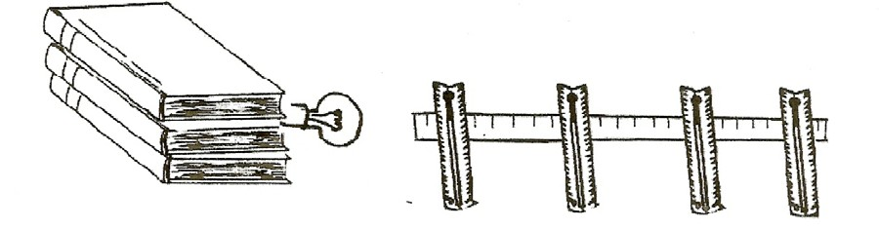
Set up the experiment: Put the lamp at ‘0’ on the tape. Place the bulb of each thermometer on the measuring tape at 30 mm, 60 mm, 100 mm, 200 mm, and 300 mm. Place a sixth thermometer on another desk to compare the results to room temperature. Have the students predict which thermometer will be 27°C (80°F). This temperature represents a ‘livable’ temperature.

EXPERIMENT: [S, predict]
Record the temperature every 10 minutes for 30 minutes. If none of the thermometers is at 27°C (80°F), predict how far from the lamp to place a thermometer to reach 27°C (80°F). Experiment to test your prediction. Discuss the results. [S, data conclusion]

[S, predict-compare results] [S, repeat-accuracy]

Distance from Lamp | Beginning temp. | After 10 min. | After 20 min. | After 30 min.
30 mm
60 mm
100 mm
200 mm
300 mm

- THE SUN SENDS US LIGHT ENERGY
Space is incredibly cold. The Sun’s light energy becomes heat only when it is absorbed by an object, and is changed to infrared light (heat). The planet Mercury is 427°C on the side facing the Sun and -170°C on the other side.
Earth’s distance from the Sun results in enough solar energy to support life.

[S, Sun-light energy]

- THE GREENHOUSE EFFECT
The gases in the Earth’s atmosphere, CO2 and H2O vapor, trap this heat energy, providing a temperature at which life can survive. Global warming is caused by too much CO2 being added to our atmosphere by man. (burning fossil fuels, destroying the rainforests) The temperature at 35,000’ above sea level is about -45°F since there are few molecules of gas to trap the solar energy. Mars might be inhabitable if it had an atmosphere to trap heat. The high temperature on Mars is -31°C (or-88°F).

MATERIALS:
For the Teacher:
solar cell motor
- alligator clip wires

DEMONSTRATE:

LIGHT ENERGY AT A DISTANCE [S, sun-light energy]
- Will the motor turn if the solar cell is a meter away from the lamp? Set up the solar cell and motor with the alligator clips. Put a paper flag on the shaft of the motor. Turn on the lamp (see above). Group the students near the experiment. Place a meter stick from the lamp down the length of a table.
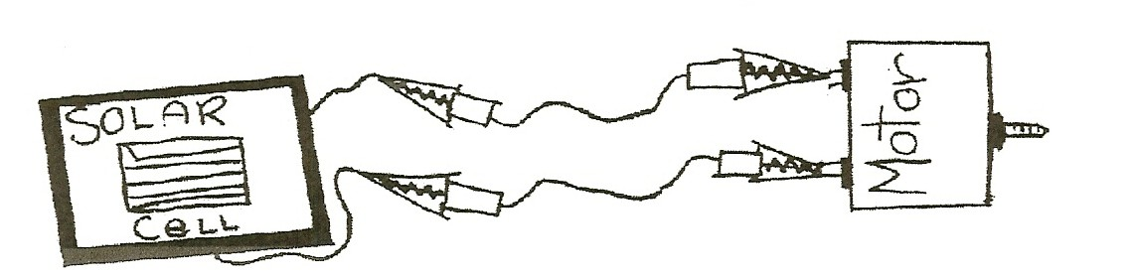
- PREDICT-EXPERIMENT-RECORD DATA [S, predict] Have the students predict the distance between the solar cell and the light for the motor to turn. Remind the students that the meter stick has 100 cm. Start with the solar cell/motor system 100 cm. from the lamp. Move toward the light in 10 cm increments. Have the students describe the action of the motor (e.g. stopped, slow, fast, very fast). Write down the distance in centimeters, for slow, fast and very fast. Relate this experiment to the amount of energy Pluto receives from our Sun compared to Earth.

[S, analyze] [S, Sun-light energy]

ASSESSMENT:
Why is Earth the only planet with life? Include the following in your answer: Greenhouse effect, atmosphere, solar energy, distance from the Sun and light energy form the Sun.

