POLLUTION

SECTION 7-TESTING FOR HARD WATER
From Hands on Science by Linda Poore, 2003.

Westminster College

OBJECTIVES
Students discover that common minerals in water can contribute indirectly to pollution by increasing the hardness of the water and subsequently the amount of soap and detergent that people use.

Students will test the hardness of three water samples.
Students will record and interpret data about water samples.
Students will infer that hard water contributes to water pollution by increasing the amount of soap and detergent that people use.

MATERIALS
For Each Student For Each Team (4)
Activity Sheet 4 1 plastic beaker
1 calibrated 1 oz cup
For the Class 1 eyedropper
3 beakers 1 marker
calcium chloride 3 test tubes
1 bottle liquid detergent 1 set measuring spoons 1 roll masking tape
1 bottle distilled water tap water

PREPARATION
- Make a copy of Activity Sheet 4 for each student.
- Make a batch of calcium chloride solution by mixing half a teaspoon of calcium chloride with 100 mL of distilled water in a beaker.

Safety Note: Follow the guidelines for use on the calcium chloride container when mixing the solution.
- Set up a water sample distribution station. Place the beaker of calcium chloride solution, a beaker of tap water, and a beaker of distilled water at the station. Label the beakers A, B, and C, respectively.
- Put 2-3 tsp. of liquid detergent into calibrated cups, one cup per team.
- Each team will need an empty beaker, an eyedropper, three test tubes, a marker, and a calibrated cup filled with liquid detergent. The teams will need to share the roll of masking tape.

BACKGROUND INFORMATION

Hardness refers to the presence of calcium and magnesium ions in water. The ions, which come from dissolved rock, have little direct effect on organisms, but they do affect the properties of the tap water coming into our homes.
The minerals in hard water react with soap, interfering with its ability to lather. The result is that homes with hard water tend to use more soap, which in turn results in more soap residue.

Additionally, calcium and iron deposits form hard water can build up in appliances that use water, such as washing machines and steam irons, shortening life span and adding to landfill problem.

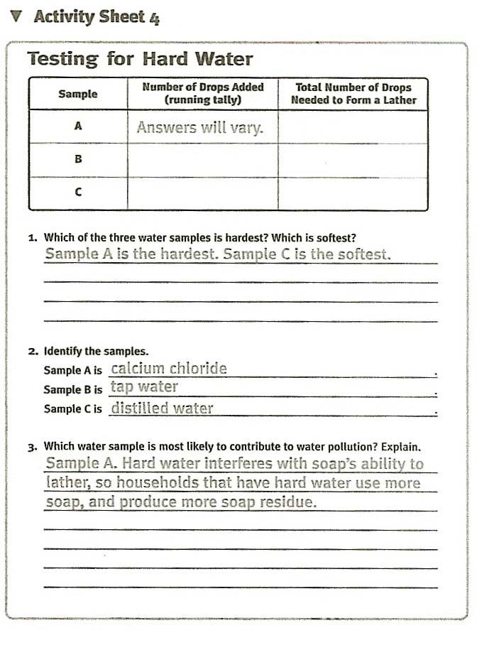

GUIDING THE ACTIVITY

- Write the term hard water on the board and ask, What do you think the term
hard water means?
Students may know that “hardness” has to do with the presence of certain minerals in water. Others may know that “hard” water makes washing more difficult.

Explain that water that contains a lot of calcium, magnesium, or iron is described as hard water. Washing is more difficult with hard water because the minerals in the water reduce the detergent’s ability to form a lather.
Explain, too, that water from different sources may contain different amount of minerals.

Write the terms soft water and distilled water on the board. Explain that water with very low concentrations of minerals is described as soft water. Distilled water has been purified (evaporated and condensed) to remove minerals such as calcium. Therefore, distilled water is soft water.

- Point out the three water samples at the distribution station. Explain that of these samples, one is hard water, one it tap water, which may or may not be hard, and one is distilled (soft) water. The students will test the samples to find out which is which.

Divide the class into teams of four and give each team one beaker, three test tubes, a marker, and an eyedropper. Tell them to use the marker and masking tape to label the tubes A, B, and C.

Point out the mL marks on the test tubes. Then invite one student from each team to bring the three test tubes to the distribution station and measure 10 mL of each water sample to the corresponding tube.

Note: For easier handling, and to avoid spills, students should keep their test tubes in the empty beaker when transporting to and from the distribution station and when not in use.

- Explain that water hardness affects a soap’s ability to form a lather: the harder the water, the fewer soap suds that will form. Have the students examine their water samples and try to guess which sample is hardest simply by observing and touching them.
Students may notice sediment or discoloration in one of the water samples (the calcium chloride solution). These observations might give them a clue as to which samples contains a lot of minerals.

- Now tell the students that they can test the relative hardness of the water samples by adding drops of liquid detergent to each test tube, shaking, and observing which forms a lather from the fewest number of drops.

Distribute a copy of Activity Sheet 4 to each student and a calibrated cup of liquid detergent to each team. Have one student from each team use an eyedropper to add one drop of detergent to water Sample A, place a finger over the top of the test tube and shake the tube vigorously.

Have the student continue adding drops, one at a time, and shaking until a permanent lather fills the test tube from the top of the sample. The other students should keep a running tally on the activity sheet of the number of drops of detergent needed to make the lather. Tell them to use one tally mark for each drop.

Have the students repeat this procedure for water Samples B and C.
If students do not know how to make tally marks, show them now before they conduct any tests.
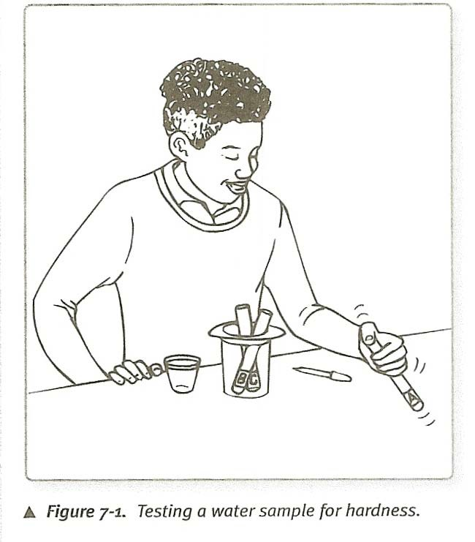

- Tell the students that hard water contains high concentrations of calcium, magnesium, and sometimes iron, and that these minerals prevent soap lather from forming.

Ask, Which of the three samples is the hardest?
Students will identify the hardest sample by letter. Reveal which sample is which at this time and have students add this information to their activity sheets. Although tap water will vary in hardness, most students should find that the calcium chloride solution is the hardest, as it needed the most detergent to produce a permanent lather.

Ask, Which sample is the softest?
Although tap water varies, students should have found that the distilled water is the softest.

Ask, Why do you think that distilled water is the softest?
Students should recall that distilled water is soft because the minerals have been removed during the distillation process.

Ask, How do you think the hardness of water in homes might contribute to water pollution? Have students write their answers on their activity sheets.
Because water hardness affects the ability of soap to form a lather, households with hard water tend to use more soap than households with soft water. As a result, hard water households produce more pollution in the form of soap residue.

Explain that soap (or detergent) residue is the lather that is rinsed off every time we bathe and wash our clothes, dishes and cars. The residue can seriously affect the water quality of the streams, lakes, and oceans into which it is discharged.
Point out that although artificially “softening” water may reduce the amount of soap needed and therefore the amount of residue produced, it does not necessarily solve the problem. Salts that are used in the softening process can also pollute the water.

