SOUND VIBRATIONS

SECTION 7: VISIBLE VIBRATIONS
From Science in a Nutshell

OBJECTIVE:
To discover how sound waves travel.

MATERIALS:
bowl of water
Journal page for Activity 7 Slinky
tuning fork

Westminster College

BACKGROUND:
The air around us is made up of tiny particles (called molecules) that are too small to see. A vibrating object bumps into the molecules of air that surround it. These vibrating molecules then bump into other air molecules causing them to vibrate too.

All of this bumping results in a chain reaction of vibrating molecules traveling away from the sound source—a sound wave. Although each vibrating molecule moves only a tiny distance, the sound being carried can travel a great distance on waves of vibration.

Liquids and solids are also made up of molecules. Sound waves travel through liquids and solids just as they do in the air—each vibrating molecule causes the neighbor molecules to vibrate. In this activity, you will see how sound waves travel.

EXPERIMENT:
- Hold one end of the Slinky with one hand and ask your partner to hold the other end. Stretch the Slinky out along the floor so that it is about 1.5 m (about 4.5 ft.) long.

- With your other hand, squeeze together several coils, then let go of the squeezed coils. Do not let go of the Slinky! Watch the “squeeze wave” travel to the other end of the Slinky. Sound waves travel from a vibrating object in a similar way.

- 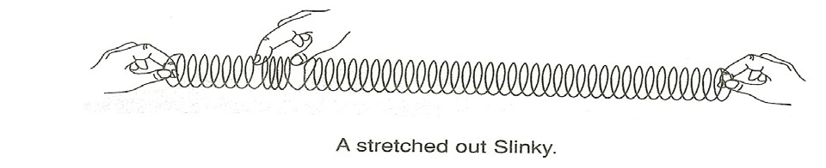Now, have your partner squeeze together several coils and release the squeezed coils. Does the squeeze wave move as it did when you squeezed and released the coils?

PRISMS-OBSERVING COLOR

- Keep taking turns as you continue your “Slinky talk” conversation. Can you send each other secret messages using the vibrating Slinky?

- Describe on your Journal page for Activity 7 how the squeeze wave traveled from one end of the Slinky to the other.

- When you release the squeezed coils, observe how the squeeze wave appears to move from one end of the Slinky to the other. Does each coil move a lot or only a little? Record your observations on the Journal page.

- How is the way that the squeeze wave moves different from the way that real sound waves move?

- Do you think that sound waves move in only one direction from the source of the sound? The next test will show which direction(s) sound waves travel from the source.

- What do you predict will happen if a vibrating tuning fork is placed into a bowl of water?

- Strike the tuning fork on the heel of your shoe. Place both vibrating tines into a bowl of water. Look carefully at the surface of the water. Be careful not to touch the tuning fork to the bottom or sides of the bowl.

- Did you see waves like ripples in a pond? Do the sound waves travel in all directions from the source of the sound or in only one direction as they squeeze wave did? Describe your observations in the journal.

- How is the Slinky wave like the sound waves? How is the Slinky wave different from the sound waves? In your journal, explain how sound waves are able to travel through the air to our ears.

IN A NUTSHELL:

Sound waves travel outward in all directions from a vibrating object.

CRACKING THE NUT:

Sound waves are carried by a chain reaction of vibrating molecules. Why do you think sounds cannot be heard in space?

