MACHINES AND MOTION

SECTION 8: CREATE A MACHINE

STANDARDS:

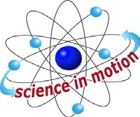
Westminster College

Students know the position of an object can be described by locating it in relation to another object or to the background.

Students know magnets can be used to make some objects move without being touched.

Students know an object’s motion can be described by recording the change in position of the object over time.

Students know sound is made by vibrating objects and can be described by its pitch and volume.

HOMEWORK:
Have students bring in toys, kitchen utensils, and simple machines from home. Advanced Legos®, Erector Sets®, and Capsela® toys have pulleys and gears in them, hand-operated can-openers, a grater with a handle, etc.

MATERIALS:
egg beater

DISCUSS:

OBSERVING MACHINES
Discuss the kitchen utensils and student’s toys and how they help do work. Items with handles are levers if it is harder to do the work without the handle. (tongs, scissors, fork, broom, hand can-opener) ‘Handles’ you turn are wheels and axles (handle on a manual can opener, door knob, salad spinner, egg beater, pencil sharpener handle.)

- A hand-operated egg beater has a wheel and axle and gears. All sharp edges on objects are wedges which are 2 inclined planes put together: scissors, knives, ax, etc.

MAKE A MACHINE
Put two crayons together with a rubber band as shown. Twist the crayons so the rubber band winds up tightly. Let go. What happens? (bump, twist, fly)
How long did it move? What is its new position?
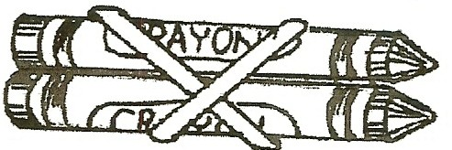

- Where did the crayons get the energy? (from the rubber band) How is this like some real toys? (wind-up toys)
What are other ways toys get energy to move? (battery)

IN ADVANCE:
Have students bring in toilet paper cardboard rolls. Read the student worksheet Buzzing Bee. Make 2 ‘bees’ one without the 3 x 5 card and a second with a card, cut with the outline of the bee.
HINTS: Use the rubber bands that are in the kit, size #82, 2 3/8” x ½” wide. Other rubber bands may not stay on. (Using 2 rubber bands may work if you do not have the kit #82 rubber bands.)
The 3 x 5 card works as a rectangle or can be cut into the bee shape. Have students precut the cards before making the sound machine.

NOTE:
The bee buzzer can be done for homework as family science or with the assistance of upper-grade student helpers in class.

MATERIALS:
tongue depressor
¼ of a toilet paper roll rubber band 3/8” x ½” 20” string
3 x 5 card
scotch tape- two 4” pieces and two 2” pieces

EXPLORE:

MAKING A SOUND MACHINE:
- Pass out a tongue depressor stick to each student. Have each student hold it firmly on their desk with 8 cm (3”) extending over the desk’s edge. Push on the extended edge to make it vibrate.
The stick will make a sound while it vibrates.
Have the students change the amount of stick that hangs over the desk and compare the noise it makes.
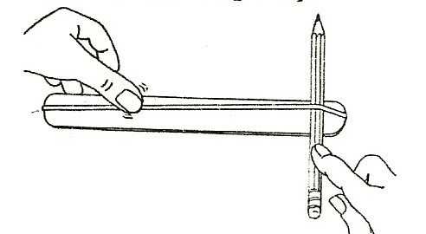
When does it make a higher pitch sound? (shorter overhang) When does it makes a lower pitch sound? (longer overhang)

- Pass out a rubber band to each student.
Can they make it vibrate? (Stretch it on the stick and pluck it.)

MAKING A BUZZING BEE:
Use the worksheet to construct the bee buzzers together. Pass out the materials: tongue depressors, cards, rubber bands, string, tape. Students need help getting the rubber band around the stick.

- Show the students a buzzer without the card.
Ask them to predict what it will sound like when you swing it. (loud, soft, high, or low)
Demonstrate by swinging it to your side.
Make sure you do not hit anything. (very small sound)
Then swing a buzzer with a card. (If no sound, swing it faster.)
Why does it sound louder? (the card vibrates—amplifying the sound)
SAFETY: Stand apart when swinging the buzzers. Go outdoors. Wind the string around your finger 5 times.
Swinging buzzers vertically at your side is safer than overhead. Buzzers that don’t work need an additional piece of folded cardboard under the rubber band to lift it off the card and stick.
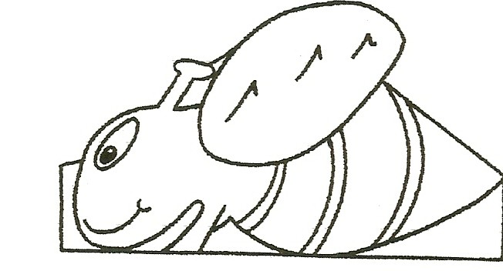

- CHANGING THE VOLUME: LOUDER-SOFTER How can you make your bee buzz softly? (Turn slower) How can you make your bee buzz loudly? (swing faster)

WHEN THE POSITION CHANGES, THE SOUND CHANGES
Listen carefully as someone else swings a bee buzzer.
You will hear the pitch change from high (when it is closer to you) to lower as it moves away from you. This Doppler effect is heard when a train, racecar, or fire engine approaches and then moves away from you.

- STRING INSTRUMENTS: Play several instruments. Make high and low sounds. Make loud and soft sounds.
Observe how the string vibrates while the sound is being made.

KEY WORD:
DOPPLER EFFECT: An apparent change in the frequency of sound waves, occurring when the source and observer are in motion relative to each other. The frequency increases (higher pitch) when the source and observer approach each other and decreases (lower pitch) when they move apart. (As the noise approaches, the sound waves are pressed closer together, causing more vibrations per second and higher pitch.)

ASSESSMENT:
Have students:
Look at a guitar or inside a piano.
Write on their paper what vibrates to make the sound in the instrument.
Practice listening to different notes and deciding which are high and low notes so they can learn to recognize pitch.
Find the thickest string and play it. (It is low.)
Compare its sound to that of a think string. Which is lower? (thick)
Write high or low on their paper as the teacher plays notes of differing pitch.

RESEARCH:
Look up Rube Goldberg, www.rubegoldberg.com, and find out why he was famous. He designed, silly, creative, useless machines.

MATERIALS:
2 magnets
worksheet Magnet Race Track

EXPLORE:

THE MAGNET RACER
- Pass out 2 magnets to each student. Have them predict what will happen if they put the magnets close together. Explore.
- Can they make the magnets jump, twirl, flip, and chase?

TWO MAGNETS CAN ATTRACT OR REPEL
Introduce the word attract (or pull) and repel (push).
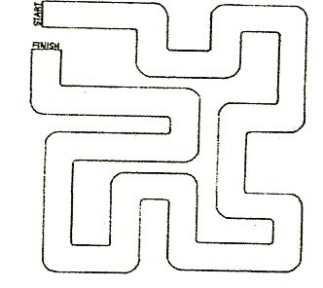
Ask the students to place 2 magnets in their hand so they attract. Observe students to check for understanding.
Ask the students to hold the 2 magnets together on the middle of their desk so they are repelling.
On the count of three, have all students let go of the magnets. (The top one flips.)
RACE: Have a race to see how fast they can push their magnet across their paper using the second magnet to repel it.
(Do not let magnets fall on the floor as they can break.)

- Give each student the maze worksheet (end of this section) and tell them they are to send their magnet race through the maze without touching it. (Students

may put one magnet under the paper letting the magnets attract or put one magnet in front of the other, pushing the magnet through the maze by repelling.) Give students time to practice moving the magnets by repelling through the maze.

REPELLING RACE:
Record the number of seconds it takes each student to push the magnet through the maze.
Have students work in pairs with one student pushing the magnet through the maze with the other magnet while the second student observes that the magnet stays on the ‘track.’
Everyone starts the race together and the teacher counts off the seconds. Each student observer records the number of seconds they hear when their partner finishes the race.
Students then change roles, so all students race a magnet. Compare times.

MATERIALS:
2 plastic cars
2 large magnets that fit on the backs of the cars

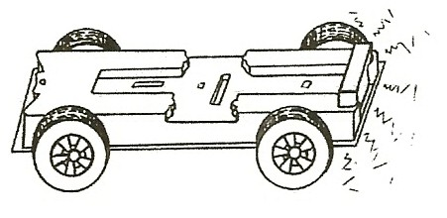
ASSESSMENT:
Put the words attract and repel on the board.
Have the students write 1. 2. 3. 4. vertically on their paper.
Show them the 2 magnets and put the magnets on the backs of the plastic cars.
Tell the students you are going to put the car backs close together. Write attract and repel on the board. These are the answers for 1-4. 1st. Predict what will happen and write the word after #1.
2nd. Put the cars together and have the students write a word to tell what they observed after number 2.
3rd. Have students write predict for #3. Tell them you are going to turn 1 magnet over. Have them write a word to show their prediction at #3.
4th. Put the car backs close together and observe. Have students write after #3 what happened with one magnet turned around.

REINFORCE:

CAR RACES
Let 2 students race the plastic cars using repel.
Have a start and finish line. Time the race. Record the time of the winter.
Give each student a magnet and a plastic car with a magnet and make the magnets repel to make the car go.

