**SECTION 8: GREAT RACE**

## LAB

**INTRODUCTION**

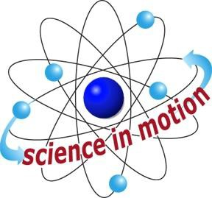

**Westminster College**

In this activity, students use gravity to accelerate a car down two ramps of different heights. Students also calculate the average speed of the car on the ramps. The last part of the activity introduces the terms kinetic energy (the energy possessed by an object because of its motion) and gravitational potential energy (energy possessed by an object that can fall). As the car descents the ramp (falls), it gains speed and kinetic energy. It also loses gravitational potential energy. This is a demonstration of the conservation of energy: as the car rolls downhill, potential energy is transformed into kinetic energy.

Eventually, the force of friction will bring the moving car to a stop.

# ASSESSMENT ANCHORS ADDRESSED

**S4.A.2.1** Apply skills necessary to conduct an experiment or design a solution to solve a problem.

**S4.C.1.1** Describe observable physical properties of matter.

**S4.C.2.1** Recognize basic energy types and sources, or describe how energy can be changed from one form to another.

**S4.C.3.1** Identify and describe different types of force and motion, or the effect of the interaction between force and motion.

# PURPOSE

In this activity, students apply Newton’s first law of motion to the behavior of a toy car.

# MATERIALS

**For Each Group For the Class** Books* Activity Sheet 8 Car

Connector Measuring tape Stopwatch

2 tracks

*Teacher provides items marked with \**

## Westminster College SIM Page 1