REFLECTION, DIFFRACTION, REFRACTION

SECTION 8: LIGHT AND COLOR

BACKGROUND:
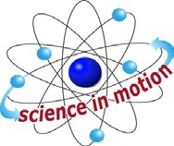
Westminster College

The retina of our eye has a large number of nerve cells that connect the retina to the brain. When light strikes special receptor cells in the retina, these specialized cells produce impulses that are transmitted by the nerves to the brain. The brain’s interpretation of these impulses is what we refer to as seeing.

Cone cells, specialized cells in the retina, are sensitive to certain wavelengths of light. When the chemical reaction in the cone cells stimulates the brain, we see in color. What color we see depends on the color of light reflected from an object into our eyes.

In optics, red, blue and green are called the primary colors. These are the primary colors because they represent the wavelengths of light that the three types of cones are most sensitive to. When all three of these colors are mixed in equal amounts, we see white light. By mixing red, blue or green light in varying amounts, all different colors can be produced. A stop sign appears red because it reflects red light and absorbs blue and green light.

Filters, transparent screens that allow only certain wavelengths to pass, are used to change the color of white light. A red filter, which transmits red wavelengths, absorbs blue and green wavelengths.

The wavelength transmitted also affects our perception. A white light with a blue filter transmits blue light and what we see becomes blue tinted. This ability is put to good use by stage directors when they control lighting effects on stage.

Primary light colors are different from primary pigment colors that you use in art class. Mixing pigments results in different colors of light being absorbed. (Pigments are insoluble materials mixed with oil, water, etc., to make colors.) An artist mixes pigments with paint to create various colors. The three primary pigment colors are magenta, yellow and cyan ( a shade of blue.) When all three pigment colors are mixed, they produce black because all light is absorbed. This is completely different result from mixing the three primary light colors of red, blue and green, to produce white light.

MATERIALS:
Flashlight construction paper
color filters white paper

PROCEDURE:
- Take three different colored sheets of construction paper and fold them in half, so that they can easily be stood on end. (Preferred: one each, red, blue, green).
- Take three sheets of white paper and fold them in half.

LIGHT AND COLOR

- Stand the colored sheets on the work surface. Place the white sheets next to the colored sheets, forming a 3-sided figure. The illustrations at the bottom of this page show how the folded paper should look.
- Shine the flashlight directly on the colored paper. Observe the reflection, as it appears on the white paper. Move the flashlight to each set of shapes. Record your observations.
- Shine the flashlight near the edge of the colored paper nearest to the white paper. Study the dark reflection at the edge of the white paper, where the central beam of the flashlight is being reflected. Note what color the reflection is for each set of folded papers.
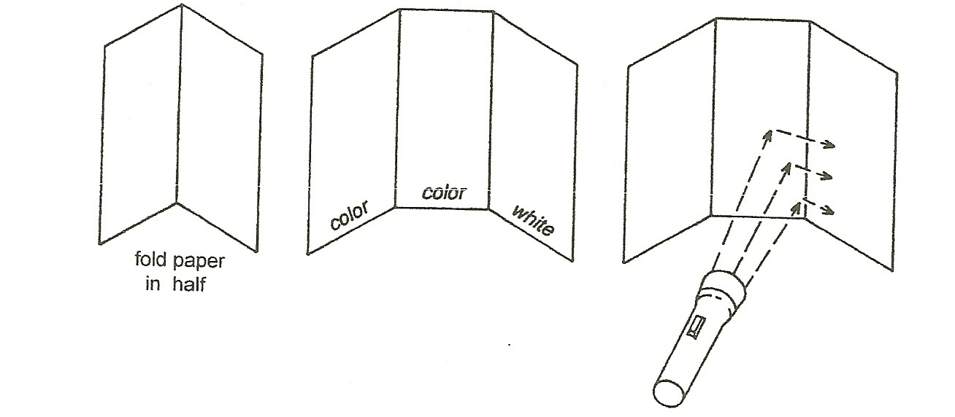

Question:
If you owned a small grocery store and wanted to increase sales, what color lights would you use in the produce and meat departments? Explain your answer.

