ROCKS, EROSION AND WEATHERING

SECTION 8-METAMORPHIC ROCKS
From Hands on Elementary School Science by Linda Poore, 2003

STANDARD:

Westminster College

Students know how to differentiate among igneous, sedimentary, and metamorphic rocks by referring to their properties and methods of formation (the rock cycle).

Students know some changes in the earth are due to slow processes, such as erosion and some changes are due to rapid processes, such as landslides, volcanic eruptions, and earthquakes.

KEY WORDS:

METAMORPHIC ROCKS:
Rocks formed when other rocks are subjected to heat and pressure. (usually sedimentary rocks) The metamorphic rock has some of the same characteristics of the rock it is made from, but it is harder. The following shows the original rock and the metamorphic rock it becomes when subjected to heat and pressure: granite→gneiss shale→slate limestone→marble

SHALE:
Composed of clay and minerals, shows the layering of mud. It is relatively soft and flat. Can be scratched with a fingernail. (sedimentary)

SLATE:
Shinier and harder than shale, used for blackboards in pioneer America. (metamorphic-from shale)

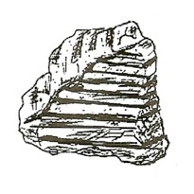
LIMESTONE: (Calcium Carbonate)
Forms when shallow seas evaporate, leaving behind deposits of shells or shell pieces. Dissolves in acid, releasing carbon dioxide. (sedimentary)

MARBLE:
Limestone or calcite that has been squeezed and heated under pressure making it shiny and hard. (metamorphic)

GRANITE:
Composed of feldspar, quartz, and mica. The crystals are large and easy to differentiate because they cooled slowly deep in the Earth. This allows time for the minerals to grow. (igneous)

GNEISS: (Pronounced nice)
Has the same minerals as granite, but is arranged in layers due to heat and pressure on granite. Light bands of quartz and feldspar alternate with dark bands

of mica. (Metamorphic-from granite) Layers are caused by the minerals solidifying at different temperatures.

MATERIALS:
For Each Pair:
granite gneiss shale slate limestone marble magnifier

EXPLORE: [S, metamorphic-properties/formation] HOW ARE METAMORPHIC ROCKS FORMED
- Discuss how metamorphic rocks are formed.
(Rocks changed deep in the Earth with heat and pressure.)
Tell students they have been given 3 pairs of rocks showing how each rock looked before and after metamorphosis.

- Have students examine rocks and pair them.
The teacher should hold up a rock, like granite, and describe it. The students then hold up the rock it turned into when it underwent metamorphosis due to heat and pressure.
Students should hold up gneiss (nice) and note that the spots became lines during metamorphosis, when minerals melted, mixed, and cooled at different rates.

- Explain how each rock changed through metamorphosis. Have the students write the names of each pair of rocks and tell how they are alike and different.

MATERIALS:
For Each Pair: For the Teacher:
1 cup hot water matches
3 colors of clay in small balls candle
plastic sandwich bag hot pot (hot water) 12” x 4” piece of foil

SAFETY:
HOT POT boils water quickly. Mix this with some cool water in each cup so that water does not burn students.

EXPLORE:

CHANGING A SUBSTANCE WITH HEAT AND PRESSURE
- CHANGES WITH PRESSURE
Show students a bag with 3 colors of clay. This is your ‘rock’. How many different ‘minerals’ does it have.
You are to use heat and pressure to change it. Distribute clay in a plastic bag to each pair of students. Make 3 balls of clay (approximately 1 cm in diameter) Place balls in the corner of the bag and add pressure.

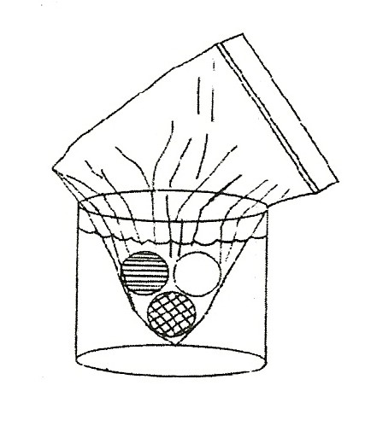
CHANGES WITH HEAT
Pass out cups with hot water.
Put the bag with clay into hot water for 1 minute. Observe changes.
Can you still recognize the original shapes? Colors? Add pressure to the hot clay to change it more/
Can you make the colors swirl?
Can you make the clay striped with the colors?
Return the bag to hot water for one more minute. Observe

- OBSERVING CHANGES Observe how the clay balls were changed. Were any balls changed into stripes of colors?
(Compare to granite’s metamorphic change to gneiss.) Minerals in granite melt at different temperatures, creating a pool of each mineral. These pools cool at different temperatures, creating the stripes(layers) of each mineral.

DEMONSTRATE:

HEAT CHANGES MATERIALS [S, changes]
Place 3 colored balls of clay in a piece of foil and make a foil ‘spoon’ with a pencil handle. (see picture)
Hold the foil spoon over a candle for 2 minutes. Observe. Did the clay melt?
Press on the clay.
Note the difference in appearance with this hotter heat source. (The clay becomes grainy, coarse, and breaks apart.)
Reinforce the concept that metamorphic rocks were formed with heat and pressure. [S, metamorphic-formation]
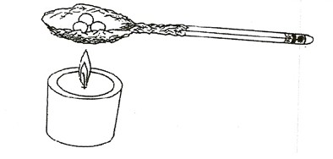

ASSESSMENT:
Have students use their clay experiment to explain through pictures and descriptions how rocks change under the Earth. Give examples. Use the words metamorphic, heat, and pressure in the description. [S, change]

