LIGHT

SECTION 8-PRISMS-OBSERVING COLOR
From Hands on Science by Linda Poore, 2003.

STANDARDS:

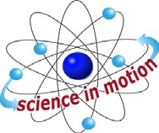
Westminster College

Students know light is reflected from mirrors and other surfaces.

Students know an object is seen when light traveling from an object enters our eye.

Students know the color of light striking an object affects the way the object is seen.

Students will repeat observations to improve accuracy, and know that the results of similar scientific investigations seldom turn out exactly the same because of differences in the things being investigated, methods being used, or uncertainty in the observation.

Students will differentiate evidence from opinion, and know that scientists do not rely on claims or conclusions unless they are backed by observations that can be confirmed.

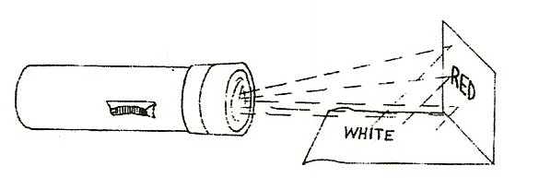
Students will collect data in an investigation and analyze them to develop a logical conclusion.

MATERIALS:
For Each Pair:
1- 3” x 5” piece of red paper 1 flashlight with batteries

KEY WORDS:

COLOR:
Visible light had different wavelengths that we see as color. The longest wavelength is red light and the shortest wavelengths are blue and violet. White light is a mixture of all the colors.

SPECTRUM:
The order of colors in the spectrum of white light from red to violet is R.O.Y.G.B.I.V. (red, orange, yellow, green, blue, indigo, violet) Our eyes cannot separate indigo and violet so we see 6 colors.

EXPLORE 1:

HOW DO WE SEE COLOR?
- Hold a piece of construction paper at 45° angle to a white paper and shine the flashlight on the red paper. (see picture)
You see the reflected color on the white paper. What color is the white paper now? (red)

- Objects appear to have color due to light reflected from the object to our eyes. Only red is reflected onto the paper and all other colors from the white light are absorbed by the red paper.

KEY WORDS:

PRISM:
Refracts or bends the different wavelengths by different amounts, spreading them out so the individual colors can be seen that make up white light.

MATERIALS:
For the Teacher:
Overhead projector
red and blue plastic pieces 1 prism

DEMONSTRATE:

WHAT COLOR IS LIGHT?
- PRISMS BEN LIGHT (REFRACTION)
Look at the white color of the projector light.
Hold the prism vertically 3 meters form the projector and 1 meter from the screen. Rotate the prism slowly until you see the spectrum focused on the white screen in the shadows next to the lighted area.

WHITE LIGHT IS A RAINBOW OF COLORS
Draw the spectrum with crayons showing the colors in order. (R.O.Y.G.B.I.V: red, orange, yellow, green, blue, indigo, violet.)

SUNLIGHT:
Hold the prism in direct sunlight, viewing the spectrum. Focus the spectrum on the side of a building in shade.

- Hold the prism up to the projector light and predict what will happen if you hold red plastic in the light in front of or behind the prism? Experiment. Discuss. Red plastic transmits red but absorbs other colors, so only red gets through the screen. If you put a red plastic piece in front of the prism, only the red end of the spectrum of light (red, yellow, orange) passes through.

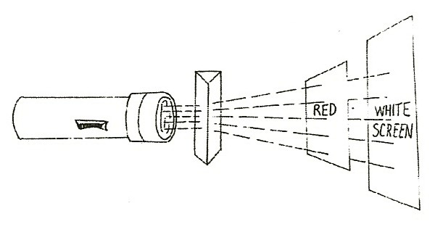
- Hold a blue plastic piece between the red plastic and the screen. What color passes through? (Since the red did not let blue through, the blue plastic has no color to transmit and you get a black shadow.)

NOTE:

THE COLOR SPECTRUM:
The spectrum of white light has red at one end and blue to violet at the other. Red plastic lets red, orange and yellow through since they are next to each other on the spectrum, but it absorbs blue, green, and violet, which have shorter wavelengths. Conversely, you cannot see red color through the blue plastic, which absorbs red. (Use a double layer of the red plastic. Information on making red and blue plastic cards follows.)

IN ADVANCE:

MAKE FRAMES: MATERIALS:
1 roll red acetate
2-8 x 10 sheets of blue (cyan) acetate 3 x 5 cards
tape

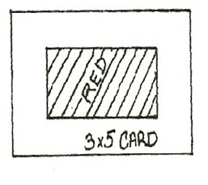

MATERIALS:
- Cut each blue plastic sheet into 12 pieces, 5cm x 8cm. Cut seven 5cm x 50cm strips of red acetate from the roll. Cut each strip into six 5cm x 8cm pieces.
- Use 3 x 5 cards to make frames for the colored pieces. This keeps the fingerprints off these ‘colored lenses’. Fold the 3 x 5 card in half and cut a 1 1/4” by 1” rectangular frame. Make 80 frames. Tape 1 piece blue plastic to one frame and put a second frame on top. Tape both frames together. The red pieces must be doubled to get a true color. To do this, tape one red piece to each card frame, putting tape along the edges only. Then tape the 2 frames together with 2 red plastic pieces inside.

For the Class:
20 double plastic pieces
20 blue plastic pieces (in frames—see above)
20 1” strips of green, blue and red construction paper 20 6” x 9” pieces of black paper
colored pictures (from a textbook or magazine)
colorful wrapping paper (3 x 5 pieces) with bright blues, reds, greens worksheet Colors

EXPLORE 2:

OBSERVING COLOR THROUGH RED AND BLUE PLASTIC
- COLOR THROUGH RED PLASTIC
Lay the red, blue and green paper strips on the black paper. Look at these colors through red plastic by holding the plastic 2” to 4” above the paper. Use two red plastics together in the frame. (see picture)
What colors do you see when you look through the red plastic? (red)
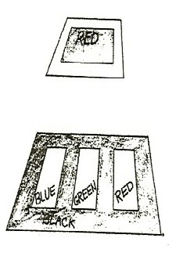
Which colors look black (You can see red, orange, and yellow through red plastic, but blues and greens may appear black as those colors are absorbed by the plastic and do not come through to your eyes. Black is the absence of color.)

OBSERVING A RED AND WHITE PICTURE
Look at a picture that has red and white together. (Red candy striped wrapping paper works well.) The red objects may appear white if the red color is next to white. Your brain is confused. From both the red and the white you are receiving only the red color through the red acetate. All the other colors are blocked or absorbed. Your brain sees both colors the same and decides they both must be white.

OBSERVING COLOR THROUGH BLUE PLASTIC
Hold the blue plastic 2” above the red, blue, and green paper strips on black paper. What colors do you see.
What color do bright red objects become? (black)
The blue plastic absorbs all the other colors and lets your eyes see only blues and greens, since they are together at one end of the spectrum.

RECORDING AND ANALYZING DATA
Use the worksheet, Colors to record what you see through the plastics. View wrapping papers or picture sin a book that you have pre-selected that show the concept. Only bright primary colors will be completely blocked and appear black. Answers to worksheet: 1. red, 2. No, 3. No

DISCUSS
Analyze the data and draw conclusions. When students don’t agree on an answer, do the experiment again.

ASSESSMENT:
Use the color squares worksheet. In advance: Have one students color the boxes in bright markers on this sheet. (4 of the boxes are split diagonally between 2 colors.) Hold the sheet horizontally in front of the class. Have all students holds double red plastic pieces in front of their eyes to view the colored sheet. Answer these questions:
1. What do you see? Why?

Answers: 1.Oh Dad, 2. Red plastic blocks the colors from the blue end of the spectrum of white light. Blue and green appear black since their color did not come through your eyes. Also, black and brown appear black.

ART:

MAKING COLOR PUZZLES
Give each student a Color Puzzle worksheet. (end of section) Show them the colored Puzzle Assessment sheet.
What colors made the Oh Dad?
Discuss what colors they would make their picture to make a color puzzle that you look at through red. (Picture would be in blue, green, black and brown since they will all look black through the red lens.)
Have them ignore the existing color words in the squares.
Draw a simple word or picture lightly on the paper. (e.g., a rocket) Color it so it can only be seen with the red plastic.
Have students look at each puzzle with their red lens to see the picture.

DISCUSS:

WHAT COLORS DO WE SEE?
Which colors are transmitted (pass) through each plastic color piece. (Red passes through red plastic and all other colors are absorbed and cannot be seen. Blue and Green pass through blue plastic and all other colors are absorbed and cannot be seen.) Look at your clothes through each plastic piece. What colors do you see.

COLORS
Procedure: Lay 1” strips of red, blue and green construction paper on a piece of black construction paper.
Hold a colored plastic piece 2” to 4” inches above the paper, between your eyes and the paper. Which colors can you see? Which colors look black?

WHEN I LOOK THORUGH THE COLORED PLASTIC I SEE:

 | MAKES THE COLOR BLUE LOOK: | MAKES THE COLOR RED LOOK: | MAKES THE COLOR GREEN LOOK:
The RED
Plastic
The BLUE
Plastic

Black is the lack of color. The colored plastic pieces let only some of the color through.

  - What color looks black when you look through the blue plastic?

  - Does the blue plastic let the red color come through to your eyes?

  - Does the red plastic let the blue color come through to your eyes?

COLOR PUZZLE: Color each square completely. Hold paper horizontally. Look at it through red plastic.
white | orange | pink | red | Red /  /brown | brown | green | / Red black\
orange | yellow | orange | yellow | black | orange | white | brown
pink | orange | white | pink | green | blue | brown | black
blue | green | brown | red | yellow | white | pink | red
yellow | black | red | white | black | blue | green | blue
black | green | blue | red | blue | white | brown | orange
pink | orange | yellow | white | Black | brown | black | green
green | brown | blue | pink | White | red | pink | white
brown | yellow | black | yellow | Yellow/  /green | green | blue | \white blue\
blue | green | brown | orange | brown | white | yellow | black
yellow | white | pink | red | black | blue | green | brown

