SOUND VIBRATIONS

SECTION 8: SOUND DIRECTORS
From Science in a Nutshell

OBJECTIVE:

Westminster College

To demonstrate how sound waves can be collected and directed.

MATERIALS:
Funnels
Journal page for Activity 8 sheet construction paper portable radio
rubber band ruler scissors
masking/scotch tape plastic tubing tuning fork

BACKGROUND:
Do you remember what you observed when you put the vibrating tuning fork in the bowl of water? The sound waves traveled in all directions away from the vibrating sound source.

How do you think distance affects the sounds you hear? As you move away from the radio, for instance, have you noticed that the sound of the radio seems softer?

Sound waves spread out in all directions as they travel away from the source (the radio). As you move away from the source, the sound waves that reach your ears have less energy. This makes the sound you hear softer.

Special devices can help you hear or be heard better. The speaking tube is one such device. It guides the sound waves through the tube and provides a vibrating column of air between speaker and listener.

Many years ago, Thomas Jefferson used a speaking tube to communicate from room to room in his large home. Before the invention of the telephone, the captain of a ship could use a speaking tube to talk with the crew in the engine room without ever leaving his pace on the bridge.

Soft sounds can be heard more easily if sound waves are collected form a wide area. Before the invention of the electrical hearing aid, a simple cone-shaped device called an ear trumpet was used by hearing impaired people to collect more sound waves, enabling them to hear better.

Some devices prevent the sound waves from spreading out in all directions and direct the sound waves to your ears. Cheerleaders use cone-shaped devices called mega-phones so that their voices can be heard over a noisy crowd. The megaphone does not increase the volume of the sounds; it directs sound waves forward and prevents them from spreading out in all directions.

All of these devices—the speaking tube, the ear trumpet, and the megaphone— have one thing in common. They all direct sound waves to prevent them from going in all directions.

EXPERIMENT:

- Measure and cut off a 60-cm (about 2-ft) length of plastic tubing. Put the 60-cm piece aside for later use.

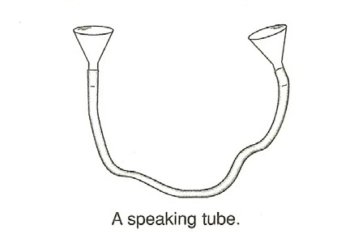
- To make a speaking tube, attach a funnel to each end of the 2-m 96ft) long piece of tubing.

- Take turns whispering and listening to your partner through the speaking tube. Is it easier to hear the whispers with or without the tube?

- Can you hear a vibrating tuning fork over a longer distance by using the speaking tube? Try it.

- Do you think that sounds will travel when the speaking tube is straight or when it is coiled? What happens if there is a kink in the tube? Are the sound waves able to pass through the kink?

- Attach a funnel to each end of the short (60-cm) length of plastic tubing.

- Turn on a small portable radio and set the volume so that you can just barely hear the sound.

- Place the funnel over the speaker. Hold the other end of the tube up to (not in) your ear. Can you hear the radio better with the device or without it? Record your observations on your Journal page of Activity 8.
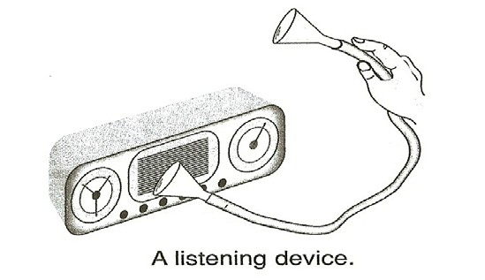

- The device you have made is similar to a stethoscope that a doctor uses to listen to a patient’s heart. Put the funnel over your heart and hold the opposite end of the tube near your ear. What can you hear?

- Roll a large sheet of construction paper to form a cone. Secure the cone with tape and cut off any uneven sections. Be sure both ends of the cone are open.

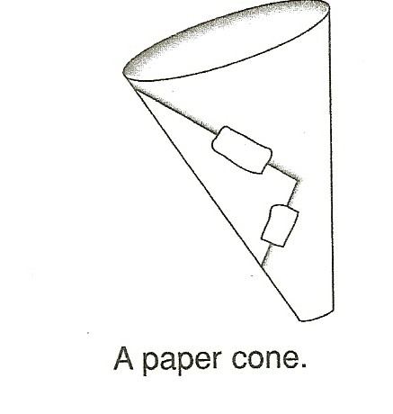

- Stand about 1 m (about 3 ft) from the radio that you can just barely hear. Place the narrow end of the cone near your ear (not in your ear) and listen to the radio. Record in your journal what you hear when you listen through the cone.

- In your journal, list the names of several animals that use their large ears to hear sounds over large distances. How do their large ears help these animals to survive?

- Use the paper cone as a megaphone. Have your partner talk into the narrow end while you stand across the room. Then ask your partner to talk to you again at the same volume but without using the cone. Record your observations in your journal.

SAFETY NUT:
  - Loud sounds can injure ears. Never shout into the speaking tube!

  - Protect your ears and your sense of hearing. DO NOT put anything into your ear.

IN A NUTSHELL:

- Sounds can be heard farther away from their source if the sound waves are prevented from scattering in all directions.

- Sounds with low volume are easier to hear if the sound waves are gathered and directed to the listener.

CRACKING THE NUT:

- Why do you think that many musical instruments such as the trumpet, trombone, and tuba have cone-shaped ends?

