SPACE

Section 8-STARS-
OBSERVING CONSTELLATIONS
From Hands on Elementary School Science, Linda Poore 2003

Westminster College

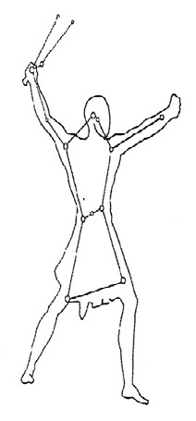
Standards: Students know the patterns of stars stay the same, although they appear to move across the sky nightly, and different stars can be
seen at different seasons.

Students know telescopes magnify the appearance of some distant objects in the sky, including the Moon and the planets. The number of stars that can be seen through telescopes is dramatically greater than the umber that can be seen by the unaided eye.

Students will repeat observations to improve accuracy and know that the results of similar scientific investigations seldom turn out exactly the same because of differences in the things being investigated, methods being used, or uncertainty in the observation.

Students will differentiate evidence from opinion and know the scientists do not rely on claims or conclusions unless they are backed by observations that can be confirmed.

SAFETY: [S, patterns of stars]
NIGHT HOMEWORK: Students should go out at night only if accompanied by an adults. If the school playground is dark at night it may be a good location for viewing constellations. Tell students which direction to face to find the Big and Little Dippers. Make constellation viewing a family science activity and require a parent signature on the Star may to ensure parent supervision.

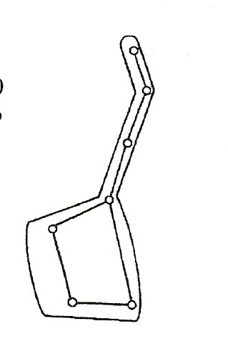
KEY WORDS:
LIGHT YEAR is the unit of measure for distance in space and equals the distance light travels in 1 year. Light travels 300,000 km (186,000 miles) per second. It takes 8 ½ minutes for light to reach us from the Sun and 4.5 light years (4.5ly) for light to reach us from the next closest star, Centauri Proxima.

MATERIALS:
- toilet paper cardboard roll (or 8x 5 ½ black paper) 1 pin
- worksheets: “Look for Constellations’ and ‘Star Map’
1 telescope

DEMONSTRATE:

HOW FAR AWAY ARE THE STARS?
The distance between the Sun and the Earth is 93 million miles. To show how far the other stars are from Earth, draw a dot on the board and label it Earth. Draw a 10cm diameter circle one inch away and label it Sun. The nearest star (besides the Sun) would be 4 miles away.

Name a store or freeway 4 miles away so they can visualize this distance. Ask students what instrument can be used to see more stars in the sky and see them clearer and closer. (telescope)

THE TELESCOPE: [S, telescope-see more stars] Show the students the model telescope in the kit. (minor assembly required). What is inside a telescope? (lenses or lenses and mirrors) How does the telescope help us see the stars and planets? (Items appear closer and clearer) Have each student look at a poster in the room with and without the telescope. Draw a picture of something on the poster with and without the telescope, showing the relative size it appears. (This can be done during a silent reading activity.) Students should notice the item appears closer. (Students use magnifiers to make ‘telescopes’ in Light by Linda Poore.)

SAFETY:
Do Not Let students take the telescope outside.
Looking at the Sun with a telescope could lead to blindness. Remind students never to look at the Sun.

EXPLORE:

THE CONSTELLATIONS [S, stars-patterns]

- CONSTELLATIONS ARE GROUPS OF STARS THAT FORM RECOGNIZABLE PATTERNS
Some stars can be recognized because they appear to be arranged in a pattern or group in the sky. To learn some of these constellations, have students poke pinholes in the constellation work sheet, ‘Look for Constellations.’
Hold a toilet paper roll or a cylinder of black construction paper to cover each circle and look toward the light. Rotate the paper to see how the constellation looks upside-down.
Orion, visible only in winter in the Northern Hemisphere, often appears to be laying on ‘his side’.
Try to find these constellations at night.

DO CONSTELLATIONS ALWAYS LOOK THE SAME?
Pass out the work sheet ‘Star Map’ and have student name the constellations using the ‘Look for Constellation’ work sheet.

Turn the work sheet slowing around 1 rotation to show the students that the constellations may be oriented in any positions.
Read the top of the worksheet to understand why they appear to rotate. (Earth is moving, not the constellations.)
The best time to view constellations in a big city is during a new moon when the sky is dark.

[S, stars appear to move]

- HOW TO FIND CONSTELLATIONS
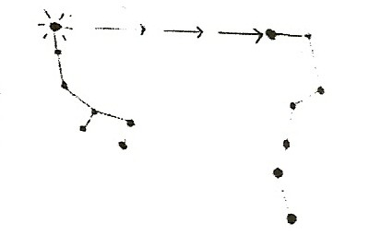
Go outside with an adult on a dark, clean night and find the Little Dipper. In the area of sky around the little Dipper’s tail you will see the constellations on the ‘Star Map’ work sheet.
The last star in the Little Dipper’s tail is Polaris, the North Star. Find the North Star and follow it across the sky to find the Big Dipper. (Or, find the Big Dipper.
The 2 first stars of the bowl point across the sky to Polaris, The North Star, in the Little Dipper’s tail.)

- Turn the chart around until it matches the sky. Because the Earth turns on its axis, these constellations will appear to change position in the sky. For instance, Cepheus looks like the letter ‘W’, and then later in the night as the Earth rotates, it looks like an ‘M’ in its new sky location. Check the constellations every half-hour for 2 hours.

[S, stars appear to move]

- Ask students to draw what the constellations look like. Fold the ‘Star Map’ worksheet in half. On the back, using one-half, write the time you first observed the constellations. Draw them as you saw them in the sky relative to the ground you stood on. Write the viewing time and date at top of the paper. After 2 hours (on the other half) draw how they appear and write the time and date. On the bottom of the paper, write how they changed.

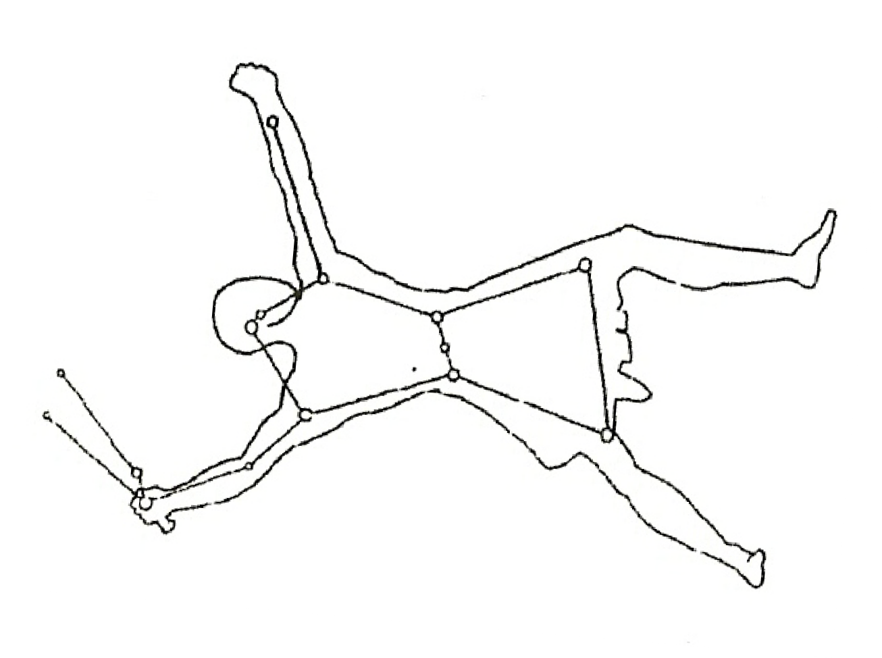
[S, evidence-observations]

← ORION

THE STARS CHANGE DURING THE SEASONS
The stars on the The Star Map are visible throughout the year. Other stars are closer to the horizon and are visible during a season due to the Earth’s tilt and its revolution through space.
Orion can only be seen during the winter in the Northern Hemisphere. He is usually seen on his side (see above). In the winter, find Orion in the sky and show students where to look for it by standing on the playground during the day and pointing. Have them draw its constellation, learn to find it by the three bright stars in the belt, and look for Orion at night with their parents.

[S, stars-season]

- TELESCOPES [S, telescopes-magnify] Every day we learn more about space through telescopes. Ask students to describe what a telescope does. (Make distant objects look closer and clearer using lenses or lenses and mirrors). Ask students who has looked through a telescope at night. What did they see?

RESEARCH:

CONSTELLATIONS:
Using a constellation book, have students find information on other constellations, such as the stars in the Big Dipper. They could also write to an observatory or planetarium requesting information.

TELESCOPES:
Research reflecting telescope, refracting telescope, and Hubble telescopes. What can we see with these telescopes? [ S, telescopes-magnify]

EXTENSION:
During Open House or a family science night, ask a planetarium or parent to bring their telescope to view a planet with its moon or view our moon’s surface.

LOOK AT THE CONSTELLATIONS

Poke holes on the dots, using a pin. Place a toilet paper cardboard roll over each circle and hold this paper up to a light. At night, try to find these constellations in the sky.
Find the Little Dipper in the night sky. Follow the last star in the Little Dipper’s tail (the North Star) across the sky until you find the Big Dipper. You will now see Cassiopeia, Cepheus, and Draco near the two ‘dippers.’ The Earth’s axis always points at the North Star, and because the Earth rotates on its axis, these constellations appear to circle the North Star. Add your favorite constellations in the 3 blank circles.
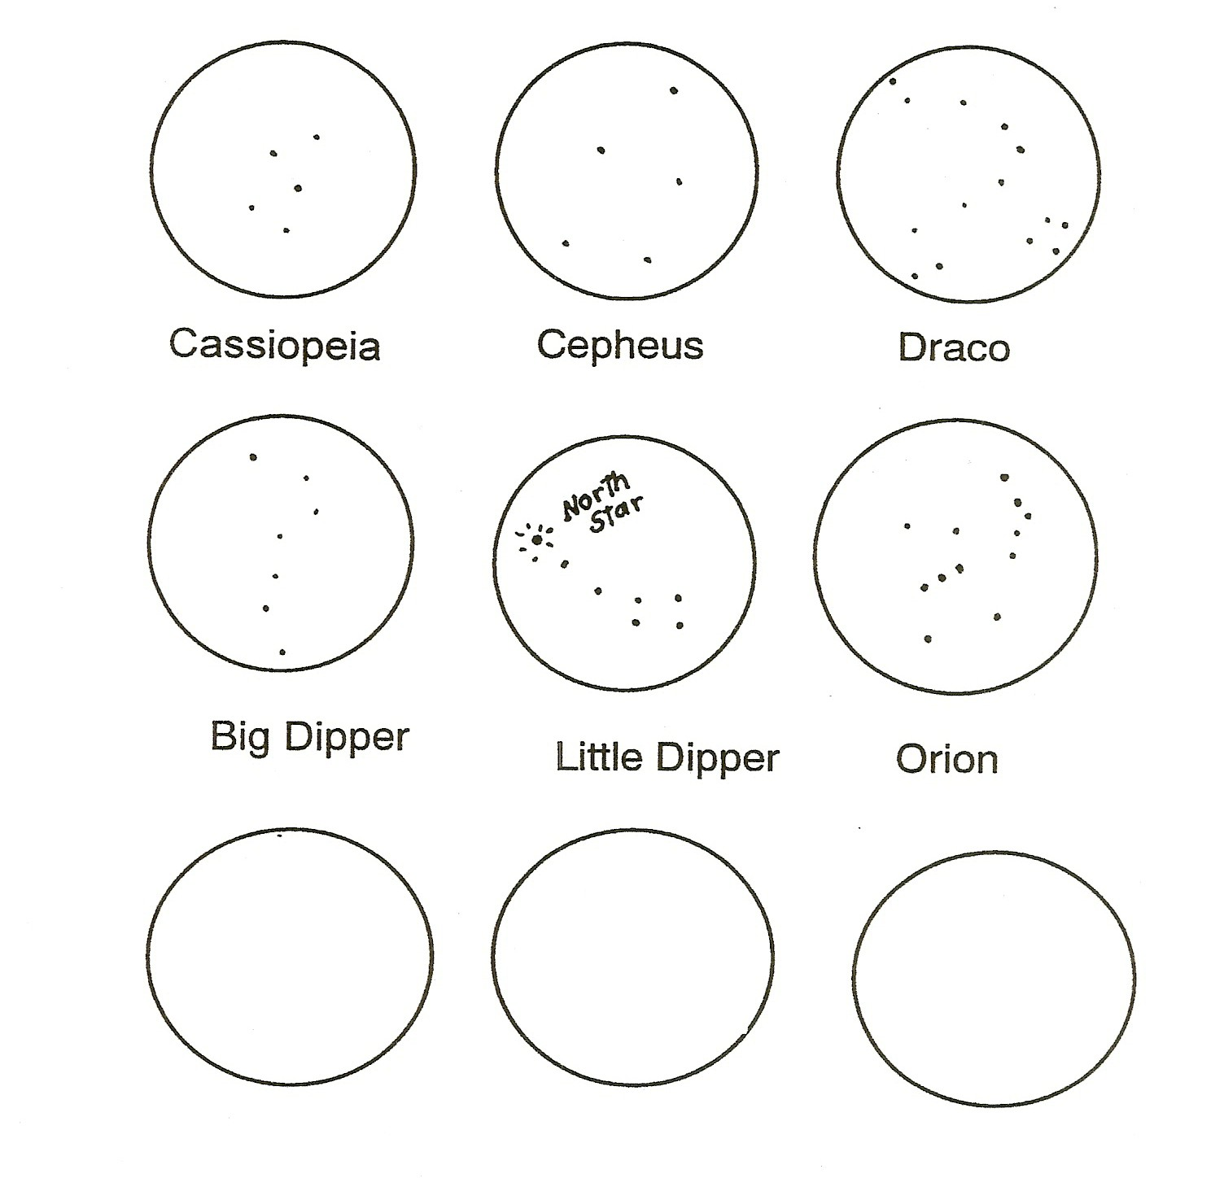

STAR MAP OBSERVING HOW CONSTELLATIONS APPEAR TO MOVE DUE TO THE EARTH’S ROTATION

  - Take this constellation map outside on a dark, clear night.
  - Look for the Little Dipper. Find the North Star. It is the last star in the tail of the Little Dipper.
  - Follow the North Star across the sky to find the Big Dipper.
  - Turn this chart around so the Little Dipper and Big Dipper appear the same on the chart as in the sky.
  - Use this map to find the other constellations.
  - The Earth’s axis always points to the North Star. As the Earth turns the stars near the North Star appear to move around it.
  - Once you have found these constellations, return to the same spot in 1 or 2 hours to see how the star positions have changed relative to the Earth.
  - Draw a picture showing how the constellations looked. Write the time and date on this picture.
