WEATHER

SECTION 8: WINDS
From Hands on Science by Linda Poore, 2003.

STANDARDS:

Westminster College

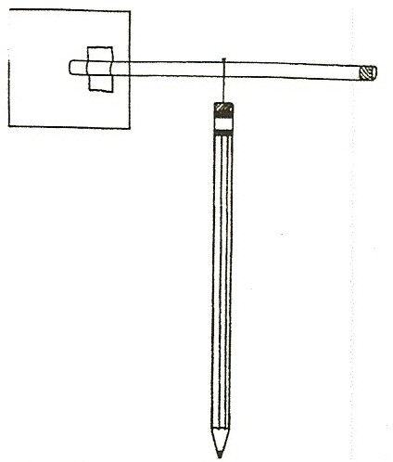
Students know how to use simple tools (e.g., thermometer, wind vane) to measure weather conditions and record changes from day to day and across the seasons.

Students know solids, liquids, and gases have different properties.

Students will describe the relative position of objects by using two references (e.g., above & next to, below & left of).

KEY WORDS:
WIND: The direction the wind comes from and its speed help predict the weather. Wind blows from high pressure to low pressure. On the ground, winds blow from cool places to warm places (from the cooler ocean to the warm beach on a summer’s day) A rapid increase in wind often means approaching rain, snow or thunderstorms.

THE COMPASS: Indicates magnetic north, not geographic north. In Southern California, geographic north is about 14° west of magnetic north. Remove all magnets from the area before using the compass to find direction.

ANEMOMETER:
A weather instrument that measures the wind’s speed.

MATERIALS:
1 compass
3” x 5” cards straws
pins
red permanent marker tape and scissors

EXPLORE:

WHERE IS THE WIND COMING FROM?
FINDING THE WIND DIRECITON USING A WIND VANE.
- Have each student make a wind vane. Cut a 1” slit in one end of a straw.
Cut 3” x 5” index cards in half. Insert the ‘half’ card in the straw slit and tape it to the straw to make a tail.

Color the other end of the straw red or push a small piece of red paper or clay into the straw.
Balance the straw on a finger. Push a pin through the point where the straw balances. (Use upper grade student helpers to make these.) Push the pin into the eraser on a pencil. The straw must rotate easily on the pin. (Make the hole a little bigger, if necessary.)

- Blow on your wind vane. Which side points to where the ‘wind’ is coming from? (The colored end.) The wind pushes the larger end (tail) away and thus the wind vane points into the wind.

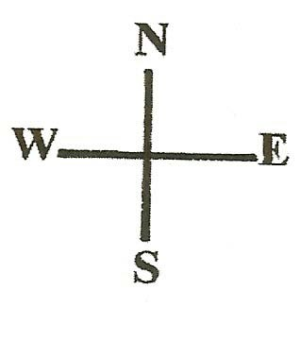
- Usually wind coming from
the north means cold weather (e.g., Alaskan cold front), the south means heat,
the east means rain,
the west means clearing.
Winds from the desert (e.g., Santa Ana winds in Los Angeles) brings hotter temperatures.

- Take the wind vanes and the compass to the playground on a windy day. You need an open area.
Put the compass the cement and use chalk to mark the directions north-south-east-west on the cement.
Have the students hold their wind vanes high to find out where the wind is blowing from. Have all the students point to where the wind comes from and check their understanding of how to use the wind vane.

- Have students describe where the wind vane points, using 2 references. (e.g., It points to the North and away from me.) Write the direction the wind is coming from on the board.

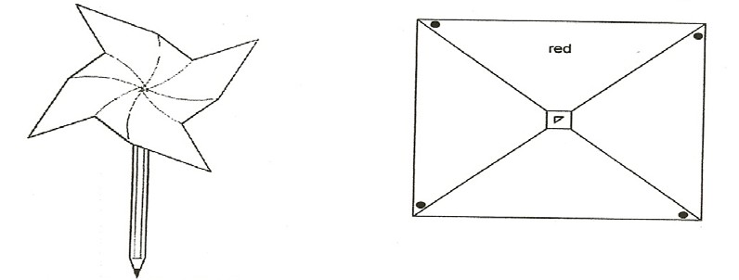

MATERIALS:
1 Pinwheel worksheet
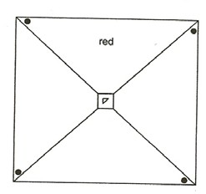
1 new pencil with eraser (flat end—not sharpened) 1 pin

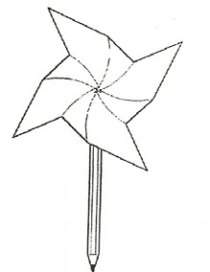
MAKING PINWHEEL ANEMOMETERS
SAFETY: Use new pencils that are not sharpened.
Have the students make pinwheels with the teacher as a directed activity.
(Teacher makes a sample to practice before this lesson.) Xerox the pattern on the work sheet.
Cut out the large square and color one section red, as indicated.
Cut on the 4 diagonal lines, but do not cut the small middle square. Push a pin through one corner dot, then the next dot, until the 4 dotted corners are stuck through the pin. Stick the pin through the center triangle and into a pencil with an eraser. Blow on your pinwheel. How can you make it go faster? (For more wind speed, blow harder.)

MEASURING AND COMPARING WIND SPEED
Take the pinwheel outside.
Run with it to see how fast you can make it go.
Hold it in the wind and count how many times it goes around in one minute. (The teacher can say start and stop.)
Start with the red piece pointing up and count each time it goes around and points ‘up’. Have all students report the number of times it goes around and record the ‘average’ number of times. Take a count on each windy day and compare wind speeds.

THE BEAUFORT WIND SCALE
A scale from 1 to 12 that helps determine wind speed by observing the effect of the wind on trees, rising smoke, etc. Use this chart on a very windy day to estimate wind speed in miles per hour. (chart is at the end of this section.)

KEY WORDS:

WIND:
The wind carries the weather from one place to another. When air is heated unevenly, air currents called wind result. Hot air rises and cold air rushes in to fill the space, creating wind. This happens during the day at the beach. The land heats faster than the water; thus hot air rises over the land and cooler air form the ocean rushes in causing a breeze.

TORNADOES:
They usually form when there are thunderstorms. Warm air rises quickly, causing winds to rotate violently. The tornado appears dark due to the large amount of water in it. The water drops do not allow light to pass through them.
The strong spiral winds smash everything in their path, uprooting trees and carrying cars for miles.

NOTE:
Paper dots from a hole punch can be added to the tornado tube to illustrate how objects fly around in the tornado and are thrown out in all directions by the force. Small houses or markers from a Monopoly® set can also be used.

MATERIALS:
tornado tube connector 2 two-liter soda bottles hole punch dots
food coloring

DEMONSTRATE:

TORNADOES ARE SPIRAL WINDS
HOW DOES AIR MOVE IN A TORNADO?

- Fill a 2-liter clear soda bottle ½ full with water.
(Food coloring and dots can be added-see note above.)
Place the plastic tornado connector tube on the bottle and invert a second empty bottle over it, connecting the tube.

- Flip the bottles so the bottle with water is on top. Note that the water stays in the top bottle. (Because there is air filling the bottom bottle.)
Swirl the top bottle in a circular motion and a spinning tornado of water forms in the top bottle. Air from the bottom bottle rushes up through the tornado from the bottom, allowing the water to fall into the bottom bottle.

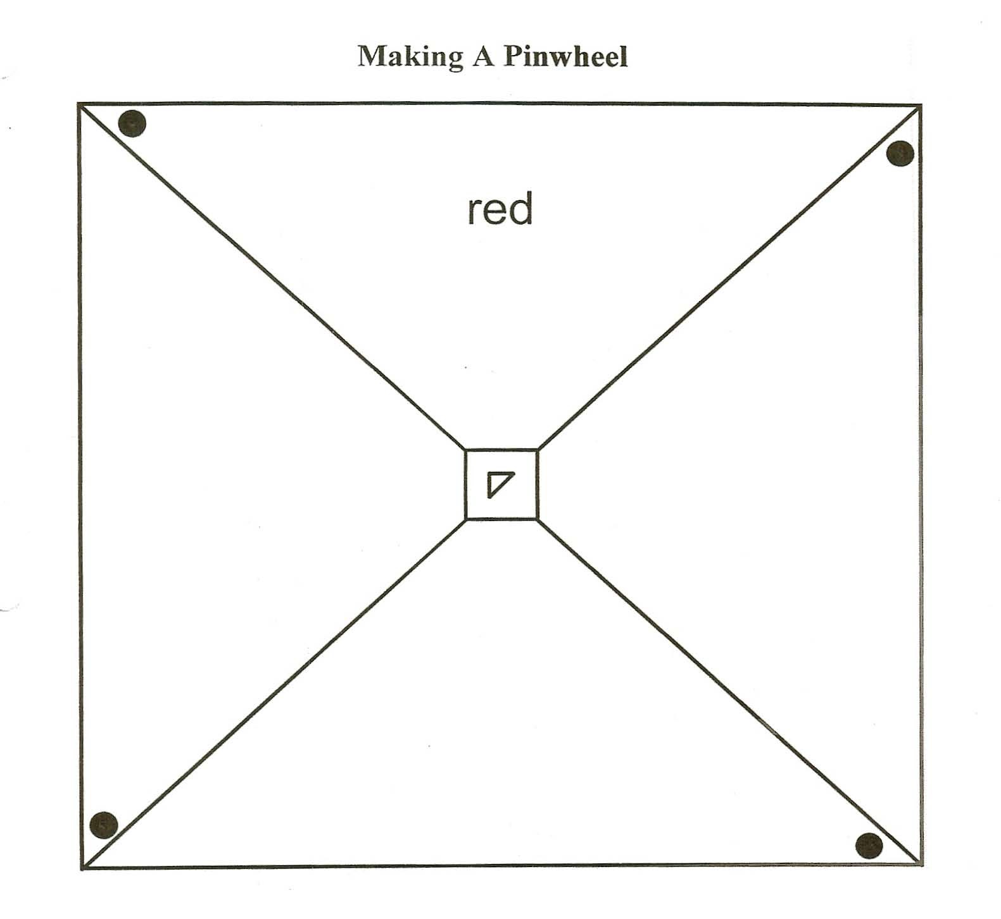

THE BEAUFORT SCALE INDICATES WIND SPEED

This scale helps estimate the speed of the wind by observing how it interacts with nature. Use this with the pinwheels to determine wind speed. When using the pinwheels, students will decide, through observation, if the wind is slow, medium, fast or very fast. The weatherman uses an anemometer that spins like the pinwheel to determine wind speed.

# description wind speed
0 | CALM | smoke goes straight up | 0-1 mph
1 | LIGHT AIR | smoke drifts | 1-3 mph
2 | LIGHT BREEZE | leaves rustle, blows a light flag | 4-7 mph
3 | GENTLE BREEZE | leaves move constantly | 8-12 mph
4 | MODERATE BREEZE | flags flap, twigs move | 13-18 mph
5 | FRESH BREEZE | small trees sway | 19-24 mph
6 | STRONG BREEZE | flags beat, large branches in motion | 25-31 mph
7 | MODERATE GALE | flags extended, whole trees in motion | 32-38 mph
8 | FRESH GALE | twigs break off trees, hard to walk | 39-46 mph
9 | STRONG GALE | awnings rip, slight damage to houses | 47-54 mph
10 | WHOLE GALE | trees uprooted, much damage to houses | 55-63 mph
11 | STORM | widespread damage | 64-75 mph
12 | HURRICANE | excessive damage | 75 or more

