DETECTIVE LAB

SECTION 8: EXAMINING FABRICS
From Science in a Nutshell

OBJECTIVE:

Westminster College

To analyze and compare a variety of different fabrics and fibers.

MATERIALS:
plastic bag assorted fabrics
fabric samples: sheets, rags, denim, sock, towels Journal Page for Activity 8
hand lens
black water soluble marker pocket microscope
scrap paper scissors microscope slide tape measure

BACKGROUND:
In the previous activity, were you surprised at how much more detail you could see in a person’s handwriting when you used the microscope? A microscope is used to magnify an object many times its original size so that you can see details you cannot see with the naked eye, or even with a hand lens. A good microscope is one of the most helpful tools in a police crime laboratory.

Fabrics are made by weaving threads or yarns together into special patterns. Sometimes, pieces of fabric found at a crime scene can be matched with the clothing that they came from.

In this activity, you will use your microscope to examine the weave of a mystery fabric and then try to match it with the fabric sample that it was cut from, just like a detective does.

EXPERIMENT:
- Use the scissors to cut a 1 in. x 1 in. square from each fabric sample. Label the empty bag “Mystery Fabrics” and put these small samples in it. Ask your partner to select one of the squares of fabric. This is your Mystery Fabric.

- Use the pocket microscope to examine the Mystery Fabric. Be sure to examine both sides of the fabric. Is there any difference in the weave when viewed from the front and then the back?

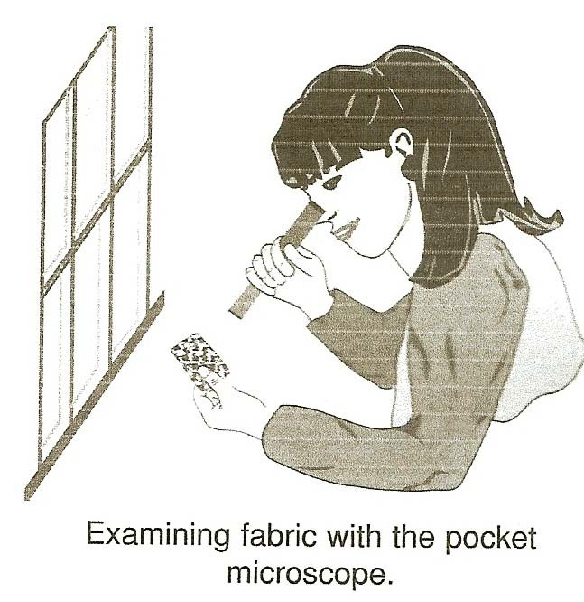
EXAMINING FABRICS

- In the circles on the Journal page for Activity 8, draw a picture of how each side of the mystery fabric appears when you view it through the microscope.

- Use a marker from the kit to label the fabric samples A through F. Use the microscope to examine each sample. Observe the size and spacing of the fibers. What is the pattern formed by the fibers?

- Which fabric samples do you think matches the mystery fabric? How are they alike? In your journal, list the similarities between the mystery fabric and the fabric that most closely matches it.

- Use the microscope to examine the ink labels A through F on the fabric samples. How does the ink act on the fabric samples? What similarities and differences do you notice?

- Use the microscope to examine the fabric in your own clothes, drapes, and furniture coverings. Compare the way the threads are woven. Look for different kinds of weaves.

- Add to your collection of fabric samples. Ask permission from an adult to collect old clothing and rags, such as an old sock, piece of old towel, denim, T-shirt, or a sheet. Examine these fabrics under the microscope.

- Can you see spaces between the fibers on every fabric? A loose weave has more space between threads than a tight weave. Find an example of a loose weave and an example of a tight weave.

EXAMINING FABRICS

- If you look at a knitted fabric (such as a sock or sweater) under a microscope, you will most likely see knots in the threads. Find examples of knitted fabrics.

IN A NUTSHELL:
- The pocket microscope works best when used in a bright light, such as near a sunny window or under a bright desk lamp.
- A microscope is used to match tiny details found on samples of fabrics.

CRACKING THE NUT:
Ask your partner to tear a piece of scrap paper into several pieces. Use the microscope to reassemble the sheet of paper correctly.

