POLLUTION

SECTION 8-THE ACID TEST
From Hands on Science by Linda Poore, 2003.

OBJECTIVES

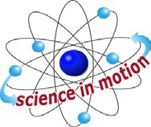
Westminster College

Students continue to explore the variations among water samples by classifying them according to how acidic or alkaline they are.

Students will use pH paper to determine the acidity of alkalinity of six different water samples.
Students will discuss how the acidity of alkalinity of water affects the plants and animals that use it.

MATERIALS
For Each Student For Each Team (4)
Activity Sheet 5 2 calibrated 1oz cups 1 marker
6 pH paper strips
4 water samples (from Activity 5)
For the Class Baking soda 2 eyedroppers
1 petri dish (top and bottom) 3 pH paper strips
1 pitcher
1 roll masking tape 1 VCR/monitor Pollution video
1 bottle vinegar
1 bottle distilled water tap water

PREPARATION
- Make a copy of Activity Sheet 5 for each student.
- Place the bottle of distilled water, a pitcher of tap water, and the students’ water sample jars form activity 5 at the water distribution station. Label the containers of distilled and tap water. Arrange the jars by team, if possible.
- Set up a demonstration area that contains the following items: a bottle of vinegar, a container of baking soda, one petri dish (both top and bottom), two eyedroppers, three strips of pH paper, and the bottle containing the pH paper.
- Each team of students will need six strips of pH paper, two calibrated cups, two pieces of masking tape, 5 mL of distilled water, 5 mL of tap water, a marker and the four water samples left over from Activity 5. The students will need access to the label on the pH paper bottle throughout this activity.

- Part Two of the Pollution video is titled “Water Pollution.” Show Part Two to the class at the end of this activity. Alternatively, you may show Part Two of the video at the beginning of Activity 9.

BACKGROUND INFORMATION
Just as water sample differ in hardness so do they differ in acidity or alkalinity. The term pH, which stands for hydrogen power, is a measure of a substance’s acidity or alkalinity. An excess of hydrogen ions causes a substance to be acidic. A deficiency of hydrogen ions causes a substance to be alkaline. A substance contains “just the right amount” of hydrogen ions is said to be neutral.

The pH scale, which ranges from 0 to 14, is used to indicate how acidic or alkaline substance is. According to this scale, 0 to 6 indicated an acid, with 0 being the strongest acid and 6 the weakest; 8 to 14 indicates an alkali, with 8 being the weakest alkali and 14 the strongest. A pH of 7 is considered neutral. Most plants and animals cannot tolerate contact with a substance that has a pH lower than 5 or greater than 9.

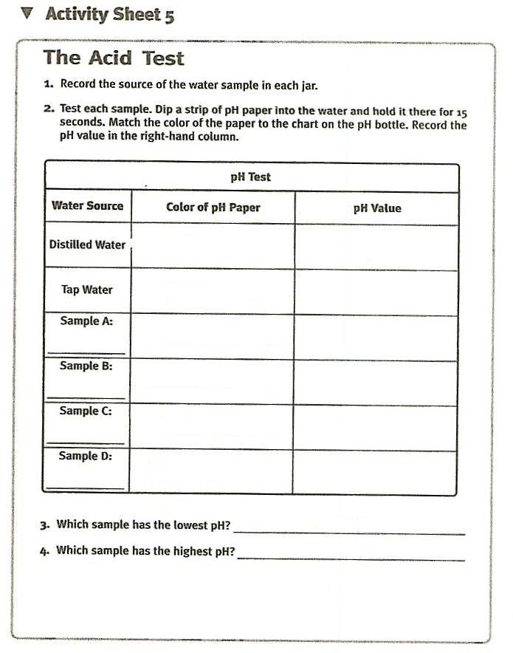

GUIDING THE ACTIVITY
- Explain to students that mineral content is only one of the many factors that can vary from one water sample to another. Tell the students that the water samples they obtained during Activity 5 can also vary in the degree of acidity or alkalinity.

Write pH on the board and tell students that pH is a measure of a substance’s acidity or alkalinity.

Draw the pH scale on the board and label it as shown below. Explain that a pH scale is a range of numbers from 0-14 showing the relative acidity and alkalinity of a substance. A ready of 0-6 indicated an acid; 8-14 indicated an alkali; and 7 is considered neutral.
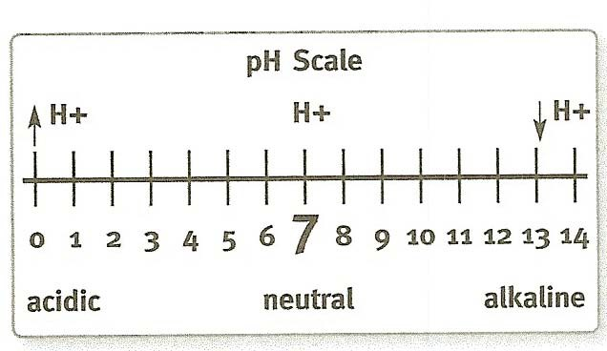

Explain that the terms acid and alkali refer to a solution’s chemical composition. Acids have a surplus of the chemical H+, while alkalis have a deficiency. When the two substances are combined in the right proportions, they form a neutral substance, a substance that is neither acidic nor alkaline.

A neutral solution will not harm an organism. If an acidic solution, on the other hand, touches an organism, the excess H+s cause a chemical reaction with the skin. If the acid is strong enough (has enough H+s), the skin can be burned.
Likewise, if an organism comes in contact with an alkaline solution, another chemical reaction occurs, and the skin can be burned as well. Many organisms are sensitive to even the smallest change in pH.

Ask, Do you think that the chemical H+ is related somehow to the “H” in “pH”?
Students should respond that they are probably related.

Write the word hydrogen on the board and explain that the chemical H+ refers to a special form of the element hydrogen. Explain also that the pH stands for hydrogen power. A pH scale, therefore, measures the amount of this special form of hydrogen present in a substance. The more H+ present, the more acidic the

substance and the lower the pH value. The less H+ present, the more alkaline the substance and the higher the pH value.

- Explain that pH paper is used to “read” the pH of a substance. Demonstrate how the pH paper works. Put an eyedropperful of vinegar into a petri dish, dip a strip of pH paper into the vinegar, and hold it there for 15 seconds. Ask a student to match the color of the pH paper with the chart on the bottle label and to read the corresponding pH value aloud.
The paper will have turned a deep orange color, indicating and acid with a pH lower range of the scale.

- Next, mix a pinch of baking soda with an eyedropperful of distilled water in the second petri dish (the lid of the first). Dip a clean strip of pH paper into the solution. Invite another student to match the color of the paper with the chart on the label and to read the corresponding pH value aloud.
The paper will have turned green, indicating an alkali with a pH in the upper range of the scale.

Ask, What do you predict will occur if I mix together the contents of these two petri dishes?
Students may realize that combining the two may produce a neutral solution.

- Test the students’ predictions by pouring the vinegar into the baking-soda solution, mixing, and using pH paper to test the new solution. Invite a student to match the color of the pH paper to the chart on the bottle and to read the corresponding pH value aloud.
The papers should have turned yellow-green, indicating a neutral solution with a pH value in the mid range of the scale. If you do not get a reading of 7 on the pH scale, you may need to add a little more vinegar or baking soda to the new solution until you do.

- Distribute a copy of Activity Sheet 5 to each student. Divide the class into teams of four (the same configurations as Activity 5) and distribute six strips of pH paper, two calibrated cups, a marker, and two pieces of masking tape to each team.

Invite one member from each team to bring the two calibrated cups to the water distribution table. Pour about 5mL of distilled water into one of about 5mL of tap water into the other. The cups should be labeled accordingly.

Have another member form each team come up to the distribution station and retrieve his or her team’s four water sample jars. Tell the students to fill in the source of Samples A-D in the chart on Activity Sheet 5.

Instruct the teams to use the strips of pH paper to test the acidity/alkalinity of their six water samples. Tell them to share the pH paper bottle so that each team has an opportunity to compare its test strips to the chart on the bottle label.
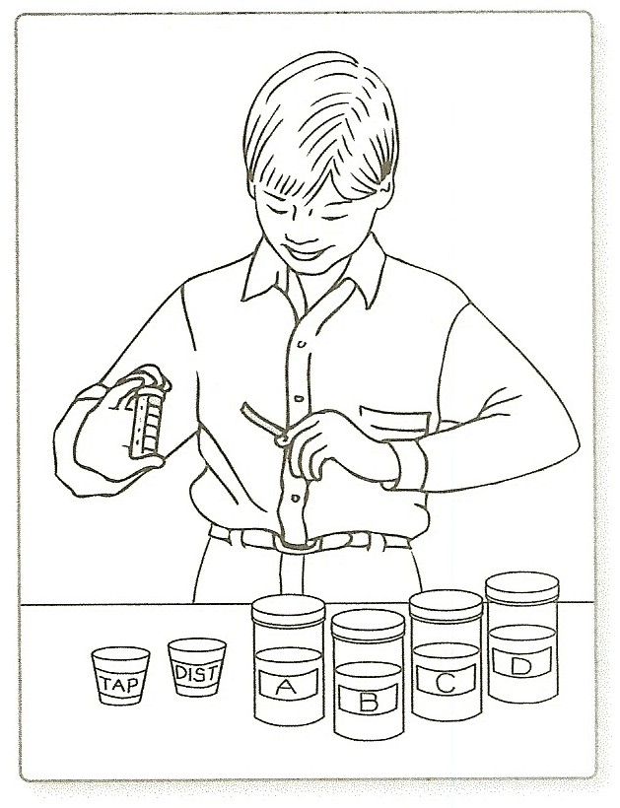
- After the teams have finished testing all six samples, ask Which water sample has the lowest pH? Which has the highest pH?
There should not be the range of color that students witnessed in the demonstration. Instead, the strips of pH paper will most likely turn anywhere from light to dark orange, depending on the sample. Distilled water and tap water will probably be yellow.

Ask, What do you think would happen if the pH of the water in a pond or river changed dramatically?
Plants and animal using the water might not survive.

Explain that while most animal and plant life fare best in neutral or almost neutral water, some organisms prefer slightly acidic or slightly alkaline conditions. (Seawater, for example, usually tests above 8 on the pH scale.)
Point out that natural water conditions can vary somewhat over time. That variability can affect the organisms that use the water.

Show part two of the Pollution video, titled “Water Pollution” to the class after completing the activity.

