LIGHT

SECTION 9- COLORS, RAINBOW AND BLUE SKIES
From Hands on Science by Linda Poore, 2003.

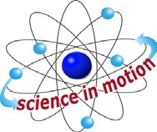
Westminster College

STANDARDS:
Students know an object is seen when light traveling from an object enters our eye.

Students know the color of light striking an object affects the way the object is seen.

Students will differentiate evidence from opinion, and know that scientists do not rely on claims or conclusions unless they are backed by observations that can be confirmed.

NOTE:
White light is produced by mixture of colors. The order of colors in the spectrum of white light is from red to violet, R.O.Y.G.B.I.V.: red, orange, yellow, green, blue, indigo, violet.

IN ADVANCE:
Arrange to have a dark room for this activity. If this is impossible, have the students sit under their desks to make it as dark as possible.

MATERIALS:
For Each Pair: For the Teacher:
- flashlight overhead projector
- diffraction grating glasses glass of water
red and blue colored plastics piece of black paper, 4” x 8”

KEY WORDS:

DIFFRACTION:
When a light beam passes through a narrow slit, it bends and separates. The narrower the slit, the more light separates, letting you see all the colors that are mixed together to make white light.

NOTE:
Diffraction gratings have over 13,000 lines, or parallel grooves, that act as ridges and affect the direction of the light as it passes through. These lines diffract or spread the light to produce a spectrum. AVOID FINGERPRINTS – DO NOT TOUCH GRATING ‘LENSES’! If you need more glasses, cut each in half and use them as monocles.

DEMONSTRATE:

DIFFRACTION SPREADS OUT LIGHT
Fold the black paper in half. Cut a 1” long thin slit at the fold. (see picture)
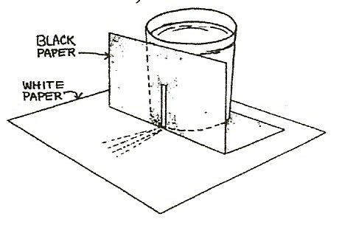
Put a glass of water in a sunny window or go outside and put it on a table. Put a piece of white paper under the glass and put the black slit paper under and in front of the glass. The sunlight goes through the glass and a small focused beam goes through the slit and lands on the paper, diffracting or separating the white light so you see the rainbow of colors. [You can also put the plastic slit card (without the colored acetate) from the kit between the black paper and jar to make a distinct slit of light.]

EXPLORE:

DIFFRACTION: OBSERVING THE SPECTRUM OF LIGHT
Pass out flashlights and diffraction grating glasses.
Have students look through diffraction glasses at the
fluorescent room lights. Discuss the colors they see. (The spectrum) Turn off the lights. Turn on the light from the overhead projector. (The colors of the spectrum are brighter from this light.)

SUNLIGHT AND DIFFRACTION GRATINGS
Go outside. Look at reflected sunlight.
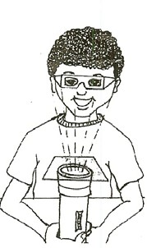
Remind students to never look directly at the Sun. What colors do you see? (The spectrum of sunlight)
Look at a tree. You may see thousands of lines close together that show the grooves on the grating that bend the light. Look at a shiny object, like a chrome car bumper reflecting sunlight. The spectrum from the Sun is brighter when reflected off chrome.)

FLASHLIGHTS AND DIFFRACTION GRATING GLASSES
Darken the room. Have students:
Hold the glasses above a flashlight and see the spectrum. Write the colors they see in order.
Hold 2 glasses together and turn them to get new effects. Place the glasses above the flashlight and look at the ceiling.

DISCUSS
The spectrum is the same as that of the Sun, fluorescent, and projector light as they are all white light.

DIFFRACTION GLASSES WITH COLORED LIGHT
Pass out the colored plastic pieces. (blue and red) Predict what spectrum will be emitted from a red light. Turn off the room lights.

Place the flashlight’s on the desks so it shines on the ceiling. Put the red plastic over the light. Wear the diffraction glasses. What colors can you see? (mostly red or red only)
Try the blue plastic. Try other colors using construction paper.

EXTENSION:

SPECTRUM ANALYSIS
Colors of the spectrum are always in the same order, red to violet (R.O.Y.G.B.I.V.) but some colors will be missing for different substances. By burning a chemical, you can see its spectrum. The spectrum of each chemical is unique; it has different amounts of each color and may lack some colors. Police do a spectrum analysis using a computer to discover the identity of a drug. Also, scientists can tell which star they are looking at by its spectrum, which differs from the spectrum of all other stars!

MATERIALS:
For Each Pair: For the Teacher:
1 flashlight overhead projector
1 cup water ¼ cup nonfat milk, 1 dropper

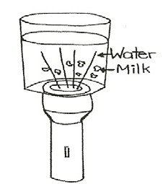
NOTE:
Darken Room. If the room cannot be made dark, have students hold their cup of water 3” above a white piece of paper and shine the flashlight down through the liquid and toward the paper.

EXPLORE :

WHY IS THE SKY BLUE AND THE SUNSET RED?
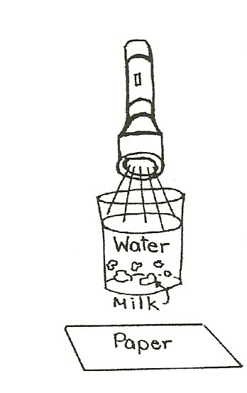
- Turn on the flashlight and stand it on a desk so the light shines toward the ceiling.
Place a cup of water on top of the flashlight. (Hold the flashlight and cup so it does not fall.)
Observe the white light from the side and top of the cup. What color is the light on the ceiling? (white)
Predict what color the water will be with drops of nonfat milk added.

- The teacher puts 10 or 20 drops of nonfat milk into each cup. Observe. Swirl to stir gently if necessary.
What color is the water in the cup? (blue)
(look at a cup across the room if you do not see blue in your cup.) Look into the cup of water at the light bulb.
What color is the light now? (yellow)

- Take the cup off the flashlight. Hold it 3” above a white piece of paper and shine the light into the cup.
What color is the light on the white paper. (yellow?) What color is the liquid? (blue)

- Sprinkle more drops into each cup and observe the color change. The color of the light will change from white to yellow to orange to reddish, depending on the amount of milk in the cup.
The Sun turns orange or red at sunset because the blue color of the light has been scattered in the sky by dust and gasses and thus is not in the spectrum. Continue adding a few drops of milk until the light is totally blocked by the milk and the light ‘disappears.’

WHY DOES THE COLOR CHANGE?
White light has all the colors of the spectrum.
Blue light is scattered from the spectrum by tiny particles of milk floating in the water, thus the milk looks blue. Therefore only the red end of the spectrum of light leaves the cup and the ceiling looks red or orange. The flashlight bulb looks red or orange if you look down into the cup of water sitting on the flashlight. (With too much milk, the particles block all the light and reflect it back into the flashlight.

THE SKY:
Tiny dust particles and air molecules in the sky scatter blue light from the spectrum of light, making the sky appear blue. As you look across the horizon through the atmosphere, the sunset appears red since the blue has been scattered (removed) from the spectrum. At noon when the Sun is overhead there is less atmosphere between you and space, so the Sun appears white or yellow as not as much blue light is removed. (The atmosphere is 20 miles thick.)

