DETECTIVE LAB

SECTION 9: EXAMINING POWDERS
From Science in a Nutshell

OBJECTIVE:
To analyze and compare mystery powders.

Westminster College

MATERIALS:
aluminum foil baking soda body powder
non-dairy creamer paper cup
Journal page for Activity 9 pocket microscope
Post-it Notes
black construction paper pencil
pipette
powders: white (such as flour, borax, baking powder, powdered sugar, laundry detergent, Epson salts, Plaster of Paris)
salt scissors sugar
artificial sweetener toothpicks
vinegar water

BACKGROUND:
Scientists in crime laboratories use microscopes to examine unknown powders and soils found at crime scenes. They also try to match soil samples collected from the bottoms of people’s shoes with soil from the crime scene to determine whether that shoe, and probably the person who wears it, may have been at the scene of the crime.

Special chemicals, called indicators, help to identify unknown materials. Indicators are chemicals that react a known way when combined with particular substances.

For example, vinegar bubbles and fizzes when it is mixed with baking soda; sugar and salt will dissolve in water; and flour will form a paste when mixed with water.

EXAMINING POWDERS

In this activity, you will inspect and identify different white powders by using a microscope and indicators.

EXPERIMENT:
- Use a pencil to write Body Powder on one of the Post-Its. Put this label on the top left corner of a sheet of black construction paper.

- Put a small amount of body powder below the label. Spread the powder out with a toothpick.

- Use the pocket microscope to examine the body powder. What shape are the particles? Are all the particles the same shape? Are they shiny or dull? Describe the appearance of the powder on the Journal page for Activity 9.

- Make labels for the other white powders in the kit: artificial sweetener, salt, sugar and non-dairy creamer. Put these labels on pieces of construction paper.

- Place a sample of each powder near its label. Avoid mixing the powders. Examine all the powders and describe them in your journal.

- If you can, examine other white powders that you can find. But first, ask an adult whether these powders are safe for you to use.

- Tear off a sheet of aluminum foil and make another set of labels for the powders. Place the labels and small amounts of each white powder on the aluminum foil.

- Use the pipette to add a few drops of water to each powder. Stir each powder with a different toothpick. What do you observe? Record in your journal how each powder reacts with water.
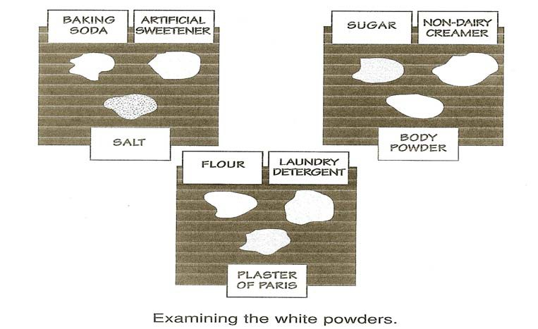

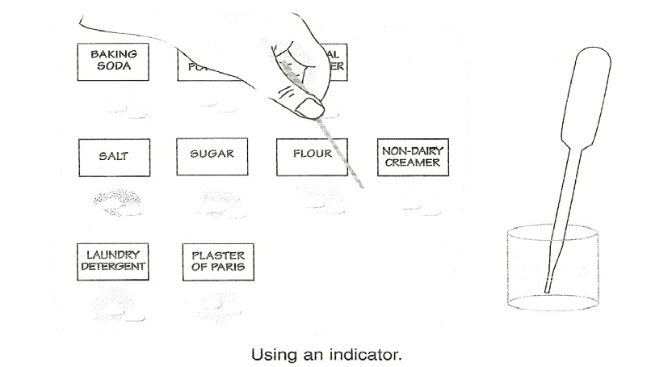
EXAMINING POWDERS

- Repeat steps 7 and 8. This time add a few drops of vinegar to each powder. In the journal, record how each powder reacts with the vinegar. Rinse the eyedropper with water before you use it again.

- Clean off one of the sheets of black construction paper. Write Mystery Powder on a Post-It. Attach it to the paper.

- Ask you partner to select one of the powders and to place a small sample on the paper. Ask your partner not to tell you which powder he or she selected.

- Examine the mystery powder using the microscope and perform any additional tests needed to identify it correctly. After you have finished investigating, write the name of the mystery powder in your journal.

- Tell your partner what you think the mystery powder is, and ask if you are correct. Now select a mystery powder for your partner to identify.

SAFETY NUT:
Be careful not to get any vinegar or powder in your eyes.

IN A NUTSHELL:
To identify unknown substances, scientists often use indicators that react in a certain way when combined with particular materials.

CRACKING THE NUT:
Scrape some dirt off the bottom of a friend’s shoe, and examine it under the microscope. Can you tell where your friend has walked—a grassy area, dry bare area, baseball field, beach or construction site?

