SOUND VIBRATIONS

SECTION 9: SOUND BEHAVIOR
From Science in a Nutshell

OBJECTIVE:

Westminster College

To compare how sounds travel through solids, liquids and gases.

MATERIALS:
bowl of water plastic funnel
Journal page for Activity 9 rubber band
wooden table/desk 60-cm plastic tubing tuning fork

BACKGROUND:
In this activity, you will explore the use of various materials in which sound waves travel. Do you think the material will affect the sound in any way? You will test a gas, a liquid, and a solid to discover whether sounds travel better through one material than another.

EXPERIMENT:
- Strike the tuning fork against the heel of your shoe and hold it about 3 inches from your ear. Listen carefully to the sound of the tuning fork as the sound waves travel through air (a gas).
- Add water to an empty bowl (or the empty Nutshell box) until it is about half-full.
- Have your partner strike a tuning fork against the heel of a shoe and then place the ends of both vibrating tines in the water, not touching the bowl.
- Can you hear the sound of the tuning fork when the tines are in the water?
- Make a stethoscope as you did in Activity 8, Step 6.
- 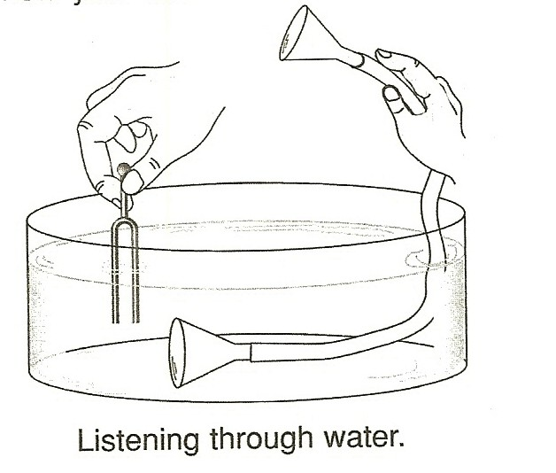Place one end of the stethoscope in a bowl filled with water as shown below. Hold the opposite end of the tube near your ear.

SOUND BEHAVIOR

- Ask your partner to strike the tuning fork and put the ends of both vibrating tines in the water. Listen carefully to the sound of the tuning fork after the sound waves travel through the water (liquid).
- Compare the sounds you hear when the vibrating tuning fork is in the air with the sounds when it is the water. On the Journal page for Activity 9, describe your observations.
- The next time you are taking a bath, tap your finger against the side of the bathtub. Then, place one ear under water and tap again.
- Do you hear a louder and clearer sound when the sound waves travel through air or through water? Do sounds travel better in air or in water?
- Put one ear flat against wooden table or desk. Have your partner strike the tuning fork against the heel of a shoe and hold the handle against the table or desk. Listen carefully as the sound waves travel through the wood (a solid).
- When do you hear the louder, clearer sound? Does sound travel better through the air or through the solid wood? Record your answers in your journal.
- Plan and conduct an experiment to determine whether sounds travel better through wood or through metal.

IN A NUTSHELL:
In general, sounds travel better through a solid than through a liquid and better through a liquid than through a gas.

CRACKING THE NUT:
Why are so many people bothered by ordinary sounds that travel through the metal pipes in their homes. Why do these sounds seem to be so loud?

