PREPARING SAMPLES FOR OTHER LAB ANALYSES
From: www.soil.gsfc.nasa.gov/index.html and www.globe.gov

- Put the #10 sieve (2 mm openings) on a large piece of paper and pour one sample into the sieve. Put on rubber gloves so the acids in your skin don't contaminate the soil pH measurement.

- Carefully push the dried soil material through the mesh onto the paper. Be careful not to bend the wire mesh by forcing the soil through. Remove the rocks (and other pieces of debris) that stay on top of the sieve and discard. Save the sieved soil from each sample for the other lab analyses.

Westminster College

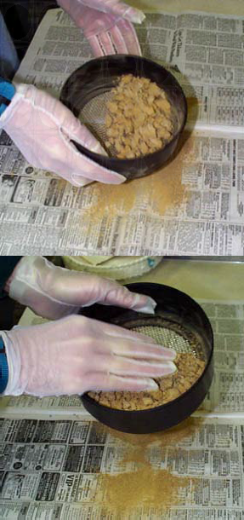
Note: If no sieve is available, carefully remove the rocks by hand.

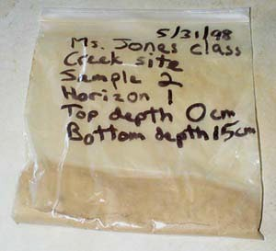
- Transfer the rock-free, dry soil from the paper under the sieve into new, clean, dry plastic bags or containers. Seal the containers, and label them the same way that they were labeled in the field (horizon number, top and bottom depth, date, site name, site location, etc.). This is the soil that will be used for the other lab analyses.

On the label, include: Site name, Sample number, Horizon number, Top depth, Bottom depth, Date

- Store these samples in a safe, dry place until they are used.

PARTICLE SIZE DISTRIBUTION
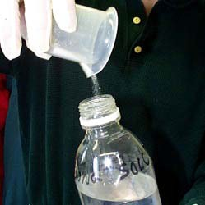
- Prepare the dispersing solution by mixing 50 g of Sodium Hexametaphosphate (or other soil dispersing agent) in 1 L of distilled water. Stir or shake until the dispersing agent has all dissolved.

- Weigh 25 g of dried, sieved soil and pour it into a 250 mL or larger beaker. Add 100 mL of the dispersing solution and about 50 mL of distilled water to the beaker. Stir vigorously with a spoon or stirring rod for at least one minute. Be sure the soil is thoroughly mixed and does not stick to the bottom of the beaker. Do not let any of the soil suspension spill out the top.

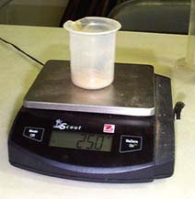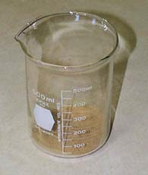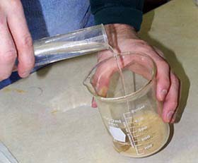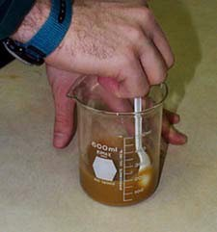
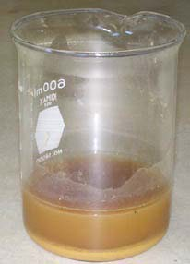
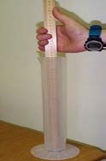
- When the soil and dispersing solution are thoroughly mixed, set the beaker aside in a safe place and allow it to sit for roughly 24 hours (for this step, the soil/dispersing solution mixture can sit over the weekend until the next class).

- Measure the distance between the 500 mL mark and the base of the cylinder. (You can place the measuring stick inside the cylinder to get this measurement.).

- Read the temperature at which your hydrometer has been calibrated (such as 15.6° C [60° F] 20° C). This temperature can be found on the body of the hydrometer.

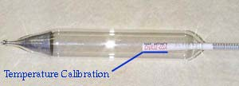
Record both the distance and the temperature on the Particle-Size Distribution Data Work Sheet.

- At the next class, stir the suspension in the beaker again, and pour it into a 500 mL graduated cylinder. Use a squirt bottle to rinse out the beaker and add this to the soil mixture in the cylinder.

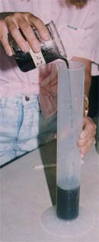

- Add enough water to fill the cylinder to the 500 mL mark.

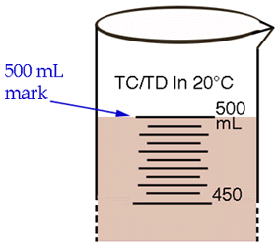

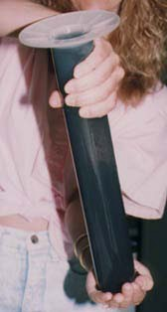
- Securely cover the top of the cylinder using plastic wrap or other secure cover.

- Mix vigorously by rotating the covered cylinder hand-over-hand at least 10 times. Be sure the soil is thoroughly mixed in the solution and does not stick to the bottom of the cylinder. Try not to let any of the suspension leak out the top.

- Gently set the cylinder down in a safe place, and immediately begin timing with a stop watch or clock with a second hand.

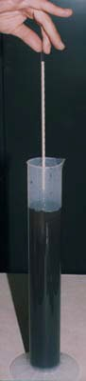
- After 1 minute, carefully lower the hydrometer into the cylinder so it floats in the suspension. Steady the hydrometer to keep it from bobbing up and down.

- At exactly 2 minutes after the cylinder was set down, read the line on the hydrometer that is closest to the surface of the soil suspension and record your result on the Particle-Size Distribution Data Work Sheet.
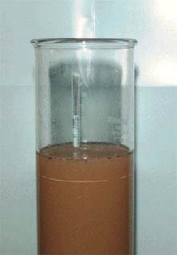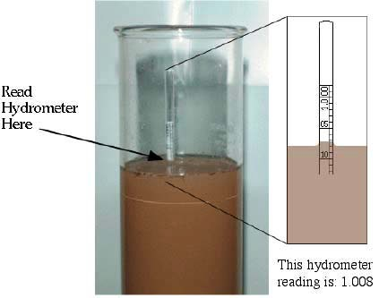

- Remove the hydrometer, rinse it, dry it, and gently put it down in a safe place.

- Place the thermometer into the soil suspension for about 1 minute. At the end of 1 minute, remove the thermometer from the suspension, read the temperature, and record the result on the Particle-Size Distribution Data Work Sheet. 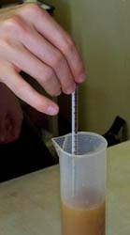
- Take another hydrometer reading in the undisturbed cylinder at 12 minutes. Place the hydrometer carefully in the suspension about 30 seconds before making the reading to allow it to settle.

- Take and record another temperature reading for the suspension.

- Rinse the hydrometer and thermometer off when they have been removed from the suspension and dry them.

- Record these results on the Particle-Size Distribution Data Work Sheet.

- Leave the cylinder undisturbed for 24 hours (or until the beginning of the same class period the next day).

- Take another hydrometer and temperature reading at 24 hours. (Note: this time period is critical and should not be longer than 24 hours). Record the results on the Particle-Size Distribution Data Work Sheet.

- Discard the soil suspension by pouring it into a special pail and spill the contents outside in a place for discarding soil materials. Do not pour the suspension down the sink!

- Carefully rinse and dry the hydrometer, thermometer, beakers, and cylinders, and repeat the above steps two more times for the same horizon so that you have a total of three sets of results for each sample.

- Repeat this procedure for each soil sample from every horizon.

MAKING SENSE OF PARTICLE-SIZE DISTRIBUTION

(Note: Refer to the Learning Activity in the 1997 Supplement to the GLOBE Teacher's Guide)

The amount of each size particle (sand, silt, or clay) in the soil is called the particle-size distribution. Knowing the particle-size distribution of a soil sample helps to understand many soil properties such as how much water, heat, and nutrients the soil will hold, how fast water and heat will move through the soil, and what kind of structure, bulk density and consistence the soil will have.

Sand, silt, and clay are the three particle sizes of mineral material found in soils. The amount of each of these is called the "particle-size distribution" and the way it feels is called the "soil texture."

Sand is the largest sized particle, Silt is medium sized, and Clay is the smallest. Relative Size Comparison of Soil Particles
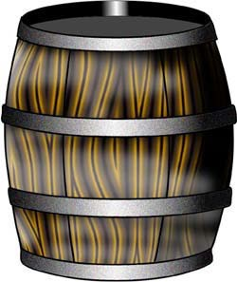
Barrel Plate Coin

Sand

Clay
Silt (feels sticky)
(feels floury)

(0.05 - 0.002 mm, USDA) (< 0.002 mm, USDA)
(0.02 - 0.002 mm, ISSS) (< 0.002 mm, ISSS)

(feels gritty) (2.00 - 0.05 mm, USDA)
(2.00 - 0.02 mm, ISSS)

There is disagreement in the scientific community about the exact size ranges of sand and silt. For GLOBE, we will measure sand and silt based on two different size definitions.

  - US Department of Agriculture (USDA) which defines the size of:

sand = 2.0 mm - 0.05 mm silt = 0.05 - 0.002 mm

  - The International Soil Science Society (ISSS) which defines the size of:

sand = 2.0 mm - 0.02 mm silt = 0.05 - 0.002 mm

Clays are the smallest particles and are defined (by both organizations) as being smaller than 0.002 mm.

Particles greater than 2.0 mm (sand size) are called stones or gravels and are not considered to be soil material.

Heavy, large particles settle first, so when a soil sample is stirred or shaken in a 500 mL cylinder, sand particles (according to the USDA definition) settle to the bottom of the cylinder after 2 minutes, while the clay and silt size particles stay in suspension.

After 12 minutes, the sand, according to the ISSS definition, has settled, leaving the clay and silt size particles in suspension.

After 24 hours, the silt size particles have settled, and only the clay stays in suspension to be recorded by the hydrometer.

Soil Particles Dispersed in Beaker

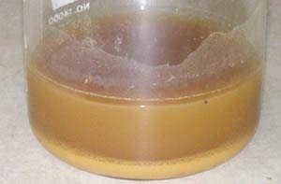

Soil Texture Class Calculation Worksheet (USDA)

Per USDA definition for sand

- 2 minute hydrometer reading

- 2 minute temperature reading °C

- Grams/L of soil (silt + clay) from table SOIL-L-1 g

- Temperature correction [0.36 x ( B - 20)] = g

- Per USDA Corrected silt and clay in suspension C + D = g

- Grams of soil (silt + clay) in 500mL (E x 0.5) = g

- Grams of sand in sample (25g — F _) = g

- Percent Sand [(G_ / 25) x 100] = %

Per ISSS definition for sand

- 12 minute hydrometer reading after 24 hours _

- 12 minute temperature reading °C

- Grams/L of soil (silt and clay) from table SOIL-L-1 g/L

- Temperature correction [0.36 x (J - 20°C)] = g

- Corrected silt and clay in suspension K + L = g

- Grams of soil (silt and clay) in 500mL (M x 0.5) = g

- Grams of sand 25g – N = g

- Percent sand [(O / 25) x 100]= %

24 hour calculations

- 24-hour hydrometer reading after 24 hours

- 24-hour temperature reading °C

- Grams/L of soil (clay) from table SOIL-L-1 g

- Temperature correction [0.36 x (R
- 20°C)] = g

- Corrected clay in suspension S
+ T = g

- Grams of clay in 500mL (U
x 0.5) = g

- percent of clay [(V
/ 25) x 100]= %

- Grams of silt (USDA) 25 – (G
+ V ) = g

- Percent of silt (USDA) [(X
/ 25) x 100]= %

- Grams of silt (ISSS) 25 – (O
+ V ) = g

AA. Percent of silt (ISSS) [(Z
/ 25) x 100]= %

