Soil Test Kit
A soil test is a process by which elements (phosphorus, potassium, calcium, magnesium, sodium, sulfur, manganese, copper and zinc) are

Westminster College

chemically removed from the soil and measured for their "plant available" content within the sample. The quantity of available nutrients in the sample determines the amount of fertilizer that is recommended. A soil test also measures soil pH, humic matter and exchangeable acidity. These analyses indicate whether lime is needed and, if so, how much to apply.

STANDARDS ADDRESSED
3.2.5.B Make and communicate observations and measurements to identify materials based on their properties.

OBJECTIVES
In this experiment, you will

- Use a Soil Testing Kit to measure the pH and nitrates, phosphates, and potassium levels in soil samples.
- Use the data collected to compare the samples.

MATERIALS
Soil Samples Soil Test Kit

pH Measurements
pH is a measure of how acidic or basic things are and is measured using a pH scale between 0 to 14, with acidic things having a pH between 0-7 and basic things having a pH from 7 to 14. For instance, lemon juice and battery acid are acidic and fall in the 0-7 range, whereas seawater and bleach are basic (also called "alkaline") and fall in the 7-14 pH range. Pure water is neutral, or 7 on the pH scale.

THE IMPORTANCE OF SOIL Ph

The pH of soil or more precisely the pH of the soil solution is very important because soil solution carries in it nutrients such as Nitrogen (N), Potassium (K), and Phosphorus (P) that plants need in specific amounts to grow, thrive, and fight off diseases.

If the pH of the soil solution is increased above 5.5, Nitrogen (in the form of nitrate) is made available to plants. Phosphorus, on the other hand, is available to plants when soil pH is between 6.0 and 7.0.

Certain bacteria help plants obtain N by converting atmospheric Nitrogen into a form of N that plants can use. These bacteria live in root nodules of legumes (like alfalfa and

soybeans) and function best when the pH of the plant they live in is growing in soil within an acceptable pH range.
For instance, alfalfa grows best in soils having a pH of 6.2 - 7.8, while soybean grows best in soils with a pH between 6.0 and 7.0. Peanuts grow best in soils that have a pH of
  - to 6.6. Many other crops, vegetables, flowers and shrubs, trees, weeds and fruit are pH dependent and rely on the soil solution to obtain nutrients.

If the soil solution is too acidic plants cannot utilize N, P, K and other nutrients they need. In acidic soils, plants are more likely to take up toxic metals and some plants eventually die of toxicity (poisoning).

Herbicides, pesticides, fungicides and other chemicals are used on and around plants to fight off plant diseases and get rid of bugs that feed on plants and kill plants. Knowing whether the soil pH is acidic or basic is important because if the soil is too acidic the applied pesticides, herbicides, and fungicides will not be absorbed (held in the soil) and they will end up in garden water and rain water runoff, where they eventually become pollutants in our streams, rivers, lakes, and ground water.

PROCEDURES:

    - In a cup or beaker, measure the pH of the distilled water you will be using. Dip the pH paper or calibrated pen or meter, into the water and obtain a reading.

    - In another cup or beaker, mix 40 g of dried and sieved soil with 40 mL of distilled water (or other amount in a 1:1 soil to water ratio) using a spoon or other utensil to transfer the soil. Stir with a spoon or other stirrer until the soil and water are thoroughly mixed.

    - Stir the soil-water mixture for 30 seconds every 3 minutes for a total of five stirring/waiting cycles. Then, allow the mixture to settle until a supernatant (clearer liquid above the settled soil) forms (about 5 minutes).

    - Measure the pH of the supernatant using the pH paper, pen, or meter.

    - Repeat steps 1-4 for each sample from each soil horizon, and record your results on the Soil pH Data Worksheet.

SOIL FERTILITY
Soils that have clay particles and organic matter usually have a negative charge.

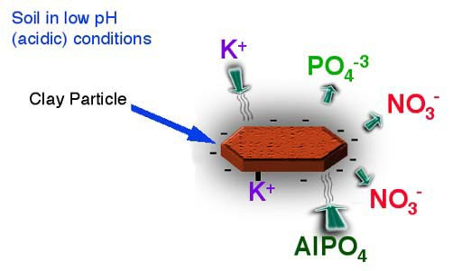

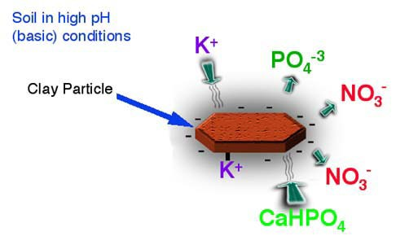

NITRATE NITROGEN (N)

This nutrient is essential for the growth of vegetation especially grass and leafy plants. The right amount of nitrogen allows for healthy growth but too much is equally damaging and will affect the plants structure.

PROCEDURES:

- Preparing the filtering device
  - Unscrew the cap on the filtering device and remove the plunger (Turning the plunger as you slowly pull it out seems to work best.)
  - Place one of the filter papers into the bottom of the plunger, ensuring a neat fit by using the end of the small plastic spoon supplied in the soil kit. (If the soil sample is particularly clay based use two filter disks together.)

- Filtering the nutrients
  - Fill the barrel to the 1 mL mark with the dry soil sample.
  - Add N1 test solution to the 2.5 mL mark.
  - Insert the plunger just inside the barrel of the device and gently shake mixture for 30 seconds.
  - Press the plunger down slowly until it touches the mixture, place on the cap and screw down slowly until you see the solution filter into the plunger. Compress out as much solution as is possible without forcing the cap.
  - Unscrew the cap and pour solution into one of the test tubes to the 1 mL mark. Add one level spoon of N2 powder, cap the test tube and gently shake for 10 seconds. Let the solution stand for 5 minutes and compare with the reading chart on the Nitrate Test Card.

PHOSPHORUS (P)

This nutrient is necessary for strong root growth and root vegetables. It helps in the formation of buds and healthy stems. A lack of phosphorus will stunt growth of a plant.

PROCEDURES:

- Preparing the filtering device
  - Unscrew the cap on the filtering device and remove the plunger (Turning the plunger as you slowly pull it out seems to work best.)
b. Place one of the filter papers into the bottom of the plunger, ensuring a neat fit by using the end of the small plastic spoon supplied in the soil kit. (If the soil sample is particularly clay based use two filter disks together.)

- Filtering the nutrients
  - Fill the barrel to the 1 mL mark with the dry soil sample.
  - Add P1 test solution to the 2 mL mark.
  - Insert the plunger just inside the barrel of the device and gently shake mixture for 30 seconds.
  - Press the plunger down slowly until it touches the mixture, place on the cap and screw down slowly until you see the solution filter into the plunger. Compress out as much solution as is possible without forcing the cap.
  - Unscrew the cap and pour solution into one of the test tubes to the 1 mL mark. Add 1/2 spoon of P2 powder, cap the test tube and gently shake for 5 seconds and compare the color of the solution with the reading chart on the Phosphorus Test Card.

POTASSIUM (K)

PROCEDURES:

- Preparing the filtering device
  - Unscrew the cap on the filtering device and remove the plunger (Turning the plunger as you slowly pull it out seems to work best.)
  - Place one of the filter papers into the bottom of the plunger, ensuring a neat fit by using the end of the small plastic spoon supplied in the soil kit. (If the soil sample is particularly clay based use two filter disks together.)

- Filtering the nutrients
  - Fill the barrel to the 0.5 mL mark with the dry soil sample.
  - Add K1 test solution to the 2 mL mark.
  - Insert the plunger just inside the barrel of the device and gently shake mixture for 30 seconds.
  - Press the plunger down slowly until it touches the mixture, place on the cap and screw down slowly until you see the solution filter into the plunger. Compress out as much solution as is possible without forcing the cap.
  - Unscrew the cap and pour solution into one of the test tubes to the 1 mL mark. Now add K2 test solution to the 1.5 mL mark. Let the solution stand for 5 minutes before taking a reading. The solution will have degrees of cloudiness according to how much potassium is present. Place the test tube on the square over the black and shaded rectangles on the Potassium Test Card and compare with the cloudiness.

DATA

 | pH | Nitrogen | Phosphorus | Potassium
Soil Sample A
Soil Sample B

PROCESSING THE DATA

- Is the soil acidic, basic, or neutral?

Soil Sample A

Soil Sample B

- Compare the two samples. Could they have been taken from the same location (field)? Explain your answer.

EXTENSION

Test soil samples from your backyard or another environment and compare to your first samples. Are the results the same or different? Try to explain why.

