SPECTRAL ANALYSIS

LAB ELEC
From World of Chemistry, L. Fruen, 1994

PURPOSE

To observe the visible emission spectrum of several elements and simple compounds and relate it to their electronic configuration.
To identify an unknown substance by observing it’s spectrum.
To understand the relationship between various primary and secondary colors.

INTRODUCTION

This activity will serve as an introduction to qualitative analysis by using the light emitted by substance when its electrons absorb energy and move to higher energy levels. As the electrons return to the ground state they emit light equal to the energy absorbed. Since every substance will have a specific and unique electron configuration they will also have a specific and unique pattern of light emitted.

EQUIPMENT/MATERIALS

Various Spectrum Tubes Color Triangle Chart
Power Supply for Spectrum Tubes Spectroscope
Electromagnetic Spectrum Chart Full Color Spectrum Chart

SAFETY

The power supplies deliver 5000 VAC to the spectrum tubes. DO NOT TOUCH THE TERMINALS WITH THE POWER ON! There are no waste disposal issues with this activity.

PROCEDURES

- 1. Observe and record the visible line spectra of several substances by looking through a spectroscope at the spectrum tube in energized power supply.
- 2. Determine the energy of the photon associated with each line
- 3. Observe the spectrum of an unknown substance obtained from your instructor.
- 4. Record the number of the unknown and the color of the visible lines
- 5. Determine the identity of the substance by comparing it to the full color spectrum chart.
- 6. Discuss the color triangle chart and how if relates to the colors we see in the spectrum and in general.

- 7. Be sure to include in your data table the following information:
a. name of substance
b. color of visible lines from left to right
c. wavelength (λ) of each color
d. energy (joules) of each photon
e. electron configuration of substance
f. at bottom of table list the unknown number and your identification of the
unknown

QUESTIONS

1. Why are some areas of the spectrum dark (black)?

2. What is the complementary color of Blue?

3. What is meant by “subtractive primary colors”?

4. The color white means that which wavelengths are being absorbed?

5. What is the identity of your unknown?

6. Which color (λ) contains the most energy?

EXTENSIONS
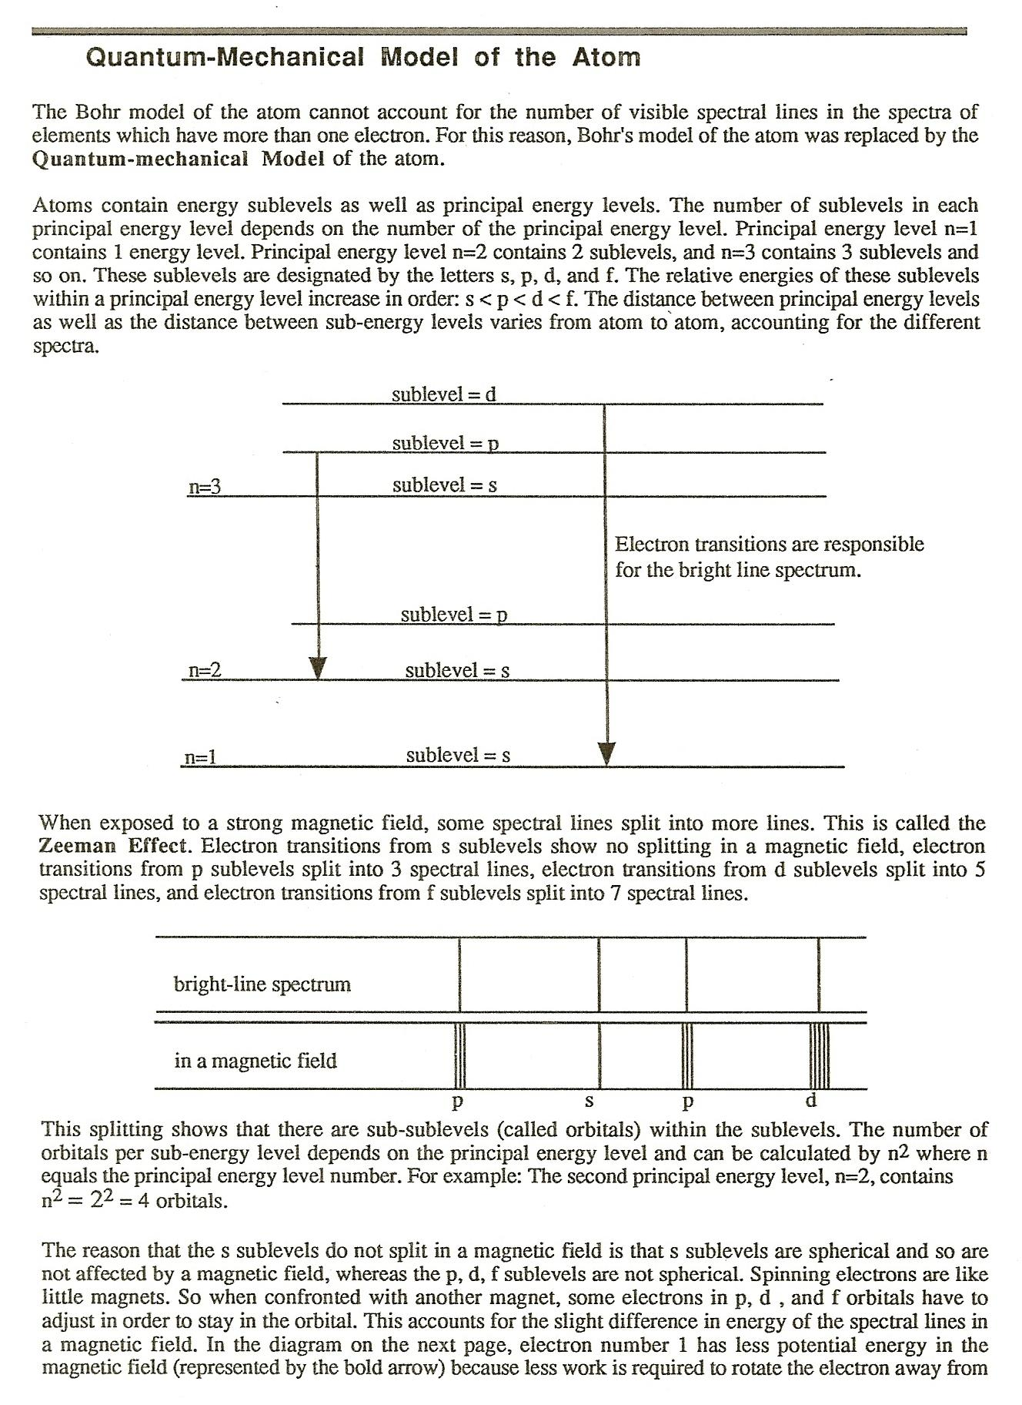

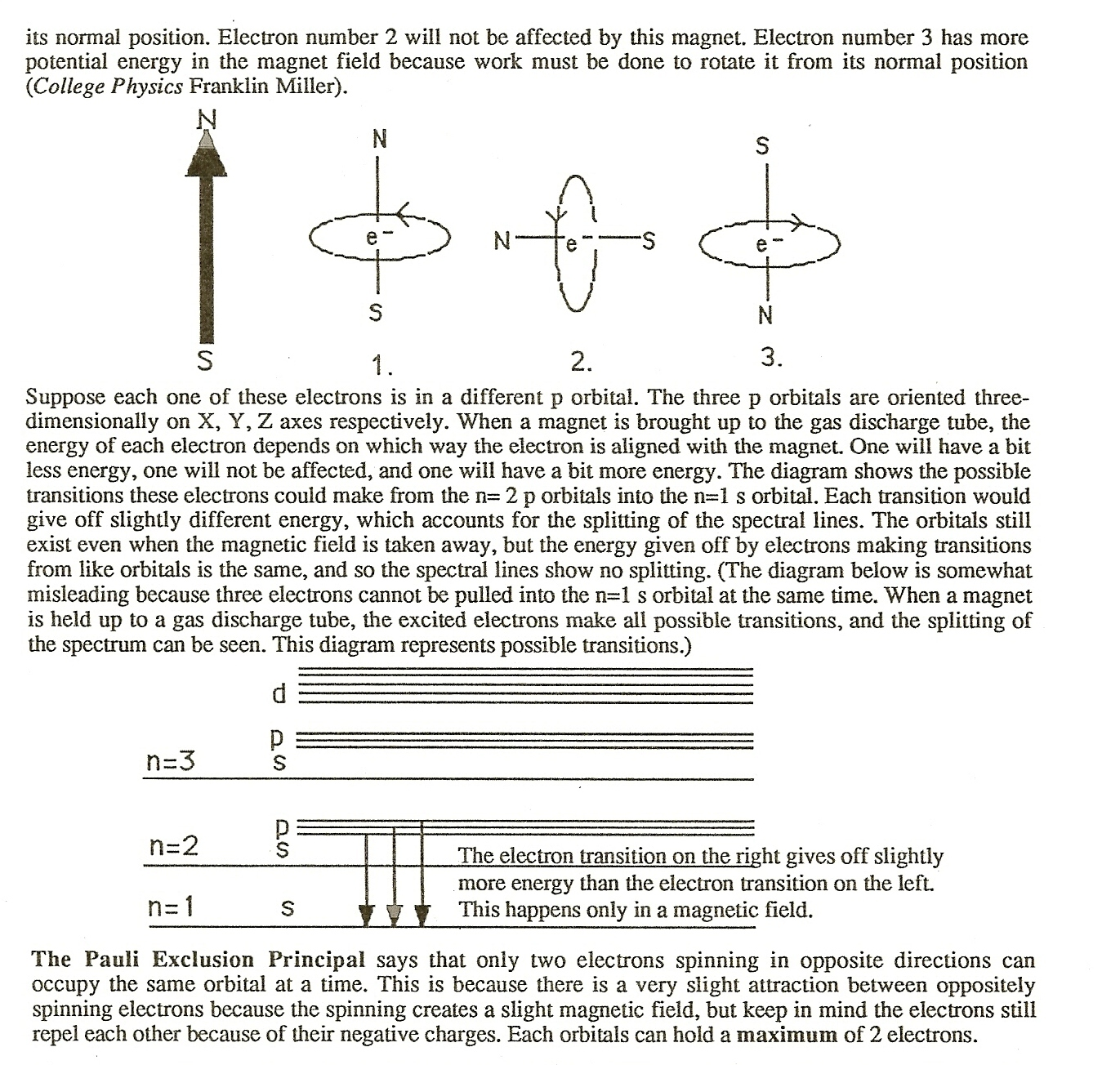
Principal Energy Level (n) | Sublevel | No. of Orbitals=(n²) | Maximum no. of e⁻/Energy Level = (2n²)
1 | s | 1 | 2
2 | s  ppp | 1  3 | 2  6
3 | s  ppp  ddddd | 1  3  5 | 2  6  10
4 | s  ppp  ddddd  fffffff | 1  3  5  7 | 2  6  10  14

