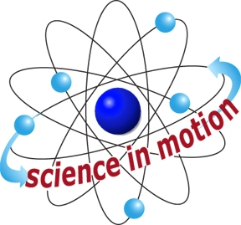
SAFETY CONTRACT
Westminster College

I am learning to be a good scientist. I know that I must be organized, net, and well behaved in the science classroom. I promise to:

- Prepare for all activities: I will listen to directions and make sure I understand before I start. I will work only at my assigned station.

- Care for equipment: I will handle objects carefully. I will not eat, drink, or taste anything in science class. This includes food and drink as well as other items. I will use my science materials only for the science activities. I will not play with things like rubber bands, paper clips or powders.

- Follow directions: I will wait until I receive my teacher’s permission to begin an activity. I will do each step in order and I will not try unknown things.

- Observe carefully. I will be as quiet and calm as possible so that I can learn more.

- Explore carefully: I will explore using the senses of touch, smell, sight and hearing. When using powders, I will try not to make dust because someone might breathe it. I will try not to touch my eyes when I am working, in case there is something on my hands that should not get in my eyes.

- Keep careful records: I will record my observations by writing or drawing on my record sheet.

- Clean up afterwards. I will put away my equipment when I am done and wash my hands and my workspace.

- Follow all additional safety rules.

- Report accidents: I will report any injury or accident to my teacher immediately.

I will share good science safety with students and family so that I can be a good investigator.

Student Signature:_________________________________________________________

I have read this Safety Contract and understand what is expected of my child during science laboratory activities.

Parent Signature:__________________________________________________________

