**THE DECOMPOSITION OF HYDROGEN PEROXIDE**

## LAB 12

From *Advanced Chemistry with Vernier, Vernier Software and Technology*

**Westminster College**

# INTRODUCTION

The decomposition of hydrogen peroxide in aqueous solution proceeds very slowly. A bottle of 3% hydrogen peroxide sitting on a grocery store shelf is stable for a long period of time. The decomposition takes place according to the reaction below.

2 H2O2(aq) → 2 H2O + O2(g)

A number of catalysts can be used to speed up this reaction, including potassium iodide, manganese (IV) oxide, and the enzyme catalase. If you conduct the catalyzed decomposition of hydrogen peroxide in a closed vessel, you will be able to determine the reaction rate as a function of the pressure increase in the vessel that is caused by the production of oxygen gas. If you vary the initial molar concentration of the H2O2 solution, the rate law for the reaction can also be determined. Finally, by conducting the reaction at different temperatures, the activation energy, *Ea*, can be calculated.

# OBJECTIVES

In this experiment, you will

* Conduct the catalyzed decomposition of hydrogen peroxide under various conditions.
* Calculate the rate constant for the reaction.
* Determine the rate law expression for the reaction.
* Calculate the activation energy for the reaction.

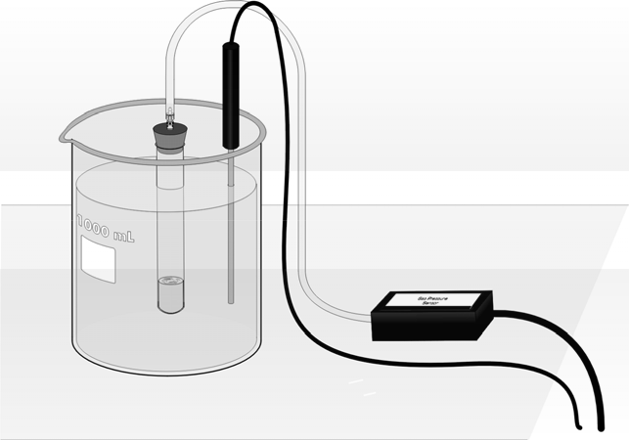

*Figure 1*

# MATERIALS

|  |  |
| --- | --- |
| LabQuest | 3% hydrogen peroxide, H2O2, solution |
| LabQuest App | 0.5 M potassium iodide, KI, solution |
| Vernier Gas Pressure Sensor | 18  150 mm test tube |
| thermometer or Temperature Probe | two 10 mL graduated cylinders |
| tubing with two Luer-lock connectors | graduated plastic Beral pipet |
| one-hole rubber stopper with stem | 1 liter beaker |
| solid rubber stopper (#1) | ~800 mL room temperature water |
| distilled water | |

**PRE-LAB EXERCISE**

The hydrogen peroxide solution that you are using in this experiment is labeled as a 3% solution, mass/volume. However, in order to complete the calculations, the concentration must be in molarity. Calculate the molarity of a 3% mass/volume H2O2 solution (Part I, II, and IV) and a 1.5% mass/volume H2O2 solution (Part III) and record these values in the table below.

|  |  |  |  |  |
| --- | --- | --- | --- | --- |
| Part | Volume H2O2 (mL) | [H2O2]  before mixing | Volume KI (mL) | [KI]  before mixing |
| I | 4 |  | 1 | 0.50 M |
| II | 4 |  | 1 | 0.25 M |
| III | 4 |  | 1 | 0.50 M |
| IV | 4 |  | 1 | 0.50 M |

# PROCEDURE

**Part I Decompose 3% H2O2 solution with 0.5 M KI solution at ~20°C**

1. Obtain and wear goggles.
2. Prepare the reagents for temperature equilibration.
   1. Obtain room-temperature water to set up a water bath to completely immerse the test tube. Use a thermometer or a Temperature Probe to measure the temperature of the bath. Record this temperature in your data table for Parts 1–3; presume that the water bath temperature remains constant throughout.
   2. Measure out 4 mL of 3% H2O2 solution into the test tube. Seal the test tube with the solid rubber stopper and place the test tube in the water bath.
   3. Measure out 2 mL of 0.5 M KI solution in a graduated cylinder. Draw 1 mL of the KI solution into a graduated Beral pipet. Invert the pipet and immerse the reservoir end of the pipet in the water bath.
3. Connect the Gas Pressure Sensor to LabQuest and choose New from the File menu. If you have an older sensor that does not auto-ID, manually set up the sensor.
4. Use the plastic tubing to connect the one-hole rubber stopper to the Gas Pressure Sensor, as shown in Figure 1. About one-half turn of the fittings will secure the tubing tightly.
5. On the Meter screen, tap Rate. Change the data-collection rate to 0.1 samples/second and the data-collection length to 300 seconds and select OK.
6. Prepare to run the reaction and collect pressure data.
   1. Remove the test tube from the water bath and remove the solid stopper.
   2. Remove the plastic Beral pipet from the water bath and quickly transfer the 1 mL of KI solution into the test tube. Tap or lightly shake the test tube to mix the reagents.
   3. Seal the test tube with the one-hole stopper connected to the Gas Pressure Sensor.
   4. Place the test tube back in the water bath.
7. Start data collection. Data will be collected for five minutes. If necessary, gently hold the test tube so that it stays completely immersed in the water bath.
8. When the data collection is complete, carefully remove the stopper from the test tube to relieve the pressure. Dispose of the contents of the test tube as directed.
9. Determine the initial rate of the reaction.
   1. Identify a linear region just beyond the initial flat portion of the graph
   2. Tap the data point at the beginning of the linear region. Drag your stylus across the graph to select about one minute of data.
   3. Choose Curve Fit from the Analyze menu.
   4. Select Linear as the Fit Equation.
   5. Record the slope, in your data table, as the initial rate for the reaction and select OK.
10. Store the data from the first run by tapping the File Cabinet icon.
11. Rinse and clean the test tube for Part II.

**Part II Decompose 3% H2O2 solution with 0.25 M KI solution at ~20°C**

1. Measure out 4 mL of 3% H2O2 solution into the test tube. Seal the test tube with the solid rubber stopper and place the test tube in the water bath.
2. Add 1 mL of distilled water to the remaining 1 mL of KI solution in the graduated cylinder. Swirl the mixture gently to mix the solution.
3. Draw 1 mL of the KI solution into a plastic Beral pipet. Invert the pipet and immerse the reservoir end of the pipet in the water bath. Allow both the test tube and the Beral pipet to remain in the water bath for at least two minutes before proceeding.
4. Repeat Steps 6–11 to conduct Part II. Remember to save the data.

**Part III Decompose 1.5% H2O2 solution with 0.5 M KI solution at ~20°C**

1. Prepare a 1.5% H2O2 solution by mixing 2 mL of distilled water with 2 mL of 3% H2O2 solution. Transfer all 4 mL of the 1.5% H2O2 solution to the test tube, seal the test tube with the solid stopper, and place the test tube in the water bath.
2. Rinse and clean the graduated cylinder that you have used for the KI solution. Add a fresh 2 mL of 0.5 M KI solution to the graduated cylinder.
3. Draw 1 mL of the KI solution into a plastic Beral pipet. Invert the pipet and immerse the reservoir end of the pipet in the water bath. Allow both the test tube and the Beral pipet to remain in the water bath for at least two minutes before proceeding.
4. Repeat Steps 6–11 to conduct Part III. Remember to save the data.

**Part IV Decompose 3% H2O2 solution with 0.5 M KI solution at ~30°C**

1. Conduct Part IV identically to the procedure in Part I, with one exception: set the water bath at 30°C.

# DATA TABLE

|  |  |  |  |
| --- | --- | --- | --- |
| Part | Reactants | Temperature (°C) | Initial rate (kPa/s) |
| I | 4 mL 3.0% H2O2 + 1 mL 0.5 M KI |  |  |
| II | 4 mL 3.0% H2O2 + 1 mL 0.25 M KI |  |  |
| III | 4 mL 1.5% H2O2 + 1 mL 0.5 M KI |  |  |
| IV | 4 mL 3.0% H2O2 + 1 mL 0.5 M KI |  |  |

**DATA ANALYSIS**

|  |  |  |  |  |
| --- | --- | --- | --- | --- |
| Part | Initial rate (mol/L-s) | [H2O2]  after mixing | [I–]  after mixing | Rate constant  *k* |
| I |  |  |  |  |
| II |  |  |  |  |
| III |  |  |  |  |
| IV |  |  |  |  |

1. Calculate the rate constant, *k*, and write the rate law expression for the catalyzed decomposition of hydrogen peroxide. Explain how you determined the order of the reaction in H2O2 and KI.
2. The following mechanism has been proposed for this reaction:

H2O2+ I– → IO– H2O H2O2 + IO– → I– + H2O + O2

If this mechanism is correct, which step must be the rate-determining step? Explain.

1. Use the Arrhenius equation (shown below) to determine the activation energy, *Ea*, for this reaction.

ln *k*1 

*Ea* ⎛ 1

⎜⎜

1 ⎞

− ⎟⎟

*k*2 *R*

⎝ *T*2

*T*1 ⎠