ENORMOUS ‘E’
INTRODUCTORY MICROSCOPE ACTIVITY
From Magnificent Microworld Adventures AIMS Education Foundation

ACADEMIC STANDARDS
3.7.4.A: Explore the use of basic tools, simple materials and techniques to safely solve problems.
3.7.4.B: Select the appropriate instruments to study materials.
S4.A.2.2: Identify appropriate tools or instruments for specific tasks and describe the information they can provide.

OBJECTIVES

The students will be able to prepare a wet mount slide, measure the field of view of their microscope at its various powers of magnification, and measure the width of a variety of objects.

BACKGROUND

The microscope is one of the most important tools of the biologist. It enables the biologist to see what is not visible to the unaided eye. Any device that produces an enlarged image of a small object can be called a microscope. A simple microscope uses a single convex lens.

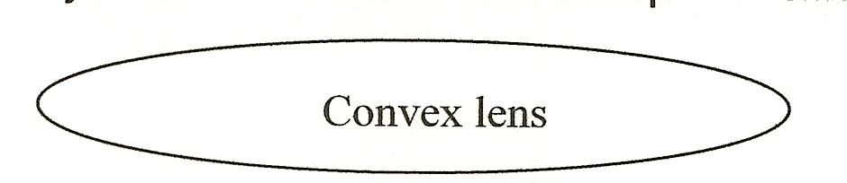
X indicates the magnification power of a lens. For example, 4X means magnified four times. A compound microscope uses two or more lenses to produce an enlarged image. The magnified images produces by the objective lens is further magnified by the eyepiece lens. Most compound microscopes can achieve a total magnification from 10X to 1000X.

The compound microscope has been in use since the late 1500s, but has only been used in the field of biology since the late 1600s. Although the first compound microscope could magnify in excess of 100 times, the quality of glass in the lenses was poor and therefore the resolution was poor and the finer details of an object could not be seen. Resolution measures the ability to separate images of objects that are very close together, for clear viewing.

Making a wet mount slide is a basic microscope skill. Because of its clarity, water is used in the wet mount slide.

MATERIALS

Microscopes (2-3 students per scope String
Paper clip Microscope slides
Strand of hair Cover slips
Small tweezers Eyedropper/pipette
Letter ‘e’ strip (see attachment) Hand lens (1 group)
Thread Scissors
Clear metric ruler (see attachment)

LESSON TIME:

This activity should take two 45 minute periods to complete. Lesson can be cut in half using the letter ‘e’ portion of the activity only.

LESSON PREPARATION:
- Have the materials readily available: slides, cover slips, eyedroppers, tweezers, rulers, scissors, thread, string, paper clips, the letter ‘e’s.
- Copy the page of centimeter rules onto transparency film. Every 2-3 students should have a ruler.
- Prepare the letter ‘e’s by punching with a hole punch.

PROCEDURE

Introduction to the microscope/troubleshooting and care

- Explain the purpose and use of the microscope (see background)
- With the microscopes in front of the groups (2-3 students) have students point to parts of the microscope while you name each part.
- Emphasize that they only hand the microscope (to move it, etc) by the arm.
- The nosepiece moves to change the lens power. Emphasize that it is best to always start out small and then work higher. When rotating the nosepiece, make sure that the lens is completely in place or students will not be able to see anything.
- When bringing an image into focus, always use the coarse adjustment knob (usually the bigger knob). Then the fine adjustment knob can be used to bring the image into focus more clearly.
- Directly under the stage of most microscopes, there is a large, flat, round knob that adjusts the size of hole to allow more or less light in. Have students make sure that it is on the setting that allows the most light or the biggest hole.
- On the base of most microscopes there is a light adjustment knob. Have students make sure that it is on the highest setting also.
- When the microscopes has the highest power lens in place be very careful when moving the coarse adjustment knob because it will move the stage and may come into contact with the slide, possibly breaking it.
- Emphasize extreme caution to the students when using the microscope and walking near the power cords.
- Students must also be careful when handling the slides as they are glass and can easily break.

Preparing the wet mount slide
- Have students clean their slides with water and Kim-wipe or tissue.
- Direct them to place a drop of water on the center of the slide.
- With the tweezers, have the students place the letter ‘e’ right side up onto the drop of water.
- Guide them to gently touch the cover slip to the edge of the drop of water, and then gently lower the cover slip onto the drop of water and letter e.
- Have students use a hand lens to observe the wet mount slide.
- Instruct them to draw a picture of what they observe on worksheet.
- Have the student put the slide on the compound microscope stage with the letter ‘e’ over the hold in the stage.
- Direct them to adjust the microscope to low power, focus using coarse adjustment knob first, then the fine adjustment knob, and then draw what they see.
- Ask them to adjust the microscope to medium and then high power (highest power is difficult to get into view clearly for many students).

Measuring Field of View
- Have students put the transparent ruler on the stage of the microscope with the metric side over the opening in the stage.
- Ask them to check to make sure the microscope is on lower power.
- Have students bring the ruler into sharp focus. Move the transparent ruler so one of the lines is just visible at the edge of the field of view, along the centerline.
- Direct them to count the number of lines that are visible in the field of view and record on the student page. (the space between the center of two lines is one millimeter-m) Have the students change to high power and repeat the procedures. (the distance across the field of view will now be less than it was under low power)
- Optional: You can have the students repeat this activity using a hand magnifier.
- To have students practice measuring the field of view, have them prepare a slide of each of the following: string, wire, thread, and a sample of their hair. Observe each sample under both low and high powers.
Materials 40X (approximate measurements)
Paper Clip 1.0 mm
Thread 0.2-0.3 mm
Hair 0.05-0.10 m
String 1.5 mm
- The students will need to lay a transparent ruler on the stage of the microscope. Have them lay their sample on top of the ruler so it is lengthwise with the mm marks.
- Have students record the estimated diameter of each item on their student pages.

Discussion
- Why is it important to use a clean slide and cover slip?
- Why does a small letter e work better than a capital E?
- Which gave the clearest image of the ‘e’, the hand lens or the microscope? Why?
- What does a compound microscope help you do?
- Why do you think scientists use such a tool?
- How does the field of view change as you go from low to high power?
- What is the difference between a simple and a compound microscope?
- Which has the broadest field of view, low or high power?
- Why is the microscope a better tool for this activity than the hand lens?

EXTENSIONS

- Have students prepare wet mounts of various objects: hair, tissue paper, nylon, etc.
- Have students measure the width of the letter ‘e’ under low and then high power. Measure the width in mm.
- Have students look up Anton Van Leeuwenhoek and Robert Hooke and write a report on who they were and what they contributed to science.
