THE TRANSFORMER

LAB ELEC 7

REFERENCES: PASCO Transformer Notes
Physics for Scientists and Engineers, Tipler, 4th Ed., Vol. 2

INTRODUCTION

Nearly all of today’s electrical energy is produced as alternating current by electrical generators. The great advantage over direct current is that alternating current can be transformed changing the voltage and current values in relation to each other over a very large range of values. The benefit is that electricity can then be transmitted at very high voltage, V, over long distances at very low current, I, with an amount of electric power, P, delivered according to P=IV and at very low power or energy loss. This is because transmission loss is largely a consequence of electrical heating given by H=I2R where H is heat produced per time, R electrical resistance. This follows when the transmission line loss is minimized by the transmission line resistance being small and especially that current I is small which is squared in the relationship. As noted, current I by transforming can be made very small and copper, a very good conducting material having very low resistivity and quite plentiful, is the commonly used material for electricity transmission lines. The electrical energy then can be produced at “safe” voltages, transformed to high voltages to the transmission lines, then reduced to “safe” voltages for use in such as factories and homes. Transformers by magnetic induction enable these changes in voltage and current. Our U.S. power is produced and delivered as sinusoidal current at a frequency of 60Hz and commonly delivered at voltages of about: 110V, 220V, and 440V.

This alternating current is quite easily produced by magnetic induction in generator coils, designed to produce a sinusoidal emf. Such a sinusoidal emf inputed to an inductor, a capacitor, or a resistor is as well sinusoidal, however, generally phase shifts occur between the generated emf and that involving induction and or capacitance. With sinusoidal emfs and currents, their maximum values are easily related. Root-mean-
(I 2 )
av

square (rms) values are typically computed which for rms current, Irms =
and for

rms emf, Erms =
(E 2
)av . The average power,Pav, dissipated in a resistor having a

resistance R is given by Pav = Irms2 R and also by Pav=Erms Irms. Further for such as a resistive circuit, Irms = Erms/R or Irms=VR,rms/R and Irms = Pav/Erms, these relationship thus being analogeous to corresponding direct current relationships.

Now a commercial transformer is composed typically of two conductive wire coils wound around a common laminated soft iron core. The coil which carries the input current is called the primary and the other coil is the secondary. The primary and secondary coils might be exchanged in the circuit so that the coils exchange the primary/secondary functions. The alternating emf applied to the primary coil induces an

alternating emf in the nearby secondary coil circuit as a result of the mutual induction of the two coils. The iron core guides and concentrates the magnetic effect produced so that the magnetic flux almost completely links the two coils. Even though small, the coils have some resistance so some energy loss occurs due to Joule heating and also small losses resulting from current loops and hysterisis set up in the iron core. Electrical power grid transformers are commonly said to be 90 to 95% efficient. For theoretical considerations we will idealize considering no power loss with power in set equal to power out, that is Ppri = Psec or Ipri Vpri = I sec Vsec. Accordingly at a certain power level P, increasing V results in I being reduced and vice versa. In consideration of magnetic flux per turn in the primary coil and for negligible flux leakage from the iron core, the magnetic flux per turn is the same for both coils so that Npri/Vpri = Nsec/Vsec where N is the number of turns in a coil. Rewriting Vsec=(Nsec/Npri) Vpri and if Nsec is larger than Npri, then Vsec is greater than Vpri and we have a step-up transformer. Likewise with Npri larger than Nsec, then a step-down transformer. If a resistance load is put across secondary coil then there will be a current Isec in the secondary circuit that will be in phase with Vsec across the resistance. This Current Isec sets up an additional flux through each turn proportional to Nsec Isec which opposes the magnetizing current in the primary. Now the voltage across the primary coil is according to the input emf such as of the generator, so is not affected by the secondary. The total flux in the iron core must be the same as when there is no load across the secondary which means that the primary coil draws an additional current Ipri to sustain the original flux. The flux through each turn produced by this Ipri is proportional to Npri Ipri and Ipri is related to Isec by

N pri I pri = −Nsec Isec
Eq. (1).

With these currents 180° out of phase thus producing counteracting fluxes and Isec is in phase with Vsec, then Ipri is in phase with the applied emf. With the power input

Vpri,rmf I pri,rmf
and power output Vsec,rmf Ipri,rmf and with the magnetizing current not

contributing to power input being 90° out of phase with input voltage, then if no losses

Vpri,rms I pri,rms = Vsec,rms Isec,rms
Eq. (2).

Generally the additional primary current Ipri is much larger than the original magnetizing current drawn from the generator when no load across the secondary. If the magnetizing current can be neglected, Eq. (2) then relates the total power in the primary and secondary transformer circuits.

Practically for our work, it should be noted that electrical meters for measuring alternating currents and voltages generally give root-mean-square (rms) values.

PURPOSE

To observe and study the function of a transformer and relate and compare such as current, voltage and power in the secondary coil with respect to the primary coil.

MATERIALS

transformer ac voltmeter (2)
(coils and iron core) decade resistance box
ac power supply or variac power strip
ac ammeter (2) connecting wires

PRELIMARY QUESTIONS

- Why are transformers not used to change the voltage of constant direct currents?

- Why would a power company transmit electricity at 100s of thousands of volts to a city 300 miles distance?

- What are the reasons that a commercial transformer core is composed of iron, that it is soft iron, and that it is built up of insulated layers of soft iron plates?

- Explain the basis of maximum power and average power of sinusoidal alternating current differing from each other.

- Power company transformers are often designed to provide some cooling; explain.

PROCEDURE

- Set up the electrical circuit according to the diagram shown. Unless stated otherwise, have the primary coil (with the smaller number of turns) fully inserted into the center of the secondary coil and the solid soft iron core fully inserted as well.

- You will note that to measure electric current, that is the rate of flow of electricity, the ammeter is placed in series at a position of interest and that for voltage or electrical potential different the voltmeter is placed parallel with the electrical component for which the voltage is of interest. Check that the meter electrical leads are inserted into the desired labeled meter ports and set each meter selection indicator to the proper function whether ac current or ac voltage and on an appropriate range scale for the particular measurement.

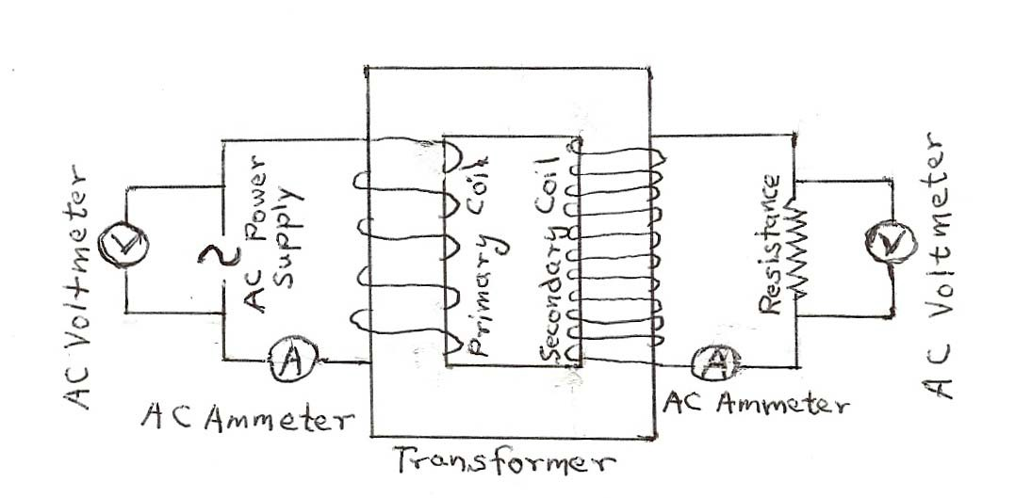

- It is to be noted that these meters, when being used as an ac ammeter or ac voltmeter, indicate measurements in root-mean-square, rms current in amperes and rms voltage in volts (refer to the INTRODUCTION section for reference to rms values).

- So as not to overload the circuit, to limit heating, and to provide adequate electricity flow for good measurement; we suggest starting with about 1.0 volt input to the primary coil with the decade resistance box, that is, with the resistance across
the secondary coil set for 50Ω. Keep this power supply input setting the same throughout the experiment. (the actual primary voltage and current values will change some as the resistance is changed).

- Guided by the DATA TABLE, proceed to take a set of data for the resistances given, ranging from 50Ω to 1000Ω ( or actually to 999Ω, the decade resistance box limitation) by 50Ω increments. Take and record in the DATA TABLE for each resistance, the voltage and current of the transformer primary coil and of the secondary coil.

- For the last two DATA TABLE entries also with 999Ω resistance, take a data set (still without changing the power input setting) with the primary coil fully inserted into the secondary coil but with the iron core in about one-half the length of the primary coil and then finally a data set with the iron core fully inserted into the primary coil but primary coil along with the iron coil inserted about one-half the length of the secondary coil core.

DATA TABLE
Rpri =0.2Ω Rsec=76.0Ω | Primary Coil Npri=235 turns |  |  | Secondary Coil Nsec = 2920 turns |  |  | Isec R (V) | I2sec R  (W) | Ppri-Psec (W) | Psec/Ppri  (%) | Vsec/Vpri
Resistance (Ω)  R | Voltage (V)  rms Vpi | Current (A)  rms Ipri | Power (W)  Ppri | Voltage (V)  rms Vsec | Current (A)  rms Isec | Power (W)  Psec
50
100
150
200
250
300
350
400
450
500
550
600
650
700
750
800
850
900
950
999
½ core 999
½ coil 999

ANALYSIS

- Proceed with data treatment/analysis much of which is outlined according to the headings of the DATA TABLE.

- Compute the power in the primary coil, Ppri = IpriVpri and record the values in the DATA TABLE. Compute the power in the secondary coil, Psec = IsecVsec and record the values in the DATA TABLE. Compute the power expended in the resistors as
a result of resistive heating given by I 2R and record the values in the DATA TABLE. Compare and discuss this power loss in the various resistors with the
sec
corresponding power in the secondary coil Psec = IsecVsec .

- Compute and record in the DATA TABLE, the percent ratios of the secondary coil power to the primary coil power, Psec/Ppri (%). Also compute and record the
actual power losses from primary coil to secondary coil, Ppri-Psec. Comment on these power losses differences. Discuss to what these power losses might be attributed
and the 90 to 95% efficiencies of power company transformers. In these comparisons note any trends in relation to the range in resistance value that is in series with the secondary coil.

- Compute the voltage drop across the resistors as the product of the secondary current and the resistance, Isec•R and record the values in the DATA TABLE. Compare and comment on these values in relation to the directly obtained ac voltmeter readings for the various resistances.

- Compute and record in the DATA TABLE the ratios of the secondary coil voltage to the primary coil voltage. How is such phenomena as these values indicate possible? Explain from a physical perspective that the values obtained make sense.

- It would be well to plot a graph of the secondary voltage vs. the secondary current. Approximately, what kind of function is implied? Comment on significance of the vertical or secondary voltage intercept. Explain that the secondary current decreases with increasing secondary voltage and the fact that the secondary voltage does increase with increasing resistance R. What significance does the input power have on this plot behavior?

- Of interest is a graph of secondary power, Psec vs. resistance, R. Does your Psec maximize at about 200Ω for R as we noted with data taken from primary coil voltage inputs of 2.0V, 1.5V, 1.0V or 0.5 volts. Explain/justify that with increasing R the secondary circuit power first increases then decreases (a hint might be I2sec R being involved).

- Discuss and explain the results of the last two DATA TABLE entries – with iron core partly inserted and with primary coil partly inserted.

