TORQUE AND FIRST-CLASS LEVERS

LAB MECH 28.COMP
From Physics, Eugene Hecht and Physical Science with Computers, Vernier Software & Technology

STANDARDS ADDRESSED
3.2.6-8.H Plan in investigation to provide evidence that the change in an object's motion depends on the sum of the forces on the object and the mass of the object.

INTRODUCTION

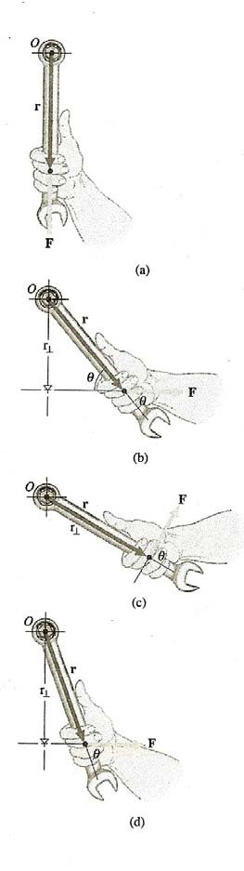
In Figure 1, note force F acting on a wrench along different directions and at different points. The axis of rotation is about the center of the bolt through point O perpendicular to the plane of the diagram. The point of application of the force, F, is indicated by the end of position vector r drawn from point O. The turning
Figure 1
effect, being of particular interest, differs for each case shown in the figure with (a) giving no turning affect and (c) giving a maximum with r indicated as r⊥ called the moment of the force passing through O and is perpendicular to the line of action of F. The moment of the force taken about O is defined as the product of force F and the moment-arm
r⊥ which we symbolize by τ(tau), thus
τ o = r⊥ • F
and is called torque (from the Latin torquere, to twist). This can then be expressed generally for Figure 1 in terms of angle θ between F and r as

τ ο =
r ⊥ F
= Fr
sin θ
(Eq.1).

Torque is common place in our world of mechanics with many applications. In this laboratory exercise we shall consider, among known as simple machines, the First Class Lever.

A lever is a simple machine used to make work easier. It consists of a long, rigid bar with a support that allows the bar to pivot. The point where the bar pivots is the fulcrum. There are three classes of levers—first, second, and third. We will examine first-class levers in this experiment. Crowbars and scissors are examples of first-class levers. A lever can help you move an object by increasing the force you exert.
Mechanical advantage (MA) is a value that tells the number of times a machine increases an applied force. In this experiment, you will study first-class levers using a computer-interfaced Force Sensor to measure resistance force and effort force (in newtons). You will then use this information to calculate the mechanical advantage of each lever.

Such a first class lever is shown in Figure 2 with the indicated mass exerting a ccw (counter-clockwise) torque about the pivot point or fulcum and the force sensor measuring the resulting force that creates a balancing cw (clockwise) torque with the lever bar maintaining a horizontal orientation and being in rotational equilibrium.

Based on Figure 2, consider the distance from the fulcrum to the force sensor as effort distance r1 , and the measured force F1 (indicated by the force sensor) and the distance from the fulcrum to the 0.500kg mass as resistance distance r2 with the weight of the mass as F2. The torque exerted by the force sensor can then be expressed as, τcw=r1F1 and the torque exerted by the 0.500kg mass can be expressed as τccw=r2F2.

OBJECTIVES

In this experiment, you will
- use a computer to measure force
- calculate the ccw and cw torques about the pivot point or fulcrum and % differences between them
- calculate actual mechanical advantage (AMA)
- calculate ideal mechanical advantage (IMA)
- calculate percent differences in AMA and IMA
- make conclusions about levers

MATERIALS
Windows PC 500-g mass
Vernier computer interface loops of string
LabPro meter stick
Vernier Force Sensor fulcrum
Force Sensor

Figure 2: Using the Dual-Range Force Sensor
Dual-Range

PROCEDURE

- Place a fulcrum near the edge of your lab table. Balance the middle (50-cm position) of a meter stick edgewise vertical on the fulcrum as shown in Figure 2.

- Attach a loop of string to the Force Sensor, F1, and also with a loop of string hang the
0.500 kg mass for F2.

- Prepare the Force Sensor for data collection.
  - For the Dual-Range Force Sensor, there is a force range switch on the probe body; set the switch to the lowest setting 10 N .

  - Hold Force Sensor with hook vertically upward and click on zero.

  - Attach the Dual-Range Force Sensor (Figure 2).

  - Prepare the computer for data collection by opening the Experiment 20 folder from Physical Science with Computers. Then open the experiment file that matches the force sensor probe you are using.

- The Resistance Force (F2) for Trials 1, 2 and 3, is that of the hanging 0.500 kg mass (force 4.9N) that will be used as the Resistance Force in DATA blanks for Trials 1, 2, and 3.

- Place the center of the mass that is acting as your resistance force on the 90-cm meter stick position (r2=40cm).

- The string attached to the Force Sensor should be looped over the meter stick at the 10-cm meter stick position (r1=40 cm). With the fulcrum between the effort and the resistance, this is a first-class lever. Pull down with the Force Sensor until the meter stick is balanced and reading has stabilized. Record this force needed to balance the meter stick in the DATA table below. This is the effort force (F1).

- Place the center of the mass acting as the resistance force on the 70-cm line (r2=20 cm). The position of the effort force (Force Sensor) should not change. Repeat Step 6.

- Now move the center of the resistance force to the 60-cm line (r2=10cm). The position of the Force Sensor should not change. Repeat Step 6.

DATA

Resistance Resistance Effort Effort Trial Distance, r2 Force, F2 Distance,r1 Force, F1
(cm) (N) (cm) (N)
1 40 _ _4.9_ 40

2 20

4.9_ _ 40

3 10

PROCESSING THE DATA

4.9 40

- Calculate the clockwise and counter-clockwise torques. Compute the % differences. Record the results in the table below and evaluate your results.

- Calculate the actual mechanical advantage for each of your three trials using the formula
AMA = F2 / F1
where AMA = actual mechanical advantage, F2= resistance force, and F1 = effort force. Record results in the table below.

- Ideal mechanical advantage is determined by the formula,
IMA = r1 / r2
where IMA = ideal mechanical advantage, r1=effort distance, and r2= resistance distance. Calculate the ideal mechanical advantage of the levers you tested. Record results in the data table below.

- Calculate the percent difference between IMA and AMA for each of your trials using the formula

% Difference =
Difference between IMA and AMA
IMA x 100

Record the results in the following table.

DATA

Trial | Torque, τccw  (N•m) | Torque, τcw  (N•m) | % Difference | AMA | IMA | % Difference
1
2
3

- What happened to the mechanical advantage as your shortened the resistance distance?

- How did moving the resistance force closer to the fulcrum affect effort needed to balance it?

- What was the mechanical advantage of the first lever you tested? Why would a lever like this be used?

- Are your values for percent difference between IMA and AMA large or small?

- Describe some factors that might contribute to the difference between IMA and AMA in this experiment and also to differences between cw and ccw torques.

- Explain the decreasing values of the τcw progressively from Trial 1, to Trial 2, to Trial 3.

EXTENSION
1. Describe the desired characteristics of a pipe wrench to loosen 4 inch diameter treaded “stubborn” pipe.

