TRANSPIRATION

STANDARDS

• 3.1.10B, E; 3.1.12B, 3.1.12C
• 3.2.10A, B, C; 3.2.12A, 3.2.12B, 3.2.12C
• 3.3.10A, B; 3.3.12A, 3.3.12B Westminster College

• 3.7.10A, B; 3.7.12A, 3.7.12B
- 3.1.9-12.J Construct and revise an explanation based on evidence for the cycling of matter
and flow of energy in aerobic and anaerobic conditions.
- 3.1.9-12.K Develop a model to illustrate the role of photosynthesis and cellular respiration in the cycling of carbon among the biosphere, atmosphere, hydrosphere, and geosphere.
- 3.1.9-12.L Use mathematical representations to support and revise explanations based on evidence about factors affecting biodiversity and populations in ecosystems of different scales.

INTRODUCTION
The amount of water needed daily by plants for the growth and maintenance of tissues is small in comparison to the amount that is lost through the process of transpiration (the evaporation of water from the plant surface) and guttation (the loss of liquids from the ends of vascular tissues at the margins of leaves). If this water is not replaced, the plant will wilt and die.

The transport of water up from the roots in the xylem is governed by differences in water potential (the potential energy of water molecules). These differences account for water movement from cell to cell and over long distances in the plant. Gravity, pressure, and solute concentration all contribute to water potential, and water always moves from an area of high water potential to an area of low water potential. The movement itself is facilitated by osmosis, root pressure, and adhesion and cohesion of water molecules.

The Overall Process: Minerals actively transported into the root accumulate in the xylem, increasing solute concentration and decreasing water potential. Water moves in by osmosis. As water enters the xylem, it forces fluid up the xylem due to hydrostatic root pressure. But this pressure can only move fluid a short distance. The most significant force moving the water and dissolved minerals in the xylem is upward pull as a result of transpiration, which creates tension. The “pull” on the water from transpiration results from the cohesion and adhesion of water molecules.

The Details: Transpiration begins with evaporation of through the stomates (stomata), small openings in the leaf surface which open into air spaces that surround the mesophyll cells of the leaf. The moist air in these spaces has a higher water potential than the outside air, and water tends to evaporate from the leaf surface (moving from an area of high water potential to an area of lower water potential). The moisture in the air spaces is replaced by water from the adjacent mesophyll cells, lowering their water potential (since the cytoplasm becomes more concentrated). Water will then move into the mesophyll cells by osmosis from surrounding cells with higher water potentials, including the xylem. As each water molecule moves into a mesophyll cell, it exerts a pull on the column of water molecules existing in the xylem all the way from the leaves to the roots. This transpirational pull occurs because of (1) the cohesion of water molecules to one

another due to hydrogen bond formation, and (2) by adhesion of water molecules to the walls of the xylem cells which aids in offsetting the downward pull of gravity.

The upward transpirational pull on the fluid in the xylem causes a tension (negative pressure) to form in the xylem, pulling the walls of the xylem inward. The tension also contributes to the lowering of water potential in the xylem. This decrease in water
potential, transmitted all the way from the leaf to the roots, causes water to move inward from the soil, across the cortex of the root, and into the xylem.

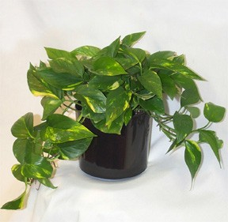Evaporation through the open stomates is a major route of water loss in plants. However, the stomates must open to allow the entry of CO2 used in photosynthesis. Therefore, a balance must be maintained between the gain of CO2 and the loss of water by regulating the opening and closing of stomates on the leaf surface.

Epipremnum aureum: Common names are pothos or Devil’s Ivy
Many environmental conditions influence the opening and closing of stomates and also affect the rate of transpiration. Temperature, light intensity, air currents, and humidity are some of these factors. Different plants also vary in the rate of transpiration and in the regulation of stomatal opening.

This experiment will measure transpiration rates of Epipremnum aureum under control conditions and under different conditions of light, humidity, temperature, and wind. The data will be collected by measuring small pressure changes as the plant takes up water into the stem. The rate of transpiration and rate of transpiration/surface area will be determined for the various environmental conditions.

GUIDING QUESTIONS
- How is transpiration related to the overall process of water transport in plants?
- What effect do changing environmental conditions (light intensity, humidity, wind, temperature) have on the rate of transpiration?
- How is the gas pressure sensor used to detect transpiration rate?

SAFETY
Use caution when cutting the plants under water. The stems will be slippery!

MATERIALS
LabQuest | metric ruler
LabQuest App | plastic gallon size bag with twist tie
Vernier Gas Pressure Sensor | 100 watt light source
utility clamps (2) | heater, small electric
ring stand | fan with slow speed
plant cuttings | aerosol spray container or plant mister
plastic tubing clamps | large plastic bin or bucket
distilled water bottle | balance
scissors, razor blade, or scalpel | extension cords & power strips

PROCEDURE
Part I Transpiration Under Control Conditions

- Position the ring stand, utility clamps, and Gas Pressure Sensor as shown in Figure 1.
- Prepare the plastic tubing. Keep the tubing submerged in water for Steps 2-4.
  - Fill the plastic bin with tap water. Remove the tubing and its connector from the Gas Pressure sensor if it is

attached.
  - Completely submerge the tubing in the water, trying to get as few air bubbles in it as possible. Slip a plastic tubing clamp onto the tubing as shown in Figure 2.
  - Submerge the water bottle and force any air bubbles out of the tip. Keeping the tubing submerged, place the tip of the water bottle in the open end (with clamp) of the tubing and force water through, removing any residual air bubbles.

- Select a plant clipping which has 3-4 leaves and a stem roughly the same diameter as the opening of the plastic tubing. Place the plant clipping under water in the plastic bin and make a new cut at a 45° angle near the base of the stem.
Figure 1. Transpiration set-up

- 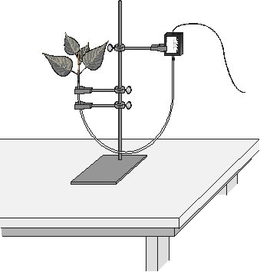Connect the plant to the tubing. Keep both the plant cutting and the tubing submerged in the bin of water for the next step.
  - Carefully push the cut stem of the plant down into the end of the tubing. Be careful not to allow any air bubbles to form between the cut portion of the stem and the water in the tube.
  - Push the plant down as far as it will go without damaging the plant. At least 0.5-1 centimeter of the plant stem should fit into the tubing. If the stem is too large for the tubing, cut the stem at a higher point where it is smaller.
  - Still under water, squeeze the tubing clamp shut as tightly as possible as shown in Figure 3.

- Place a finger over the adaptor end of the tubing and hold the plant clipping end with the other hand. Lift the whole tubing
assembly straight out of the plastic bin.
Important: Be sure the tubing is filled completely with water. The water column must be flush with the stem. There should be no air visible at the base of the stem. If water moves down the tube away from the stem after it has been inserted, check for a leak in the system.
- Connect the plastic tubing to the sensor valve securely, using a twisting motion. Caution: Do not allow water to enter the valve of the Gas Pressure Sensor. The sensor adaptor that attaches to the tubing should be facing downward as shown in Figure 1.
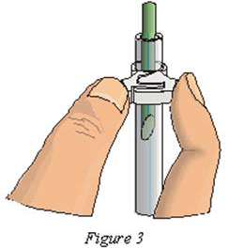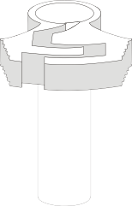
Figure 3

Figure 2

- Secure the plant in an upright position with the utility clamps as shown in Figure 1. It should be positioned so that the cut stem is approximately 8 cm below the water level at the other end of the tubing.

- Place your plant setup in an area where the wind, humidity, and temperature are reasonably constant. This will be your control setup.

- Allow the system 5 minutes to adjust to the environment. While the system is adjusting, set up the sensor and LabQuest.

- Connect the Gas Pressure Sensor to LabQuest and choose New from the File menu. If you have an older sensor that does not auto-ID, you will see a blank screen (Fig. 4a) To manually set up the sensor, stay in the Meter mode.

  - Select Sensors → Sensor Setup….→. A sensor set-up screen will appear showing all the available probe ports (Fig. 4b).
  - Select the channel that the Gas Pressure sensor is plugged into (ex. CH1 for channel 1), and tap the arrow to the side of the channel box. A list of compatible probes will appear in alphabetical order. Scroll down the list and select “Pressure”, then “Gas Pressure”.
  - Select to return to the Meter mode screen. A red box will now be in this window displaying the channel the Gas Pressure sensor is plugged into (Fig. 4c). The LabQuest is reading pressure in kPa.

Figure 4. Example of LabQuest Screens and Sensor Set-Up

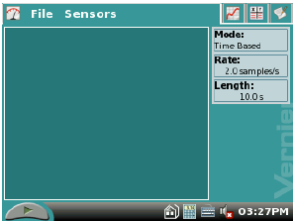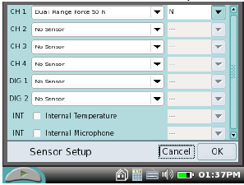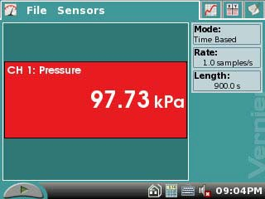
a. Blank start up screen b. Sensor set-up screen c. Meter mode screen

- Data collection will occur for 10 minutes (600 seconds). Check the gray Length box to the right of the screen. If it is not reading 600 s, tap this Length box. The blue Data Collection screen will appear (Figure 5). Tap the Length box, and change the data- collection length to 600 seconds using the touch keyboard. Select to return to the meter mode.
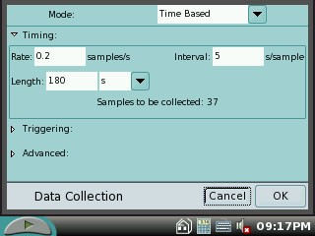
- Check the base of the plant stem in the water tube to make sure that no air bubbles or air pockets have formed that will prevent the plant from taking up water. If an air pocket has formed, refit the plant in the tubing before initiating data collection in Step 14.

- Select the graph tab at the top of the screen. If the experimental parameters are set correctly, a Figure 5. Data Collection

graph will appear. The X-axis will display Time from 0 to 600 seconds(s) and the Y-axis will show Pressure from 0 to 220 kiloPascals (kPa).

- After the plant has equilibrated for 5 minutes, start data collection by pressing the Start button at the lower left of the screen. Data will be collected for 10 minutes and a graph of pressure vs. time will be displayed. The LabQuest will automatically stop taking data after 10 min. If it is necessary to quit data collection early, you can press the Stop button to end data collection and view a graph of pressure vs. time.

- When data collection has stopped, perform a linear regression to calculate the rate of transpiration. If the entire graph is not linear, use the blue stylus to press and drag over a linear portion of the curve. Analysis will occur only on the gray shaded area of the graph.
  - While still in Graph mode choose Curve Fit → Pressure from the Analyze menu.
  - Select Linear as the Fit Equation (top right corner of screen). The linear- regression statistics for these data sets are displayed for the equation in the form
y = mx + b
where x is time, y is pressure, m is the slope, and b is the y-intercept.
  - Using scientific notation, enter the absolute value of the slope, m, as the rate of transpiration in Table 1 on your Data Sheet.
  - Select OK.
- Store the data from the control experiment by tapping the Cabinet icon at the upper right of the LabQuest screen. The screen will show a blank graph and be ready to collect data for Run 2.

- Do not dismantle your transpiration set-up! Proceed directly to Part II. Part II Transpiration Under Different Environmental Conditions
- Your instructor will assign each group an environmental condition: light, heat, wind or humidity. Record which condition you are testing in Table 1 of the Data Sheet. Use Table 1 below to set up your individual environmental test situation.

Table 1
Environmental Condition | Experimental Set-up
Light | Use flood lamp to shine as much light on the plant leaves as possible, without overheating the leaves.
Humidity | Use the plant mister to apply an even layer of moisture on the plant leaves.

Wind | Use a hair dryer (set on “cool”) or small fan to provide a constant breeze on the plant leaves.
Heat | Pre-warm a hot plate on a setting of “5”. Place it under the plant leaves, without directly touching them.

- Expose your plant leaves to the environmental condition (ex. turn on the light) and let the plant leaves adjust to the new situation for 5 min.
- Follow Steps 15 and 16 to collect data for the new environmental condition.

- To display both graphs simultaneously, tap the box and select All Runs. The graph for both the control and experimental conditions will appear on the graph. The linear equation information for both runs will also be displayed to the right of the screen as well.
Part III Using Mass to Determine Leaf Surface Area
- This method requires a balance.
  - Cut all the leaves (not stems) off your plant and determine their mass using a balance.

Total Mass of Leaves (g) =

  - Estimate the total leaf surface area in cm2 for your plant by cutting out a section of leaf 3 cm × 3 cm.
  - Determine the mass for this leaf section and divide by 9 cm2 to find the mass of l cm2 of leaf.

    - 3 cm x 3 cm Leaf Mass (g) = g

    - 3 cm x 3 cm Leaf Mass (g) = g = g/cm2 9 cm2 9 cm2
  - Divide the total mass of the leaves (answer in a. above) by the mass of l cm2 (answer to c(2) above) to find the total leaf surface area .

Total mass of leaves (g) = g = cm2 Mass of l cm2 (g/cm2) g/cm2

  - Record the calculated surface area in Table 1. If the same set of leaves are used for both the control and the experimental, this value will be the same for both.

- Calculate the rate of transpiration/surface area. To do this, divide the rate of transpiration by the surface area for each plant. These rate values can be expressed as kPa/min/cm2. Record the rate/area in Table 1.
Rate of Transpiration (kPa/s) = kPa/s = kPa/s/cm2 Surface area of Leaves (cm2) cm2

- Subtract the control (rate/area) value from the experimental value. Record this adjusted rate in the last column of Table 1 of the Data Sheet.
- Record the adjusted rate for your experimental test on the board to share with the class. Record the class results in Table 2 on the Data Sheet for each of the environmental conditions tested. If a condition was tested by more than one group, take the average of the values and record in Table 2.

- Make a bar graph that shows the effect of different environmental conditions on the transpiration of water in plant cuttings. Using the data in Table 2, plot the adjusted rate for each test on the y-axis and the test label on the x-axis.

REFERENCES

The College Board Advanced Placement Program. Lab Manual for Students, Lab 9: Transpiration. (2001). College Entrance Examination Board. pp. 99-106.

The College Board Advanced Placement Program. Lab Manual for Teachers, Lab 9: Transpiration. (2001). College Entrance Examination Board. pp. 67-71.

Kelly Redding and David Masterman. Advanced Biology with Vernier. Transpiration. (2008) Vernier Software & Technology; 13979 S.W. Millikan Way, Beaverton, OR pp. 9-1 to 9-7, 9-1T to 9-2T.

CREDITS

Special thanks John Thompson of Neshannock High School, Neshannock Township, PA and Bill Foore of Reynolds High School, Greenville, PA, for testing methods found in this protocol. The lab was revised and adapted from the above references by Dr.
Stephanie Corrette-Bennett.

Name: Group: Date:

DATA SHEET

Table 1
Test | Slope (kPa/s) | Surface area (cm2) | Rate/area (kPa/s/cm2) | Adjusted rate (kPa/s/cm2)
Experimental
Control

Table 2
Class data
Test | Adjusted rate (kPa/s/cm2)
Light
Humidity
Wind
Temperature

DATA ANALYSIS

- How was the rate of transpiration affected in each of the experimental situations as compared to the control? Explain why this increase or decrease may occur.
  - Light –

  - Humidity -

  - Wind –

  - Heat -

- Explain the role of water potential in the movement of water from soil through the plant and into the air.

- What adaptations (both structural and physiological) enable plants to decrease water loss? How might each affect transpiration?

- What is the advantage of closed stomata to a plant when water is in short supply? What are the disadvantages?

- Why did you need to calculate leaf surface area in tabulating your results?

