USING A GAS CHROMATOGRAPH: IDENTIFYING UNKNOWN COMPOUNDS
From Organic Chemistry with Vernier

EXPERIMENT 26 INTRODUCTION

Westminster College

There are many different types of chromatography: paper, thin layer (TLC), liquid (LC), high-pressure liquid (HPLC), and gas (GC). Chromatography is applied in many fields. Biochemists use liquid chromatography to separate proteins; chemists use GC, TLC, and HPLC to identify organic compounds. Forensic scientists and other specialties use gas chromatography for drug tests, toxin screens, and environmental analysis.

All types of chromatography use the same principles that include a stationary phase and a mobile phase. The stationary phase is immobile on the column or the plate and the mobile phase travels from a start point to an end point. Compounds travel from the start to the end at a specific rate depending on their competing affinity for the mobile gas/liquid phase versus the stationary solid phase. Compounds adhere to the stationary phase through dipole interactions, dispersion forces, or ionic interactions.

The Vernier Mini GC uses a metal outer column with a coated stationary phase. A sample, consisting of one or more compounds, is injected into the column and is carried by atmospheric air, which is the mobile phase. Organic compounds flowing out of the chromatography column are indicated as a peak on a chromatograph, as shown in Figure
- The unique time it takes for a specific compound to exit the column after it is injected is called the retention time. Using a GC, a compound can be identified from a mixture of compounds by its retention time.

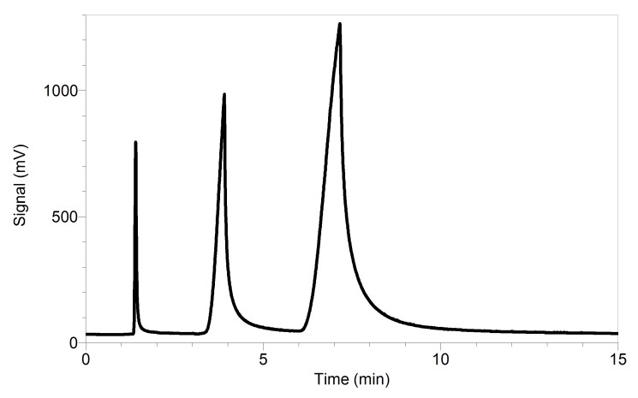

Figure 1: Sample gas chromatogram
Several factors can affect a compound’s retention time. More volatile compounds
(i.e., compounds with a lower boiling point) will move through the column faster because they are flowing in the mobile phase and not strongly bonded with the stationary phase.

The surface functional groups present on the compound are also a factor. For example, alcohols may weakly bond with a polar stationary phase more than esters because alcohols are capable of forming hydrogen bonds. The molecular weight of a compound may also play a role to a slight extent, although it is not a direct relationship between molecular mass and the time it will travel through a GC column.

In this experiment you will explore the process of identifying one or more unknown species using gas chromatography. First, you will practice using a gas chromatograph by testing several known substances. You will then use this information to identify the substances present in an unknown mixture.

OBJECTIVES
In this experiment you will
  - Measure and analyze the retention time of each of six substances as they pass through a Vernier Mini GC.
  - Measure and analyze the retention time of an unknown mixture of the substances.
  - Identify the substances present in the unknown mixture based on retention times.

MATERIALS

LabQuest or computer | Ethanol
LabQuest App or Logger Pro | Propyl acetate
Vernier Mini GC | Butyl acetate
1 µL glass syringe | 2-butanone
Kimwipes® or paper towel | 4-methyl-2-pentanone
Methanol | Unknown mixture

PRE-LAB EXERCISE
Complete the table below. This information is a common starting point for understanding the behavior of a set of substances, being testing by gas chromatography, which may be found in a mixture. For each substance, identify it by its organic family: alkane, alkene, alcohol, aldehyde, ester, ether, ketone, etc.

Compound | Boiling temperature (℃) | Molar mass (g/mol) | Bonding functional group
Methanol
Ethanol
Propyl acetate
Butyl acetate
2-butanone
4-methyl-2-pentanone

PROCEDURE

Part I: Test Known Compounds

- Obtain and wear goggles. Protect your arms and hands by wearing a long-sleeve lab coat and gloves. Conduct this reaction in a fume hood or a well-ventilated room.

- Obtain a glass syringe and a set of vials containing the six known substances and one unknown mixture containing three substances to be identified. You will not only test methanol but use it to clean the syringe needle.

- Prepare the Vernier Mini GC for data collection. Set the Temperature-Pressure values to:

Start temperature | 40℃
Hold time | 1 min
Ramp rate | 10℃/min
Final temperature | 60℃
Hold time | 12 min
Total length | 15 min
Pressure | 5.0 kPa

- Collect a 0.10 μL volume of methanol for injection. Once the Mini GC has reached the correct start temperature and pressure, the LED should turn green. Insert the needle into the injection port of the Mini GC. Simultaneously, depress the syringe plunger and start data collection. Pull the needle out of the injection port immediately.

- The data collection will end after fifteen minutes or you can choose to end it early if you are satisfied that your species has eluted completely. Analyze your chromatogram using Peak Integration. Store the run.
- Repeat Steps 4 and 5 to test the remaining five known substances.

Part II: Test the Unknown Mixture
- Clear the graph of data before testing your unknown:
  - In LabQuest App, proceed directly to Step 8.
  - In Logger Pro, choose Graph Options from the Options menu. Choose Axes Options. Scroll down the list in the Y-axis box and remove the check marks in each of the runs for your known compounds. Leave only the Latest box checked. Click done.

- Repeat Steps 4 and 5 to test your unknown mixture, but this time inject 0.30 μL and do not store the run. When the run is completed, change its name to Unknown.

- After you have completed the test of your unknown mixture, save your file for use at a later time. Save the file as directed by your instructor.

- Turn off the Mini GC. Keep your test results open in Logger Pro or in LabQuest App; you will need to refer to the various chromatograms to answer the Data Analysis questions.

DATA TABLE

Compound | Retention time (min)
Methanol
Ethanol
Propyl acetate
Butyl acetate
2-butanone
4-methyl-2-pentanone

DATA ANALYSIS
- Discuss the retention times of the six substances with regard to their molecular weights. Describe any pattern that emerges.

- Discuss the retention times of the six substances with regard to their boiling points. Describe any pattern that emerges.

- Identify the substances that are present in your unknown mixture. Support your identification.

