VIRTUAL FRUIT FLY GENETICS

STANDARDS
• 3.1.7A, 3.1.7B, 3.1.7C
• 3.2.7A, 3.2.7B, 3.2.7C
• 3.3.7C INTRODUCTION

Westminster College

Drosophila melanogaster, the fruit fly, is an excellent organism for genetics studies
because it has simple food requirements, occupies little space, is hardy and completes its life cycle in about 12 days at room temperature. While you will be using a computer program that simulates Drosophila genetic crosses, it is important to understand the life cycle of this organism (Figure 1).

T he L ife C yc le o f Dro so phila

The Eggs: The eggs are small, oval shaped and have two filaments at one end. They are usually laid on the surface of the culture medium and, with practice, can be seen with the naked eye. The eggs hatch into larvae after about a day.

The Larval Stage: The wormlike larva eats almost continuously, and its black mouth parts can easily be seen moving back and forth even when the larva itself is less distinct. Larvae tunnel through the culture medium while eating; thus, channels are a good indication of the successful growth of a culture. The larva sheds its skin twice as it increases in size. In the last of the three larval stages, the cells of the salivary glands contain giant chromosomes, which may be seen readily under low­power magnification after proper staining.

The Pupal Stage: When a mature larva in a lab culture is about to become a pupa, it usually climbs up the side of the culture bottle or on to the strip provided in the culture bottle. The last larval covering then becomes harder and darker, forming the pupal case. Through this case the late stages of metamorphosis to an adult fly can be observed. In particular, the eyes, the wings and the legs become readily visible.

The Adult Stage: When metamorphosis is complete, the adult flies emerge from the pupa case. They are fragile and light in color and their wings are not fully expanded. These flies darken in a few hours and take on the normal appearance of an adult fly. They live a month or more and then die.

A number of factors determine the length of time of each stage in the life cycle. Of these factors, temperature is the most important. At room temperature (about 25°C), the complete cycle takes ten to twelve days.

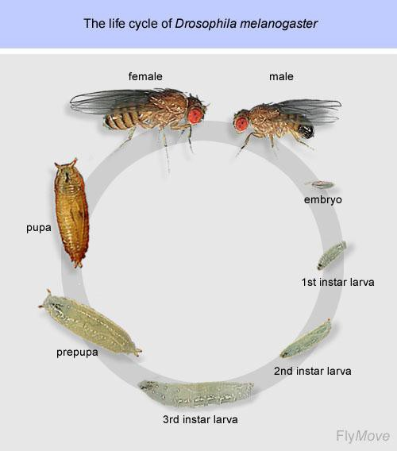
Figure 1.

Dro so phila Ge net ic s

The fruit fly is useful for studying genetics because they have only 4 chromosome pairs, with well studied traits. In a genetic cross, the offspring receive one allele, or version of a gene, from each parent (Fig. 2). The

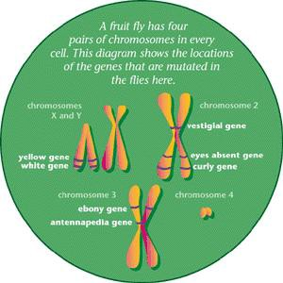trait being studied in this lab involves wing size. In a wild­type (normal) fly, the wings are long and straight (Fig. 3). A mutation in one of the wing genes can result in vestigial wings (vg), or wings that are too small to allow for flying. The vestigial wings are a recessive mutation. Recessive means that an offspring must receive a vestigial allele from both parents to have the tiny wings. The normal version of the wing gene is called dominant. This means that if the offspring receives one normal wing allele
and one vestigial allele, its wings will have a long­wing phenotype, or appearance.
The normal, or wild­type (wt), allele “hides” the presence of the mutant allele.
Figure 2. Fruit Fly Chromosomes

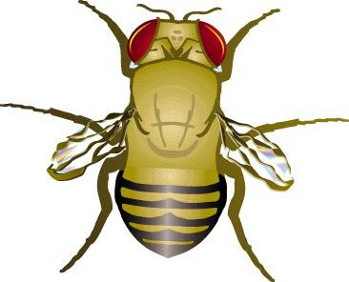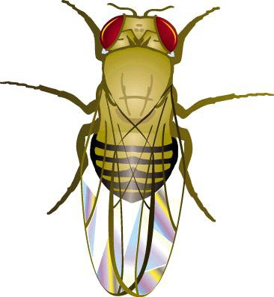
Figure 3. Comparison of Normal and Vestigial Wings in Fruit Flies
Normal Wings
Vestigial Wings
You will use a computer program to simulate a genetic cross between a wild­type fly and a fly with vestigial wings. A Punnett square will be used to predict the results of the genetic cross. The Punnett square helps you make an estimate what the possible gene combinations for wing­type will be given the wing alleles that each parent has to donate. You will compare your predicted results with the actual, or observed results from the simulated genetic cross.

GUIDING QUESTIONS
- What are the identifying characteristics of male and female fruit flies?
- How do you use a Punnett square to predict the phenotypes and genotypes that result from a genetic cross?
- What are dominant and recessive genetic traits?

MATERIALS
DrosophiLab 1.0 program Computer

PROCEDURE

Par t I Nor ma l Wings x Vest ig ia l Wing s
- Turn on the laptop computer. Double click on the DrosophiLab icon . Close the “Tip of the Day” window. A blank program window will appear.

- Select File>New Experiment from the menus at the top left of the window. The following “Create New Experiment” window will appear (Figure 4). Create an experiment name and type it in the Experiment Name box.

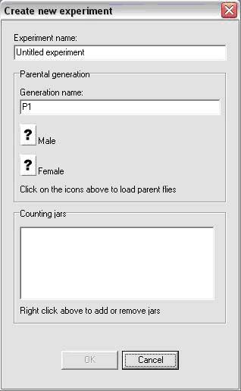Figure 4. New Experiment window

- Click on the “?” icon next to the Male parent. A window showing a series of “.fly” files will appear. Select the male fly with the name “Expt1male.fly”, then click Open. If you have done this correctly, a fly icon will appear where the “?” used to be, and the
name of the Experiment file will be written to the right of the fly icon.

- Repeat Step 3 to choose the female fly with the name “Expt1female.fly”.

- 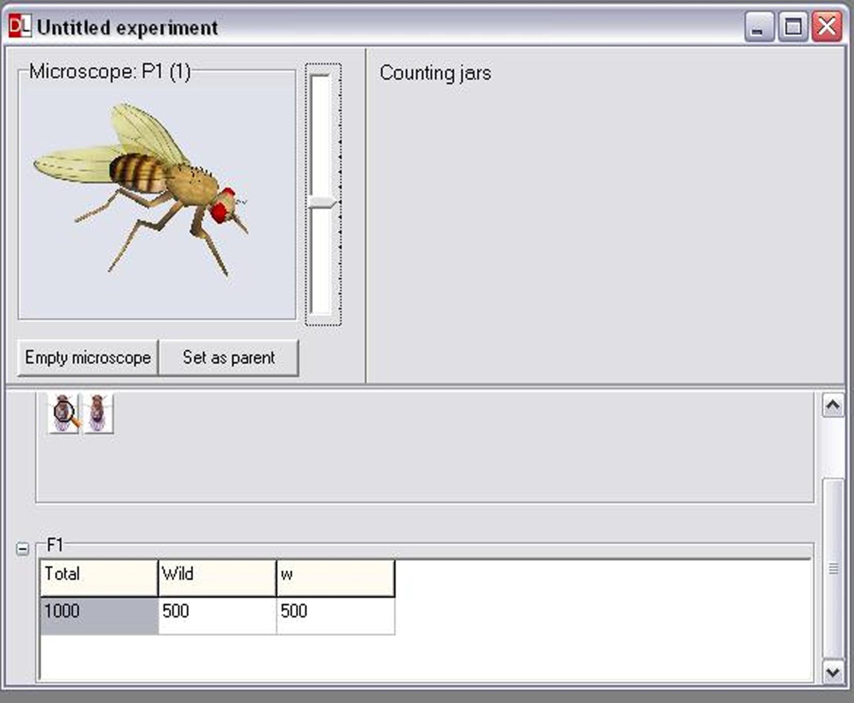Select OK when you have chosen the appropriate male and female parents. The main experiment screen will appear (Figure 5). At the top left portion of the window, there is a microscope window which should be empty. Below this is a box labeled P1, showing the two parent fly icons. To examine one of the parent flies, click on one of the P1 fly icons just below the microscope and drag the fly to the microscope box. A 3D model of the fly should appear as shown in Figure 5.
Figure 5. Main experiment screen

- It is a good idea to look at the parent flies under the virtual microscope, as you should
be familiar with identifying the male from the female. You will also want to determine which parent has the long wings (wt) or the recessive vestigial (vg) phenotype. There are several ways in which you can manipulate the fly to examine it more closely.

  - Shift + Left click allows you to center the fly in the field of view.
  - Ctrl + Left click allows you to rotate the fly so that you can see certain sections of the body more clearly.

- Examine the first fly under the microscope and determine whether it is a male or female (Figure 6). In general, males are slightly smaller than females. The most distinguishing features are found on the abdomen of the flies. The female has several transverse stripes, and an ovipositor which gives the fly a more pointed abdomen. The male abdomen is darker, and has a much blunter tip.

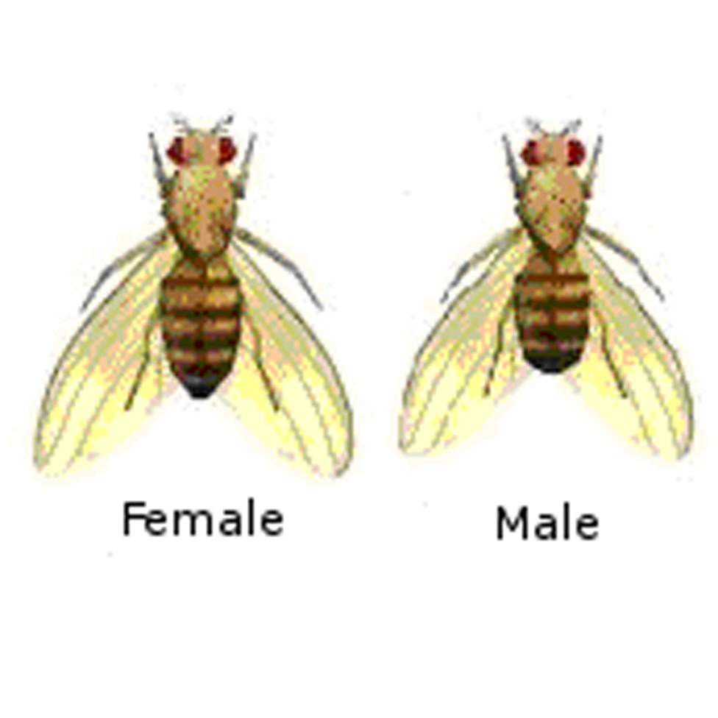Figure 6. Female and Male Drosophila

Abdomen with Several Transverse Stripes
Heavily Pigmented Tip of Abdomen

Pointed Ovipositor Blunt Tip of
Abdomen

- Note if the fly has the vestigial (vg) mutation associated with it. Record the sex and wing phenotype on the Data Sheet. Select “Empty Microscope” when you are done.

- Drag the second parent fly to the microscope and follow steps 7 & 8. Select “Empty Microscope” when you are finished recording the sex and mutation information.

- To predict what phenotype and genotype the offspring will be, you need to complete a Punnett square. One is provided for you on the Data Sheet.

Figure 7. New Generation window

- 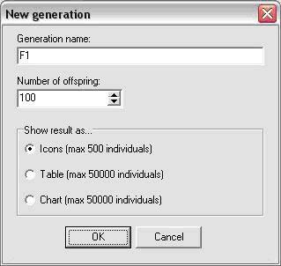Record your predictions for the phenotype(s) of the offspring in the space provided. For this type of analysis, it is easiest to record your predictions as a percentage. For example, if from
the Punnett square you expect 3 wild­type (long wing) and 1 vestigial (small wing), you would record this as 75% wild­type and 25% vestigial.

- To create a genetic cross and produce offspring from these two flies, select
Experiment>New Generation from the top menu. A “New Generation” window will appear (Figure 7). Under Generation name,

keep the F1 and add any mutation name you have given the flies. Set 200 as the Number of offspring, and select the Chart button. Select OK when finished. You have just performed a genetic cross of the 2 parent flies and created 200 offspring.

- The Main Experiment screen will appear again, this time with an F1 panel displaying a chart listing the phenotype of the offspring and the number of flies for each phenotype (Figure 8). You may have to maximize the size of the window to see the complete chart.
Figure 8. Chart of Wing­length genetic cross.

- 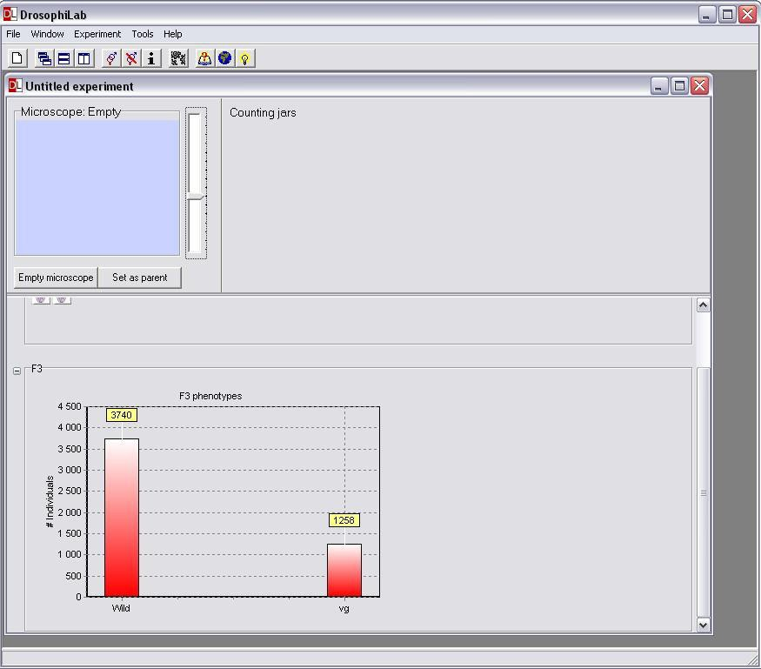On the chart, the flies will be sorted by sex as well as by wing phenotype. You will use these data to calculate the percentages of offspring that have a certain wing type. There is a table on your Data Sheet which will help you record this information. To calculate percentage:

  - From the chart, add the # of male and female flies that have the same type wing. For example, the male and female flies that are listed as WT all have long wings, so these numbers should be added together.

  - Divide this number by 200, the total number of offspring produced by the genetic cross.
  - Multiply by 100 to obtain the percentage of flies which all have the wing type.

- Use the information from the genetic cross and calculations to answer the questions on the Data Sheet.

REFERENCES
The College Board Advanced Placement Program. Biology Lab Manual for Students.
La b Seve n: Ge net ic s o f Organis ms. ♥ 2001 by the College Examination Board. Pp. 78­89.

The College Board Advanced Placement Program. Biology Lab Manual for Teachers.
La b Seve n: Ge net ic s o f Organis ms. ♥ 2001 by the College Examination Board. Pp. 51­57.

DrosophiLab 1.0, ♥ Hannes Jensen, 2004­2005. Educational links to other Drosophila websites are included in this website.
ht t p://www.dro so phila b. co m/

Drosophila Life Cycle image obtained from:
www. flickr. co m/p hoto s/11304375@N07/2993342 324/

Fruit Fly Chromosomes (Fig. 2) and Normal vs. Vestigial Wings (Fig. 3) images obtained from:
ht t p://www.exp lo r ato r iu m. edu/e xhib it s/ mut ant _ flies/ mut ant _ flies. ht ml

CREDITS
This lab design was revised and adapted by Dr. Stephanie Corrette­Bennett using the DrosophiLab 1.0 computer download and the AP Biology laboratory manuals.

DATA SHEET

Name: Group: Date:

Parent Flies: Sex Phenotype
Sex Phenotype
Punnett Square
Pr ed ict io n o f Phe no t ype
Female
vg vg
% long wing (WT):
% short wing (vg):
Male
wt
wt

Results of Genetic Cross
Phenotype | # of flies with phenotype (male + female) | % phenotype  (Total # phenotype −; 200 flies) X 100
Long wing (WT)
Short wing (vg)

QUESTIONS
- Compare the phenotype percentages from your Punnett square to the ones generated by your genetic cross.

Comparison of Predicted % with Observed Results %
Phenotype | Punnett square % | Genetic Cross %
Wild­type (wt)
Vestigial (vg)

- Are the percentages of wing type similar or different?

- How did the Punnett square help you predict the type of wings you would get from these 2 parents?

- Based on the results from the Punnett square, each offspring should receive two different alleles for wing type.

  - What are the two different alleles?

  - What type of wing (long or short) is represented by each allele?

  - When a fly has one of each of these alleles, why do you see only one phenotype?

BONUS QUESTION
If you did a genetic cross with one female offspring and one male offspring from the above experiment, what would the phenotypes of their children be? Use the Punnett square below to predict the results of this cross. Calculate the % of long and short wing flies produced.
Punnett Square
Female
Pr ed ict io n o f Phe no t ype

% long wing (WT):
Male
% short wing (vg):

