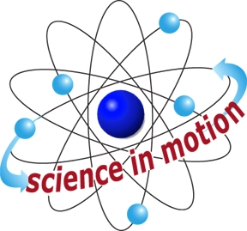
Westminster College

WHAT CAN MAPS CAN TELL US ABOUT LAND AND WATER ON EARTH?

LESSON 1: What is a Map?
Obtain information from a variety of maps to explore how maps represent patterns of land and water on Earth.

LESSON 2: Kinds of Land
Obtain and communicated information from a card sorting activity about the patterns of land on Earth. Develop and compare models of the shapes and kinds of land on Earth.

LESSON 3: Kinds of Water
Obtain and communicate information from a card sorting activity about the patterns of water on the Earth.

LESSON 4: Solids and Liquids
Plan and carry out a collaborative investigation into the properties of solid and liquid water. Use data from the investigation to recognize patterns in the properties of solid and liquid water.

LESSON 5: Snow Globes
Obtain information from models about the patterns of solid water on Earth. Use data and evidence to develop a model of the patterns of land and water on Earth.

LESSON 6: Patterns on Earth
Obtain information from a text to determine patterns of land and water on Earth. Develop a model to represent patterns of land and water on Earth.

LESSON 7: Maps around the World
Obtain information about how maps represent patterns of land and water. Identify common features and differences in how maps represent patterns of land and water.

LESSON 8: Making a Legend
Develop symbols to model the patterns of land and water on Earth.

LESSON 9: Mapping My Model - Part 1
Develop a map that represents the patterns of land and water in the Land and Water Model. Evaluate the ability of a map to represent the patterns of land and water in the Land and Water model.

LESSON 10: Mapping My Model – Part 2
Obtain information from a map to identify the corresponding model. Compare maps to find common features and differences in symbols.

