
WHAT LEAF IS IT?
Westminster College
From Young Naturalist Company 1990
Carolina Biological Supply Company

STANDARDS
- 3.1.K.A
- 3.1.5.A

The importance of Leaves:

The one vital difference between plants and animals is the way they feed themselves. Animals must get their food from other living materials such as plants or other living animals. By contrast a plant produces its own food by turning non-living matter into living matter. This wonderful process is made possible by the green substance known as chlorophyll.

Chlorophyll is often called leaf green because it is found chiefly in leaves. When this substance is activated by sunlight, chemical changes occur that transform non-living matter into life-giving matter and life-sustaining matter. Animals do not have chlorophyll; they cannot manufacture food from raw materials, air and sunlight. Without plants, therefore, animal life could not exist.
If you examine some of the leaves in this kit, you will notice that they are darker green on the upper side than underneath. The reason for this is that chlorophyll bearing cells on the top surface are packed more closely, thereby catching as much sunlight as possible.

MATERIALS
Identified and Unidentified leaf specimens
Key book
Leaf Identification Poster

ACTIVITY 1
CLASSIFYING OBJECTS

The word classify means to arrange or group objects into sets of subsets. We can classify things according to properties such as size, shape, color, texture, temperature, hardness or any other properties. A classification system is neither correct nor incorrect. No classification system is final. Even the traditional classification systems which have been set up for plants and animals are continually undergoing change as new discoveries are made.
Exhibit 1 is an example of a classification system set up for buttons. This exhibit can be drawn on the blackboard to give the students a better idea of how a classification system works.

Procedure
- Draw the button key, exhibit 1, on the board and explain how this is a two property key and therefore a two stage key.
- Draw a new box on the board and ask the students to give you the names of nine different objects to be written in the box. Students can select any objects they wish such as rocks, twigs, birds, glass, stories of any other objects.
- Have the students decide on the physical properties to use to classify these objects and then list each one of these properties as a different stage of the key.
- Key out each object until each one of the nine objects stands alone at the end of the key.
Observation Questions
- How many stages did this new classification system have?
- What name would the students give to this key?
- Are there any different properties the students could use to reclassify these objects.

Activity 2
DESIGNING A STUDENT KEY
Just as you classified buttons and objects so too can you design a key for the students in your classroom and use that key to key out each student.

Procedure
- Begin this activity by asking the students what makes people different. Is it their clothes or jewelry? Not really because two people can wear the same clothes and jewelry on the same day. What actually makes people different are their physical features such as hair color, height, eye color, etc.
- Decide as a group on which physical features your class would like to use for this key.
- Write your class key on the board with the agreed upon physical features for the different stages.
- Now have the students separate into pairs. Each student is to key his/her partner out by going through the key given on the board. Once done have the student write the name of his/her partner at the end of the appropriate key on the board.
- There will not be any students alike in class. Each student is a unique individual with his/her own physical attributes therefore each student should be keyed out to be alone at the bottom of the student key.

Activity 3
WHAT LEAF IS IT?
Using the same techniques that we used to classify buttons, objects and people we will now key out our unknown leaves using a dichotomous leaf key. The word dichotomous comes from two Greek words that together mean “to divide into two parts”. A dichotomous key is based on the idea of making a choice between two alternatives. Each pair of phrases in the leaf key we’ve provided describes different features. However only one of the phrases correctly describes the leaf being keyed out. As they are keying out their leaves each student will need to pick out which phrase applies to the particular leaf he/she is trying to key out. This correct phrase will either guide the students to the next pair of phrases or state the name of the tree the leaf came from.

Procedure
Alternative 1
- Give each student a copy of the leaf key and picture diagram of leaf terms.
- Give each student one unknown leaf.
- Have each student use the leaf key to key out their unknown leaf.
- Have each student write down the number of the unknown leaf and the type of tree they think it came from.

Alternative 2
- Teacher sets up thirteen leaf stations with a different unknown leaf at each station.
- Each student receives a copy of the leaf key and picture of the leaf terms.
- Students go to each station and use their key and diagram of leaf terms to identify all thirteen leaves.

Activity 4
LEAF INVESIGATION

This activity is designed to develop skills of observation and description. It will enable students to determine the useful characteristics in describing and identifying leaves.
Procedure
- After students have completed the identification of the thirteen unknown leaves activity, give the students the opportunity to once again examine these thirteen leaves and to make notes about their characteristics. Students may also wish to sketch a picture of the thirteen different leaves to help their memory.
- For homework each student will be asked to bring in two leaves from their neighborhood that closely resemble two leaves in the lesson plan.
- Remind students in selecting their two leaves that they are to try to get typical leaves which means leaves from a regular tree not leaves from tree stump growth or leaves from tree seedling growth.
- Each student must also be reminded that when they gather their two leaves they must know whether they are opposite or alternate.
- When students bring their two leaves in the next day have them explain in what ways their two leaves are similar to two leaves in the lesson and in what ways they are different. Characteristics such as size, shape, veins, leaf margins, arrangement on twig (opposite/alternate) should be discussed.
- The two leaves for each student should be sorted into total class leaf piles of similar looking leaves.
Questions
- How many piles of different kinds of leaves did the students find?
- Which type of leaf was most commonly found by students? Is this leaf similar to a leaf in the lesson plan? If not, is the leaf from a tree that is very common to the area? What type of tree did this leaf come from?
- How many leaves were found that matched leaves from the lesson plan kit?
- What was the most common leaf characteristic of all the leaves found? For example were there more simples leaves found that compound leaves or more smoothed margined leaves found than tooth margined leaves.
Activity 5
DESIGNING YOUR OWN LEAF KEY
This activity can be done by an individual or a group. It can be done with the unknowns in the kit or with new leaves found by the class. Our example will use the leaves found by students doing Activity 4. We will start with a minimum of six different kinds of leaves found by the students. Since the leaves will eventually dry and become brittle try to use these leaves as soon as possible.

Procedure
- Give each leaf a letter identification label from A to F.
- Have the students examine each leaf and make a list of it’s physical characteristics such as needle like or broadleaf, simple or compound smooth or serrated margins.
- Have the students design a diagram of a leaf key based on the leaves A-F and their physical characteristics.
- In setting up their own leaf key diagram the students must first picture all of their leaves as a total group of leaves. They should then find one leaf or group of leaves that doesn’t fit into the total group because of a different physical characteristic. This split will be our first substage. Examples to look at for first substage are needles like vs. broadleaf, simple vs. compound. As we get to lower substages we can look at margins, shape of leaf, type of compound leaf and other physical characteristics. An example diagram would look like this: 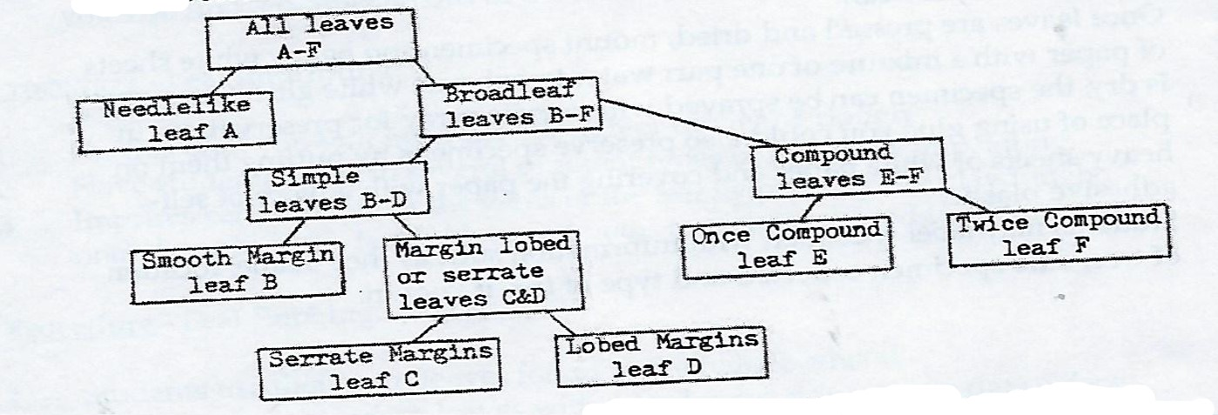
- There would be many variations of this diagram depending on the leaves you have chosen. Opposite and alternate characteristics have been left out of this diagram because this is an unknown unless you do this exercise in the field or use the specimens in the kit.
Activity 6
COLLECTING AND PRESSING FALL LEAVES
Pressing is a simple yet magical way to capture autumn’s glorious colors. As the seasons change, the altering colors and textures of leaves can be recorded by pressing. Pressed leaves are dried specimens that will last indefinitely if properly pressed and mounted.

Procedure
- Have each student bring in several fall leaves that show different fall colors. Students may collect leaves that are still on the tree as long as these leaves are showing color or students may collect leaves that have just fallen off the tree and are not crinkly or crispy.
- Have the class make its own leaf press. This press can be made with two pieces of thin plywood. The plywood covers should be slightly larger than the inside sheets of paper. The inside sheets can be folded newspaper of 11 ½ x 14 inches. Put leaves to be dried in between folds of newspaper. Corrugated cardboard, cut from boxes can be placed between the sheets of newspaper. Place a heavy object such as a brick or books on tope of the plywood or wrap a belt or straps around the press to give you the pressure you need for drying. Drying time is generally three to four weeks.
- Leaves that are put in the press should be spread out flat with no overlapping among leaves or parts of the same leaf.
- You may speed the drying process by placing the press on the radiator, in the sun or in front of a fan.
- Once leaves are pressed and dried, mount specimens on heavy white sheets of paper with a mixture of one part water to one part white glue. Once glue is dry, the specimen can be sprayed with acrylic spray for preservation. In place of using glue you could also preserve specimens by putting them on heavy sheets of white paper and covering the paper with a piece of self-adhesive plastic.
- Students may label specimen with information such as their name, location of tree, date specimen collected and type of tree if known.

Activity 7
LEAF ART
There are several ways in which students can translate into picture form what they experience through their sense of touch and vision. Offer the student these easy techniques and some exciting art forms will be created. Students can make a simple print or silhouette, take an imprint or rubbing of a leaf or trace or sketch leaves freehand.
Leaf Printing
- Have each student bring in several leaves found in their neighborhood.
- Fragile leaves should be glued onto a block made from a piece of wood.
- Have the students paint or ink the side of the leaf where veins are more pronounced.
- Have the students press the painted leaf onto paper or fabric leaving a printed impression. Have the students experiment with different colors of ink and different colors of paper.
Leaf Silhouettes
- Lay leaf specimens on a sheet of paper taped or glued down so they will not move.
- Have students paint with steady strokes from just inside the edge of the leaf onto the paper.
- When students have painted all around the leaf take it off the paper and you will find a perfect record of the leaf’s shape.
Leaf Imprinting
- For this craft you will need play dough or modeling dough.
- Have the students bring in several different types of leaves for imprinting.
- Imprints can be taken of the veins of the leaf by pressing the playdough onto the side of the leaf with raised veins to yield a molded impression.
Leaf Rubbing
- Students use their own leaves found in the neighborhood.
- Have students place leaves with raised veins side up on a flat surface.
- Have students place a sheet of paper over the leaves and rub on the paper with a pencil or crayon.

