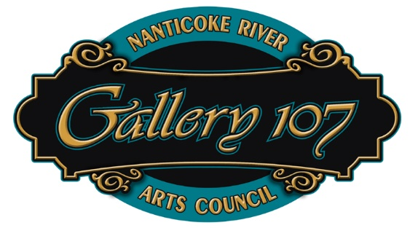

Membership Application
Nanticoke River Arts Council

Name_____________________________________________Date___________________

Address__________________________________________________________________

City_________________________State_________________Zip Code________________

Phone#______________________email________________________________________

Membership: Artist ($35.00____________Non-artist friend ($25.00) _________________

Family/Couple ($45.00) ________________Student ($10.00) ________________________

Signature_________________________________________________________________

We will send notification of NRAC events by email only. New artist’s artwork shall be reviewed by the Board of Directors prior to being accepted for exhibit in Gallery 107. Commission on Gallery 107 sales is 20% of the purchase price. The Square fee for credit card sales is 2.6% + 10c which is deducted from the artist’s side. Monthly exhibit fees are $10 for members volunteering at least 4 hours per exhibition month in Gallery 107 sitting time or $20 monthly for those who choose not to volunteer. Our shows are typically two month long.

We are an all volunteer organization and therefore Gallery 107 operates with the help of our membership!

