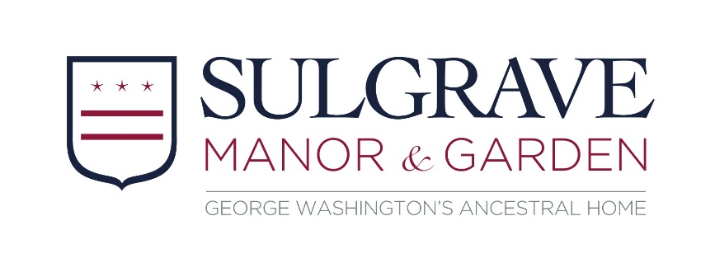

Volunteer Role Description: House Volunteer
About Us
Sulgrave Manor is a fine example of a Tudor and Georgian house which was built and lived in by the direct ancestors of George Washington, the first President of the USA. It was opened to the public in 1921 as a symbol of friendship between Britain and America, and is run by Sulgrave Manor Trust.

About The Role
Sulgrave Manor is open on Thursdays, Fridays and Sundays from April to September. Visitors explore at their own pace, engaging with the displays and activities. Our volunteers bring the house to life for visitors by sharing their knowledge and also help us keep the manor and collections safe and secure.

By getting involved, you could…
- Become part of a dedicated and friendly team
- Learn about this unique property and share its stories
- Use and improve your communication and presentation skills
- Enjoy new experiences and gain new skills
- Have the opportunity to make a real difference to our visitor experience

What’s involved?
- Increasing your knowledge of Sulgrave Manor to bring it to life for our visitors
- Answering questions from visitors about the building, family and history
- Ensuring visitors stay safe within the building and in the event of an emergency
- Acting as a guardian of the house’s fabric and collection
- Becoming familiar with and following our policies at all times (including Health & Safety)

This role will suit you if you…
- Are enthusiastic and friendly with a talent for communicating
- Have an interest in history
- Enjoy meeting new people and being part of a team

Extra Information
- Expenses: We’ll cover agreed travel expenses between home and Sulgrave Manor.
- Hours and frequency: at least one day (Thursday, Friday or Sunday 11:30-5:00) per week or fortnight from April - September, there may be opportunities with tours on other days
Find out more
To find out more information or to apply please contact Thea Young on groupbookings@sulgravemanor.org.uk or 01295 760205 option 3

