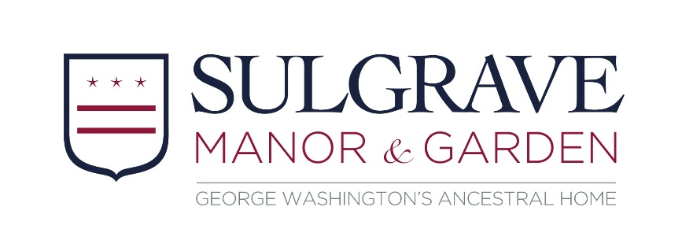

Volunteer Role Description: Learning Engagement Volunteer
About Us
Sulgrave Manor is a fine example of a Tudor and Georgian house which was built and lived in by the direct ancestors of George Washington, the first President of the USA. It was opened to the public in 1921 as a symbol of friendship between Britain and America, and is run by Sulgrave Manor Trust.

About The Role
The Learning Engagement Team delivers learning programmes to approximately 5000 school children a year, as well as offering family activities during school holidays. We’re looking for volunteers to help us bring Sulgrave Manor to life and provide a fun experience for our school and family audiences.

By getting involved, you could…
- Become part of a dedicated and friendly learning team
- Learn about this unique house and garden, and share its stories
- Use and improve your communication and presentation skills
- Enjoy new experiences and gain new skills
- Have the opportunity to make a real difference to our visitor experience at Sulgrave Manor.

What’s involved?
- Supporting school visits by setting up, assisting with workshops and clearing up afterwards.
- Supporting informal learning and events, including preparing and delivering activities.
- Being a friendly face for visitors, welcoming them to Sulgrave and answering their questions.
- Being familiar with and following our Health & Safety policy and emergency procedures.
- Being familiar with and following our Safeguarding policy at all times

This role will suit you if you…
- Are enthusiastic and friendly with a talent for communicating
- Are comfortable working with children and families
- Enjoy meeting new people and being part of a team

Extra Information
- Expenses: We’ll cover agreed travel expenses between home and Sulgrave Manor.
- Hours and frequency: This is a flexible role, to assist with booked visits and events.

Find out more
To find out more information or to apply please contact Leonie Gardner on education@sulgravemanor.org.uk or 01295 760205 option 2

