DEVONSHIRE
HOLIDAY
CELEBRATION
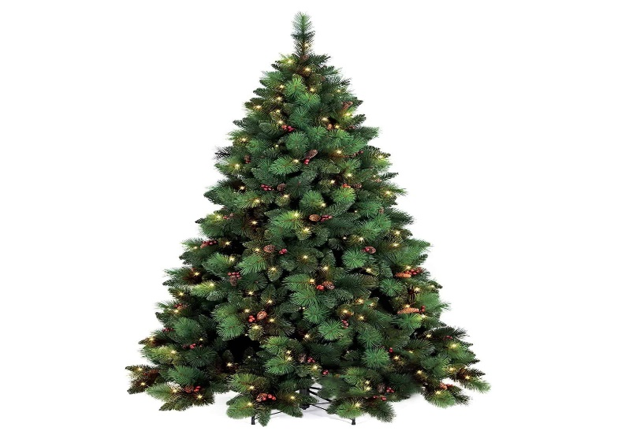
TUESDAY
DECEMBER 14
3:OO PM

An informal gathering of Devonshire residents
On the side lawn of 3636 Kingswood Court

Bring a chair, a beverage, a snack if you wish
And share some Holiday greetings
No Golf Carts on the lawn, please

